|  |
| --- |
| © Deltares, 2012 |

Agnese Boccalon, Neeltje Goorden, Ronald Vernimmen, Jaap Schellekens

**Use of Global Datasets for Hydro-Meteorological Analysis in Areas with Sparse Data**

**Instruction manual and exercises**

Prepared for:

Joint Cooperation partners

**Use of Global Datasets for Hydro-Meteorological Analysis in Areas with Sparse Data**

**Instruction manual and exercises**

Agnese Boccalon, Neeltje Goorden, Ronald Vernimmen, Jaap Schellekens

Report

March 2014

1201430

**Preliminary**

|  |  |  |  |  |  |  |  |  |  |
| --- | --- | --- | --- | --- | --- | --- | --- | --- | --- |
| **Client** | | Deltares | | | | | | | |
| **Title** | | Use of Global Datasets for Hydro-Meteorological Analysis in Areas with Sparse Data | | | | | | | |
| **Abstract** | | | | | | | | | |
|  | | | | | | | | | |
| **References** | | | | <begin hier> | | | | | |
| Ver | Author | | | Date | Remarks | Review | | Approved by | |
|  | Agnese Boccalon, Neeltje Neeltje Goorden, Ronald Vernimmen | |  |  |  |  |  |  |  |
|  | Neeltje Goorden | |  |  |  |  |  |  |  |
|  | Ronald Vernimmen | |  |  |  |  |  |  |  |
|  | Jaap Schellekens | |  |  |  |  |  |  |  |
|  |  | |  |  |  |  |  |  |  |
| **Project number** | | | 1201430 | | | | | | |
| **Keywords** | | |  | | | | | | |
| **Number of pages** | | | 132 | | | | | | |
| **Classification** | | | None | | | | | | |
| **Status** | | | Preliminary | | | | | | |
| This report is a preliminary report, not a final report and for discussion purposes only.  No part of this report may be relied upon by either principal or third parties. | | | | | | | | | |

wlL5wlSummary

Contents

wlL2wlL1wlL3wlL4

1 Introduction 1

1.1 General information 1

1.1.1 What can you do with this manual 1

1.1.2 Suggested timing for the use of the manual during a workshop 2

1.1.3 Content of your USB stick 3

1.2 Hydro-meteorological analysis using freely available software and global datasets 3

1.2.1 Required input parameters for hydro-meteorological analysis 3

1.2.2 Freely available global datasets for the analysis 5

1.2.3 Freely available software for the analysis 6

2 Working with Quantum GIS 8

2.1 Installation of QGIS 8

2.1 Exercise: Getting started using QGIS 14

2.2 Background information on the Coordinate Reference System 16

2.3 Working with vector layers 20

2.3.1 Exercise: how to create a sub-selection from a vector layer based on its attributes 21

2.3.2 Exercise: how to re-project a vector layer 24

2.4 Working with raster layers 26

2.4.1 Exercise: how to visualize a raster layer 27

2.4.2 Exercise: how to homogenize the view settings of different layers to a common format 29

2.4.3 Exercise: how to merge different raster layers into one raster 30

2.4.4 Exercise: determining the resolution of a raster layer 32

2.4.5 Exercise: how to reproject a raster layer 32

2.4.6 Exercise: how to create a sub-selection from a raster layer using a vector file (clipping) 35

2.4.7 Exercise: how to convert a vector layer to a raster layer 38

3 Topographic data 40

3.1 General description, typology and use 40

3.2 Preparing topographic data as input for WFlow 40

3.2.1 Exercise: how to change the resolution of a raster layer (resampling) 40

3.2.2 Exercise: convert your resampled map to ArcInfoAscii format 42

3.2.3 Exercise: change the cell size of your ArcInfoAscii grid 44

3.2.4 Exercise: convert the ArcInfoAscii grid to PCRaster format 44

4 Land use and land cover data 45

4.1 General description, typology and use 45

4.2 GlobCover (ESA) 46

4.3 Preparing land use and land cover data as input for WFlow 48

4.3.1 Exercise: prepare a land cover reclassification table 49

4.3.2 Exercise: associate land cover class with soil depth 49

4.3.3 Exercise: estimate soil depth for land cover categories based on rooting depth 53

5 Soil data 54

5.1 General description, typology and use 54

5.2 Digital Soil Map of the World (FAO) 56

5.3 Preparing soil data as input for WFlow 57

5.3.1 Exercise: preparing the soil reclassification table 58

5.3.2 Exercise: determine how many DOMSOI categories exist in Indonesia 59

5.3.3 Exercise: determine how many soil classes exist in Indonesia 60

5.3.4 Exercise: computation of water storage capacity of soils 61

5.3.5 Exercise: computation of infiltration capacity parameters 63

5.3.6 Exercise: computation of the saturated hydraulic conductivity Ks 64

5.3.7 Exercise: computation of the fraction of compacted area per grid cell 65

5.3.8 Exercise: computation of rooting depth 65

6 Precipitation and potential evapotranspiration data 66

6.1 Preparing meteorological data as input for WFlow 66

6.1.1 Exercise: convert format of TRMM precipitation maps and reproject 67

6.1.2 Exercise: clip the meteorological maps to your catchment 68

7 Extra exercises 76

7.1 Preparing input data for WFLOW with QGIS for Bian and Citarum 76

8 Hydrological modelling with WFlow 83

8.1 Basics of WFLOW model functioning 83

8.1.1 Rainfall Interception 84

8.1.2 River and overland flow 85

8.1.3 Soil processes in WFLOW 86

8.2 Input data for WFLOW 88

8.3 Delineate the catchment and create the static maps 88

8.3.1 Exercise: Catchment delineation 89

8.3.2 Exercise: making static and instate maps 90

8.3.3 Exercise: Run WFLOW model 91

8.4 Create the parameter tables for WFLOW 92

8.4.1 Parameter data 92

8.4.2 Sources 93

8.4.3 Making the input table with the text editor 95

8.4.4 Exercises with the tables 96

9 Water Balance 98

9.1 Theoretical background on the water balance 99

9.2 Water balance in WFLOW 101

9.3 Retrieving of the parameters 101

9.4 Analyzing the values 102

9.4.1 Computing the area of the catchment 102

9.4.2 Calculating terms of the water balance 102

9.4.3 Exercise 1 103

9.4.4 Exercise 2 103

9.4.5 Exercise 3 103

10. Precipitation and discharge analysis 104

10.1 Precipitation analysis 105

10.1.1 Exercise: Determine monthly, annual, dry and wet season average precipitation in your catchment 105

10.2 Discharge analysis 109

10.2.1 Exercise: Determine monthly, annual, dry and wet season average discharge in your catchment 110

10.2.2 Exercise: For a selected year, plot the hyetograph of your catchment against its corresponding hydrograph 113

10.2.3 Exercise: For a selected 10-year time period, provide the scatter plot of the rainfall to runoff relation and make considerations about your findings 114

10.3 Validation of discharge series 115

10.3.1 Comparison of modelled data with measured data 115

10.3.2 No non-sense validation 117

10.3.3 Exercise: Compute the runoff coefficient (RC) for your catchment: 118

11 Sensitivity analysis 119

11.1 Exercise: Perform the sensitivity analysis on the river discharge by testing 3 variables from Table 2 120

12 References 121

wlListTabswlListFigswlListPhotoswlListSymb

List of Figures

Figure 1‑1 Example of global datasets used for environmental modeling. 5

Figure 2‑1 QGIS initial screen overview. 14

Figure 2‑2 Administrative layer of Taiwan 15

Figure 2‑3 World map of UTM zones 16

Figure 2‑4 Latitude and Longitude 16

Figure 2‑5 UTM zones for Indonesia. 17

Figure 2‑6 The shape of the Earth 18

Figure 2‑7 WGS CRS with different EPSG codes 19

Figure 2‑8 Map and attribute layer of administrative units in Bolivia 21

Figure 2‑9 Use of the Save selection as function 23

Figure 2‑10 Use of the Save as function 25

Figure 2‑11 Conversion of raster formats. 33

Figure 2‑12 Select the correct data format for your raster. 33

Figure 2‑13 Conversion of raster format from ArcInfoAscii to GeoTIFF. 34

Figure 2‑14 Reprojection of raster. 34

Figure 2‑15 Reprojection of raster from WGS84 to UTM54S using Warp function. 35

Figure 2‑16 Layer properties of the WS EDB – UTM54S.shp 36

Figure 2‑17 Clipping a raster. 37

Figure 2‑18 Clipping your raster using a predefined extent which is shown as the red rectangle on the map. 37

Figure 2‑19 The DSMW map for Borneo in a vector format 38

Figure 2‑20 Selection of the Vector to Raster function 38

Figure 2‑21 Definition of the Rasterize function 39

Figure 2‑22 The raster visualization of the DMSW for Borneo 39

Figure 3‑1 Properties of the SRTM WS EDB clipped – UTM54S.tif 41

Figure 3‑2 Resampling a raster file using the Warp function. 42

Figure 3‑3 Convert the resampled 270 m SRTM raster from GeoTIFF to ArcInfoAscii format. 43

Figure 3‑4 Header of the SRTM WS EDB clipped resampled 270 m– UTM54S.asc 43

Figure 3‑5 Adjusted header of theSRTM WS EDB clipped resampled 270 m adjusted – UTM54S.asc 44

Figure 4‑1 Overview of rooting depth based on Land Cover (blue 0.8m, purple 1.5m, red 3.5 m). 52

Figure 5‑1 Porosity for different soil types. 54

Figure 5‑2 Overview of the FAO Digital Soil Map of the World, with a zoom to Indonesia. 57

Figure 5‑3 Infiltration Capacity Curve for Different Soil Types 64

Figure 5‑4 Saturated hydraulic conductivity for different soil types. 64

Figure 6‑1 Precipitation (based on corrected TRMM 3B42RT) on 1 Jjanuary 2009 for Indonesia. 66

Figure 6‑2 Convert precipitation data in PCRaster format (.map) to GeoTIFF (.tif). 67

Figure 6‑3 Wrong clip of theTRMM precipitation data. 68

Figure 6‑4 Example of the clipper functionality of the TRMM data for the Citarum catchment 69

Figure 6‑5 Clip the TRMM data with Translate 69

Figure 6‑6 Resample your precipitation data with the warp function 70

Figure 6‑7 Clip your TRMM data with the prjwin in Translate 71

Figure 6‑8 Check of the clip of your TRMM grid. 71

Figure 6‑9 Save your file as ASCII grid with Translate 72

Figure 6‑10 Example of the AsciigridTRMM file you have to change. 73

Figure 6‑11 Convert the ascii grid to map format with the Translate function in QGIS 73

Figure 6‑12 Use the raster calculator to calculate daily potentional evapotranspiration maps 74

Figure 9‑1 Area of focus for the water balance analysis 98

You will first retrieve the data from the model (the blue boxes in Figure 9.1) and then you will analyze them with Excel (Figure 9.1 green box). This chapter will start with a short explanation of the theory behind the water balance, and will then show you the correspondence between the water balance elements and their representation in WFlow. After the theoretical part, it will be discussed how to retrieve the water balance data from the model and how to perform the computation. *Figure 9‑2 Illustration of the water cycle* 98

Figure 9‑3 Example of the water mass balance 99

Figure 9‑4 Location of the parameters to be changed 101

Figure 9‑5 Citarum River catchment in Aguila 103

# IntroductionIntroduction

## General information

This manual was developed within the framework of the Joint Cooperation Program (JCP) initiative started in 2011 under the financing of the Dutch Embassy in Jakarta (Indonesia). The program is a collaborative 5-year partnership established between Dutch and Indonesian institutes working in the field of climate and water resources management. Phase I of the JCP started in February 2011 and it is due to finish in December 2012. The objective of the cooperation as stated in the Joint Cooperation Agreement is to carry out a long-term knowledge sharing and capacity building program between the four participating institutes, namely KNMI, BMKG, PusAir and Deltares. The ultimate aim is to increase the state of the art of the knowledge base of the institutes involved and to strengthen the institutional capacity of Indonesian organization involved in planning, development and management of water resources systems.

This manual has been further developed as part of the Deltares R&D program for the OpenStreams framework ([www.openstreams.nl](http://www.openstreams.nl), http://wflow.googlecode.com)

### What can you do with this manual

This manual is intended for hydrologists and water resources managers and planners active in the field of hydro-meteorological analysis at the river basin scale. In this manual it will be explained how to generate hydrological time series for one or more selected river basin(s) for contexts where field measurements are either non reliable, scarce or not available.

The manual provides the tools (theory and exercises) to construct and populate a freely accessible hydrological model using open source data required for hydrological modelling based on climate, morphological and site-specific physical input requirements.

More generally, this manual also provides basic theoretical background for the use of open source Geographic Information System (GIS) tools to generate the required input for river basin hydrological modelling.

Upon generation of the river discharge series, users will be able to use this input for a diversity of hydrological analysis at the catchment or river basin scale for the selected time period of simulation, with a daily time scale resolution.

### Suggested timing for the use of the manual during a workshop

The time schedule presented in table 1.1 below provides a suggestion of how the content of this manual could be distributed in time based on the topic discussed and on the propaedeutic data preparation to run the hydrological model.

Depending on the technical preparation of the participants and on the detail of the analysis, the required time to carry out the workshop can be shortened to about 3 days or expanded to up to 2 weeks.

A description of how the work can be organized is further provided below.

Table 1.1 Suggested time plan and program of the workshop

|  |  |  |
| --- | --- | --- |
| **Day** | **Session** | **Content** |
| Day 1 | M | * Introduction, short participants self-introduction, groups formation and familiarization among attendees * Data and software distribution + installation * Introduction to the analysis tools used in this workshop |
| A | * Introduction to Quantum GIS; * Introduction to data preparation (selection in a raster and vector environment, use of different coordinate systems, layers formatting); * Group daily report drafting and presentations |
| Day 2 | M | * Recap on previous day * Preparation of topographic data * Preparation and reclassification of land cover data |
| A | * Exercises * Group daily report drafting and presentations |
| Day 3 | M | * Recap of previous day * Preparation and reclassification of soil types data * Preparation of precipitation and potential evapo-transpiration data |
| A | * Exercises * Group daily report drafting and presentations |
| Day 4 | M | * Recap of previous day * Introduction and use of PCRaster and WFlow models |
| A | * Exercises * Group daily report drafting and presentations |
| Day 5 | M | * Summary on the content of the workshop * Final presentation by trainees and participants * Follow up * Handing out of certificates |

(M = morning, A = afternoon)

Ideally, the workshop can be organized in 5 daily sessions. For each session, participants will form working groups of 3-4 people to exercise on each module. Each group will be assigned a river basin to carry out the analysis. At the end of each day, the different groups will have to draft a short daily report summarizing on the activities carried out during the day. This report will later be used to draft a final comprehensive report on the set of activities performed during the workshop, the methodology and the approaches used for data analysis, retrieval and preparation.

At the end of each daily session – and after carrying out the exercises – the groups will also give a short presentation about their daily work to share their experience with the rest of the participants. It is suggested that, despite all groups having to write a daily report, only one group at a time presents its work for each day of the workshop. This will be a moment for discussion and confrontation about methodology and approaches used during the analysis, problems encountered and type of solutions found. To stimulate collaborative participation among the attendees, the workshop should be as interactive as possible. This way, participants will have the opportunity to apply the theoretical knowledge to real cases by working along with colleagues from partner institutions, and with the trainers from Deltares.

### Content of your USB stick

All the software and information required for this training are provided with the USB drive that has been given to you at the beginning of this workshop.

The content of the USB is organized using a thematic structure. On the USB you will find the following directories:

1. General info
2. QGIS
3. W-Flow
4. Data
5. Literature
6. Supporting docs

## Hydro-meteorological analysis using freely available software and global datasets

### Required input parameters for hydro-meteorological analysis

Hydro-meteorological analysis in the context of water resources management is an important tool for decision-makers to assess water resources availability in a temporal and spatial scale. With this information, plans for natural resources developments or conservation can be identified and evaluated against physical and structural constraints.

A thorough hydrological analysis takes into account quantitative and qualitative aspects of water availability. However, although most studies start from an analysis of the quantitative component, water availability alone is not enough. With increasing pollution from domestic consumption, agricultural and industrial production, water resources need equally to be assessed in terms of their water quality to effectively plan current and future potential water uses. Along with water governance (how to manage water sector projects from an institutional point of view), water *quantity* and water *quality* are therefore the two major areas on which water resources managers need to focus their efforts on.

For the specific scope of generating discharge series at the river basin scale, this workshop will only deal with the quantitative aspects of the hydrological analysis. At a later stage, the results of this analysis can then be used to evaluate available water resources also based on their qualitative aspects.

With the river basin as the unit of analysis for hydrological modelling, there are a number of hydro-meteorological input parameters needed to prepare a thorough water resources assessment. As a general practice, a hydrological analysis includes a *water supply* and a *water demand* component.

Water supply is understood in terms of water availability through natural (i.e. precipitation, river discharge, groundwater) and artificial (i.e. dams, rain water harvesting) sources, while water demand represents the requirements for water driven by anthropogenic (e.g. domestic, agricultural and industrial water use) *and* ecosystem services (e.g. ecological water requirements). Once the patterns of water availability are known, they can be combined with the water demand functions from the different water users to formulate a basin-wide water balance analysis, describing how, if and when the water demand is met with the available water supply.

The focus of this workshop will be mainly on the water supply component, and more specifically, on the quantification of the surface water available at the catchment level through (net) precipitation and run-off. Aspects related to water demand will be dealt with only to account for the water losses produced by vegetative water use (i.e. water lost through evapo-transpiration of vegetative land cover and/or crop water requirements) but not for aspects related to anthropogenic domestic and industrial water demands.

Available water resources at the catchment level are usually quantified in term of river discharge series. To calculate river discharge, a number of input parameters need to be known to ultimately compute surface water flow. These parameters are:

* Precipitation;
* Potential evapo-transpiration;
* Crop water factors;
* Topography;
* Soil types;
* Land use and land cover types.

This workshop will specifically focus on these parameters to carry out the hydrological analysis for the selected river basins.

Precipitation is the main input factor determining the gross amount of water received from the atmosphere. Potential evapo-transpiration determines the amount of water which returns to the atmosphere depending on location-specific factors such as wind speed, solar radiation, surface and air temperature. Crop water factors determine the amount of water used by crops during their growing stages. Catchment morphology determines the direction and speed of flow based on slope patterns. Soil types determine infiltration and water saturation rates, and therefore directly determine run-off formation and accumulation. Ultimately, land use and land cover determine vegetative water demands and, to a more limited extent, the speed of the rainfall to runoff transformation process.

### Freely available global datasets for the analysis

All of the above-mentioned input factors are nowadays freely available from regional and international research institutes that work in the field of natural resources management and spatial and atmospheric interactions, and are often available at the global scale. For this reason these datasets are often referred to as *global datasets*. Global datasets are information-rich databases that provide public and private users with detailed and sector specific quality input for data retrieval and management. Figure 1.1 shows an example of the number and type of global datasets that are nowadays available for environmental modelling.

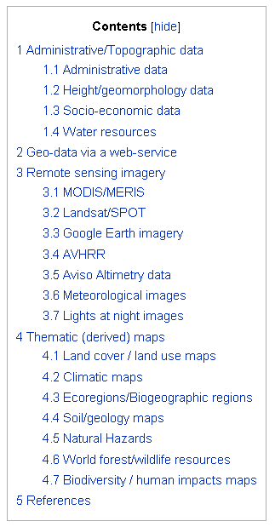

Figure 1‑1 Example of global datasets used for environmental modeling.

Source: <http://spatial-analyst.net/wiki/index.php?title=Global_datasets>

A good example of a global widely-used dataset is the FAO (Food and Agriculture Organization of the United Nations) Harmonized World Soil Database (HWSD) which is a metadata pool of information on physical characteristics, occurrence, and geographical distribution of different soil types at the global scale.

In general terms, the number and types of global datasets which can be used to run a hydrological analysis varies. NASA (National Aeronautics and Space Administration), FAO and ESA (European Spatial Agency) provide for example good quality sources, some of which will also be used during this workshop.

To provide freedom of choice related to data sourcing, each section of the manual dealing with the data input required for the hydrological analysis will also provide a brief description of the alternative available sources of input available on the net. This list however is not comprehensive, it is only intended to remind about the different alternatives available in terms of data sourcing.

During this workshop, the global datasets that have been selected to perform the data preparation process and subsequently run the hydro-meteorological assessment are:

* Precipitation data from the NASA Tropical Rainfall Measuring Mission (TRMM);
* Topography data from the NASA Shuttle Radar Topographic Mission (SRTM);
* Land cover data from the ESA GlobCover database;
* Soil data from the FAO Digital Soil Map of the World (DSMW);
* Evapotranspiration data from the Consultative Group on International Agriculture Research – Consortium for Spatial Information (CGIAR-CSI) Global-PET database

The individual modules of this workshop will explore these global datasets with the aim to combine them into the hydrological model that will be used to generate the river discharge series.

Whenever possible, it is always good to compare the information obtained from the global datasets with available measurements or other global data sources. Depending on the quality of the measured data, this comparison will allow the user to formulate critical judgements on the reliability and precision of the information being analysed. This is an important point of attention to ensure data quality management.

### Freely available software for the analysis

To be able to generate discharge series for the selected river basins, this workshop will focus on the use of the freely available GIS software Quantum GIS (or Q-GIS) used in combination with W-Flow, a distributed hydrological model built using a dynamic GIS language called PCRaster. Quantum GIS will be used for the data preparation phase, while WFlow will be used for the generation of the river discharge series based on the input prepared with QGIS.

If you will experience some problems during the execution of the exercises, this can be due to the different version of QGIS used. In this case, please refer to the User’s Manual instructions provided by the software developer to overcome the problem.

With reference to the hydrological model used for data processing, we will make use of the GIS-based distributed hydrological WFlow model. The model has been developed by Deltares. It is an open source General Public License (GPL) product which is distributed at no cost and without any warranty. More specific information related to the model functioning and characteristics is provided in Chapter 8. For further information about model’s see <http://wflow.googlecode.com> of http://www.openstreams.nl

Participants will be introduced to the use of Quantum GIS in Chapter 2, and will use its functionalities in Chapters 3 to 7. The data preparation to run WFlow will mostly be performed with QGIS. Soil reclassification will be performed by making use of both QGIS and Excel.

# Working with Quantum GIS

In this chapter participants will be introduced to the use of the freely available GIS software Quantum GIS.

Quantum GIS, or in its short form QGIS, is an open source Geographic Information System software which has been developed by the Open Source Geo-Spatial Foundation (OSGeo) and which supports several vector, raster, and database formats, such as for example ESRI shape files and GeoTIFF files.With QGIS it is possible to view and overlay different data formats (i.e. vector and raster data) without conversion to a common format. Most of the functions available with non-open source software (i.e. ArcGIS) are available within QGIS.

On the internet, you can access different fora where users share their knowledge about the use of QGIS. An example of such a page is: <http://www.baruch.cuny.edu/geoportal/practicum/gis_prac_intro.html> edited by Frank Donnelly. This website provides quite an amount of useful information on the use of QGIS. Some of the content of this workshop has also been extracted from this webpage.

An overview of the different formats used for each of the module components we will analyze is given in Table 2.1 below:

Table 2.1 Types and formats of used input data.

|  |  |  |  |  |
| --- | --- | --- | --- | --- |
| **Data input** | **Source** | **Format** | **Resolution (m)** | **Extension** |
| Precipitation | TRMM | Raster | Approx. 28000 | .map |
| Topography | SRTM | Raster | 90 | .tif / .asc |
| Land cover | GlobCover | Raster | 300 | .tif |
| Soil types | FAO | Vector | - | .shp |
| ETpot | CGIAR | Raster | 1000 | .tif |

Please note that to make use of the raster functions described in this manual, your raster files need to be in GeoTIFF (.tif) format. If the raster file is in a different format, convert the file via *Raster -> Conversion -> Translate (convert format)* (see also Section 2.4.5).

## Installation of QGIS

Quantum GIS can be downloaded from [www.qgis.org](http://www.qgis.org). During this workshop, we will be using the latest released official QGIS version Lisboa 1.8.0 (June 2012).

As an alternative to the official version, the user can also opt to download a master version, which is a development version of the latest stable release of the programme (the official version). Compared to the standard version, the master version includes additional functionalities developed by users, and can offer improved data elaboration tools. Yet, master versions can generate unexpected error which might cause loss of data or recurrent errors when different applications conflict with each other. In this manual, we will use the official version Lisboa 1.8.0 for its stability in processing input data.

For those users who want to test the master version, this is available on the same website by browsing the following path: *Home page -> Downloads -> Master -> Download OSGEO4W Installer -> (use) Advance Install -> install qgis-dev.*

*Installation of QGIS with internet access*

When you download the programme directly from the internet, connect to [www.qgis.org](http://www.qgis.org) and click on the download icon.



After the download will be completed you will be prompted to the following screen:

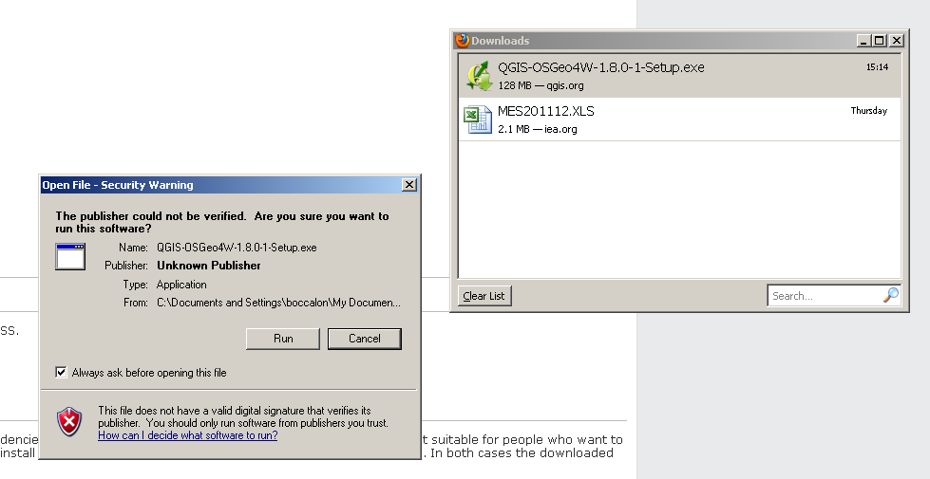

Click on *Run* and select where you want to save the program (normal default option on C: drive is recommended):

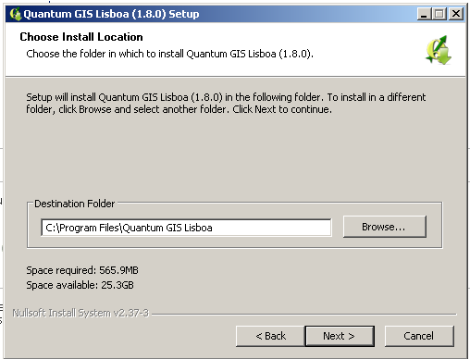

In the *Choose components* window, do not install the additional component. Simply click on *Install*.

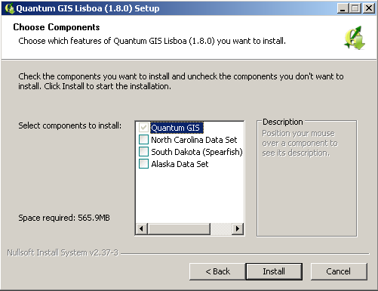

Once the programme will be installed, the following shortcuts will appear on your desktop:

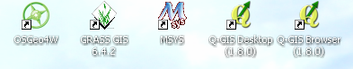

During this workshop we will only make use of the *Q-GIS Desktop* icon. If you wish, you can proceed to delete all the other shortcuts.

You are now ready to start using Quantum-GIS.

*Installation of QGIS without internet access*

For the installation and use of Q-GIS in remote areas where there is no stable internet signal, installation of QGIS can also be performed remotely by first preparing all the required material for download from an internet-secure station, and by subsequently distributing it to users working in areas where no internet access is guaranteed.

The instructions provided below describe the procedure to follow once all the required packages have been downloaded beforehand.

If you have installed QGIS with an internet connection, you can skip this section.

To proceed with the installation of QGIS without internet access, follow accurately the instruction provided below. Please make sure you do not skip any step described in the manual. This might result in incomplete importing of files or parts of the application, and can cause reduced functionality of QGIS during data elaboration.

These installation instructions are written for Windows, and have been tested with Windows 7.

On your USB stick, in the Installation directory you find 4 folders, namely:

* OSGeo4W
* OSGeo4Wstartmenu
* Shortcuts
* Python

Copy the folder OSGeo4W to your C drive. Just copy the folder in the drive and not in another folder (i.e. Program Files) cause this may cause operational problems later on while running the application. Most of the required installation material is contained in this directory.

Now you can choose if you want to start QGIS through a shortcut from your desktop or if you prefer to start it from your computer Start Menu.

To be able to use the shortcuts, copy the shortcut files contained in the Shortcuts folder (so not the folder itself but the files contained in it) to your desktop.

To import the program in your Start Menu, access from your USB stick the OSGeo4Wstartmenu folder and drag it to the *Programs* directory accessible through the *Start menu* as shown in the picture below.



After following these instructions, you can now run Quantum GIS from your desktop by double clicking on the desktop icon or, from the start menu, by selecting the following path: *Start🡪Programs🡪OSGeo4Wstartmenu🡪Quantum GIS*. This procedure gives you access to the basic functionalities of Quantum GIS. However, since we are using a beta version of the programme, we can make use of additional functionalities for GIS data management by selecting and importing a number of important plugins. Plugins are optional applications that render available additional functionalities for data management.

Plugins are available directly from the internet, and the available options are visualized through the *Plugins* menu when opening QGIS as shown in the figure below.

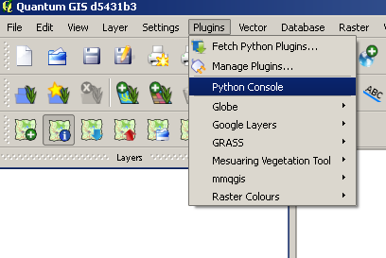

The selection *Fetch Python plugins* allows you to browse new available plugins that are supported by the programming language Python. The selection *Manage Plugins* allows you to select which available plugins you want to render active while working with QGIS, and which ones are not needed and therefore can remain available but hibernated.

Some of the plugins we will use are already contained with the downloaded version of QGIS. Additional plugins useful for the data preparation have been downloaded from the internet and saved in the Python folder provided with the USB stick. Follow the procedure described below to render the available plugins active for use with our version of QGIS.

In one of the two following paths: *C:\users\<name>*or *C:\Documents and Settings\<name*> search for the folder named .*qgis*. Where the folder is located will depend on the version of Windows that is installed on your computer.

Access the *Python* folder from the USB stick (contained in the Installation folder), and copy it into the *.qgis* directory. Close all the open folders and restart Quantum GIS. From the Main menu go to *Plugins🡪Manage Plugins* and select all the available plugins in the list and click ok.

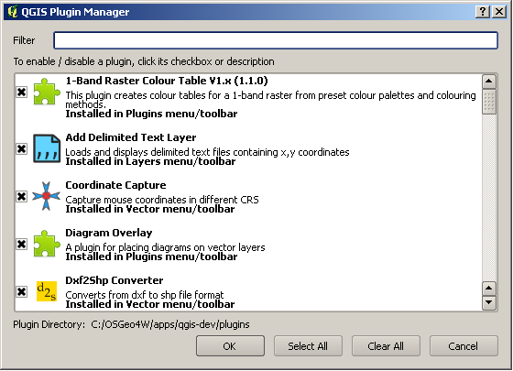

With this last step you have just installed all the functionalities required to start working with Quantum GIS.

Once you have QGIS installed on your computer and you have started the program, the initial screen will appear as from the image below (except for the map and map layers):

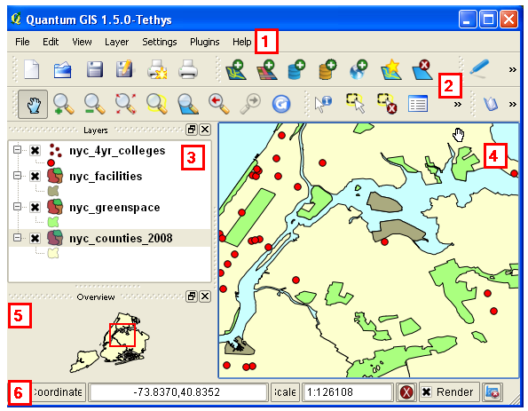

Figure 2‑1 QGIS initial screen overview.

Source: <http://www.baruch.cuny.edu/geoportal/practicum/gis_prac_2.html>

In Figure 2.1, number 1 to 6 correspond respectively to: 1- Menu bar, 2-Tool bar, 3-Map legend, 4-Map View, 5-Map Overview and 6-Status bar. Play around the menu and tool bars and the map functions to get familiar with the available options.

### 

### 2.1 Exercise: Getting started using QGIS

To start working with QGIS, create a new project and name it after your river catchment name and today’s date: i.e. Mekong 06.12.2012. This can be achieved in 2 different ways:

* 1. from Menu bar, *Settings-> Project Properties -> General -> Project title*;
  2. from Menu bar, *New project* icon -> *File -> Save project as*

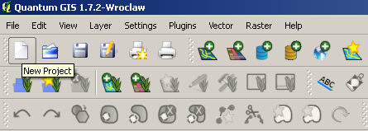

Once you have saved your project, you need to import the input layers that will be used for data analysis and preparation. We will discuss the difference between the types of layers in Sections 2.3 and 2.4. However, in order to be able to work with the Coordinate Reference System exercises described in the next section, and to become familiar with the functionalities of QGIS, we will briefly explain here the procedure to import layers in a project.

The import procedure for a layer in Q-GIS depends on the type of layer to be imported, for which we make a distinction between raster and vector layer. As an example we will import a vector layer containing the administrative boundaries of the country where your basin is located.

A useful and open-access source of administrative boundaries worldwide (at different administrative resolution, i.e. region, province, district) is provided by the work done by Robert Hijmans, who developed a global map of administrative areas. At his webpage <http://www.gadm.org/> you can freely download either the global map or the administrative data by country.

From the webpage above provided, select and download the country of interest for your basin. By making use of the tools bar, import the layer containing your country administrative boundaries. The commands to import layers in your projects are located at the top of your QGIS toolbar as shown in the picture below.

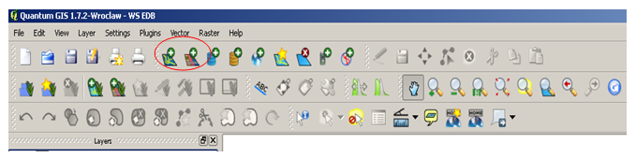

You will soon notice that QGIS gives you the option to choose between vector, raster and other format of data to be imported. Select the appropriate option based on the layer type you are importing (the administrative gadm map is a vector layer). After this operation, the layer should appear in your map view as in the example provided in Figure 2.2 where the country of Taiwan is represented. If the layer doesn’t show on the map view, right click on the layer name on the map legend and select the option *zoom to layer*.

You are now ready to start working with QGIS on the different modules of this workshop. Good luck!

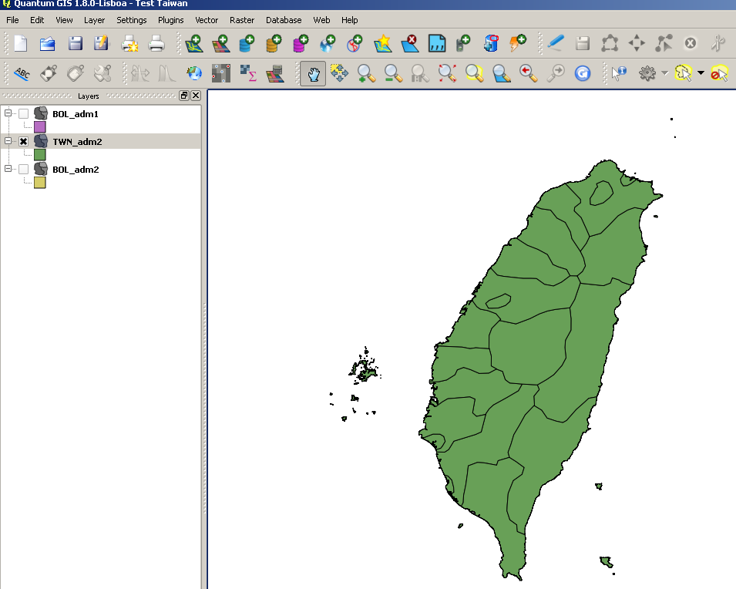

Figure 2‑2 Administrative layer of Taiwan

## Background information on the Coordinate Reference System[1]

A coordinate reference system (CRS) is a geographical coordinate-based univocal mapping system that allows for referencing spatial information in a plane by making use of a set of coordinates (X, Y, Z) and/or latitude/longitude and height (INSPIRE, 2009). While working with GIS maps, the use of the same CRS ensures that all the projected data (i.e. topography and precipitation maps) use the same spatial reference.

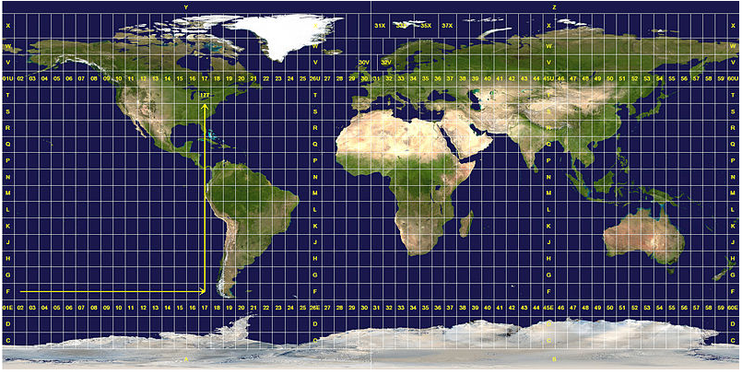

Figure 2‑3 World map of UTM zones

Source: <http://en.wikipedia.org/wiki/File:Utm-zones.jpg>

In the majority of cases, spatial reference is provided by using a system of equidistant lines known as Parallels (running West to East) and Meridians (running North-South), which respectively define latitude and longitude specific for any given location. The range of latitude is [90˚ North – 90˚ South], that of longitude is [180˚ West – 180˚ East]. To measure the location of a specific point in the plane, we measure the distance between the location of this point and the reference latitude and longitude lines in our system (the Equator and the Greenwich Meridian, both at 0˚ latitude and 0˚ longitude respectively). Such a distance is measured in degrees (for specific information on how to transform angular measurements in metric distances refer to the next section).

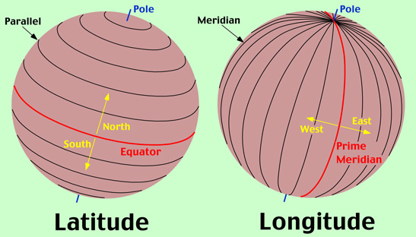

Figure 2‑4 Latitude and Longitude

Source: <http://www.physicalgeography.net/fundamentals/2b.html>

The most widely known coordinate reference system based on latitude and longitude is the World Geodetic System 1984 (WGS 84). A geodetic datum defines the reference systems that describe the size and shape of the earth[2].

An alternative spatial reference system to geo-reference a point in a plane is the widely known Universal Transverse Mercator (UTM) system, which defines points in a map based on a 2-dimensional Cartesian coordinate system represented by cells organized in a grid characterized by unique values. In the UTM any location can be associated with a reference grid cell based on its spatial location. Figure 2‑3 shows the grid cell system of the UTM for the entire world. A selection of the UTM grid cells for Indonesia is on the other hand shown in Figure 2‑5 below. As it can be seen from this figure, the whole of Indonesia is covered by 18 UTM zones, ranging from 46N to 54S. The nomenclature N and S stands respectively for North and South of the Equator.

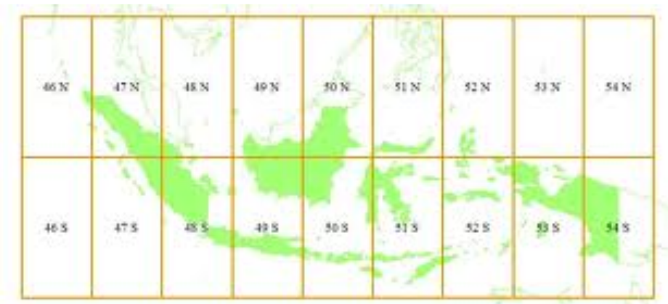

Figure 2‑5 UTM zones for Indonesia.

*General information on angular measurement system*

In a GIS environment distances and coordinate reference systems are often defined based on angular measurements (degrees, minutes, seconds), rather than a linear scale. This is because of the subdivision of the Earth in a system of coordinates defined by a reticulate of horizontal and vertical equidistant lines known as parallels and meridians. Because the Earth surface is not a perfect sphere, but rather an oblate ellipsoid (2 of its 3 radius are of equal length), the equatorial circumference differs from the polar circumference. The values of these two circumferences are:

* Equatorial circumference: 40,075.017 km
* Polar circumference: 40,008 km

In angular measurements, the following equivalences exist:

* 1 degree is defined as 1/360 of the circumference of the Earth;
* 1 minute is defined as 1/60 of a degree;
* 1 second is defined as 1/60 of a minute

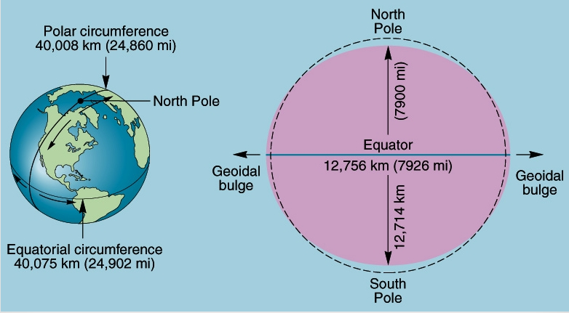

Figure 2‑6 The shape of the Earth[3]

A distance in 12 angular seconds – usually referred to with the symbology of a double aphostrophe ( “ ) is normally referred to as 12 arcsec. Based on this definition, the following example is given for the computation of an equatorial distance:

1 arcsec (=or 1’’) = 40,075.017 Km* 1/360degrees *1/60min * 1/60sec

= 0.0309 Km = 309 m

You can follow this procedure to determine the equivalence between angular and linear measurements.

*Setting the CRS of your project*

When you start a new empty project, under *Settings -> Project Properties -> Coordinate Reference System* you can define the CRS for your project. For the exercises described in this manual, and where not stated differently - the CRS that will be used is the World Geodetic System - 1984 (WGS 84, EPSG: 4326). While working with QGIS and importing layers, make sure you are always working in the same projection system.

On the other hand, when you have a new project open and you import a layer which already has a defined coordinate system, QGIS automatically recognizes the projection system used in the imported layer and uses it to define the default CRS for the project. This occurs when the imported layer already has defined projections (i.e. a shape file with the .prj file). This automatic recognition of the CRS only takes place when the layer imported is the first one of the project. For the other layers imported, when the CRSs of he layers are different, you need to re-project the layers to the same coordinate system to be able to visualize them on the same map view.

*Tip!* Use the *zoom to layer* function from right clicking on the layer in the map legend, to be able to visualize where your layers are and in which coordinate system they are projected.

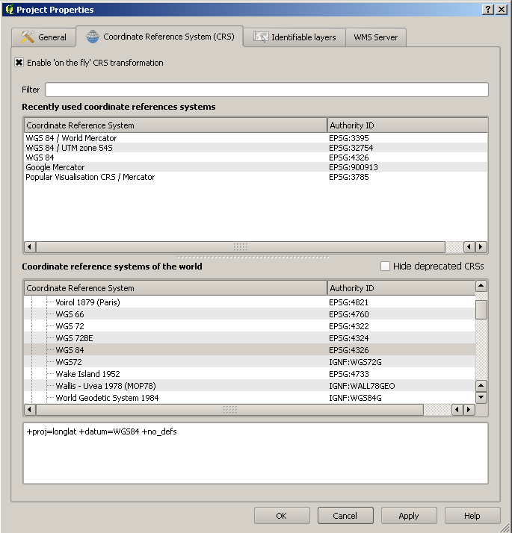

**Note**! WGS84 also exists under the *Projected Coordinate System (PCS)*, which uses a different coordinate system from the *Geographic Coordinate System (GCS)* just described. You can distinguish between the two CRS by spotting the difference between the coordinate library European Petroleum Services Group (EPSG) codes. The difference between the two reference systems is shown in Figure 2‑7 and explained in the text box below.

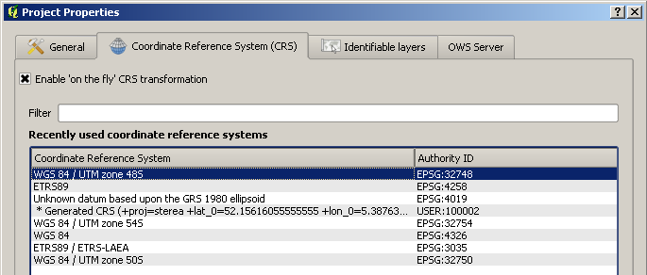

Figure 2‑7 WGS CRS with different EPSG codes

***On the difference between Geographic and Projected Coordinate Systems***

Collectively, when you have these three elements: a spheroid or ellipsoid, a datum, and a coordinate system, you have a so-called Geographic Coordinate System (GCS). The terminology is confusing, as a coordinate system is one part of a geographic coordinate system, and some systems are named based on the datum they use. For example, WGS84 (World Geodetic System of 1984) is the most common GCS and uses the WGS84 spheroid, WGS84 as a datum, and latitude and longitude as a coordinate system. WGS84 is used by the Global Positioning System (GPS) of satellites and thus by individual GPS units as a default, and is commonly used by online mapping applications. There are other systems; in North America NAD83 (North American Datum of 1983) is widely used, particularly by government agencies. It uses GRS 1980 as a spheroid, NAD83 as the datum, and lat and long as the coordinate system.

If you add a map projection as the fourth element to the spheroid/ellipsoid, datum, coordinate system trio, you have a projected coordinate system (PCS):

Projection: Map Projections are mathematical systems for taking the three dimensional earth and transforming it to a flat two dimensional surface. There is no way to take a 3D shape and accurately represent it on a 2D surface, so map projections are designed to preserve one quality of the earth - area, shape, or distance/direction, or are created as a compromise to make the earth appear the way we expect it to appear on a flat surface.

It's important to understand the distinction between a GCS and a PCS, because when you go to transform a layer or define a projection these two systems will be stored or organized in the software separately, under different menus or tabs. You should use a GCS when you're doing analysis, measuring distances, or working in a relatively small geographic area. You shoulduse a PCS when you're creating a thematic map or need to have a certain quality of the earth (area or shape) preserved.

Source: <http://www.baruch.cuny.edu/geoportal/practicum/gis_prac_4.html>

You can check the coordinate reference system (CRS) of your layer by *right clicking* on your layer and choosing *Properties* and navigating to the *General* tab. If no CRS is available you can specify it here.

## Working with vector layers

A vector (shape) layer is a digital map that represents points, lines or polygons in a system of coordinates. In a vector layer, the user can draw and define vectors and perform a large number of other operations directly on all the vectors within this layer, or only on a selection of them. A vector layer has an attribute table where all the attributes of the features in the layer are described. The attribute table can be used to make sub-selections or to create queries for refinement of features identification. The most common format of a vector layer is a shape file (.shp), but other vector formats do exist (for instance .bna). An example of a vector layer is the administrative boundaries layer of Bolivia, which displays the administrative boundaries units as polygons. The country map and the associated attribute table of the administrative layer is shown in Figure 2‑8.

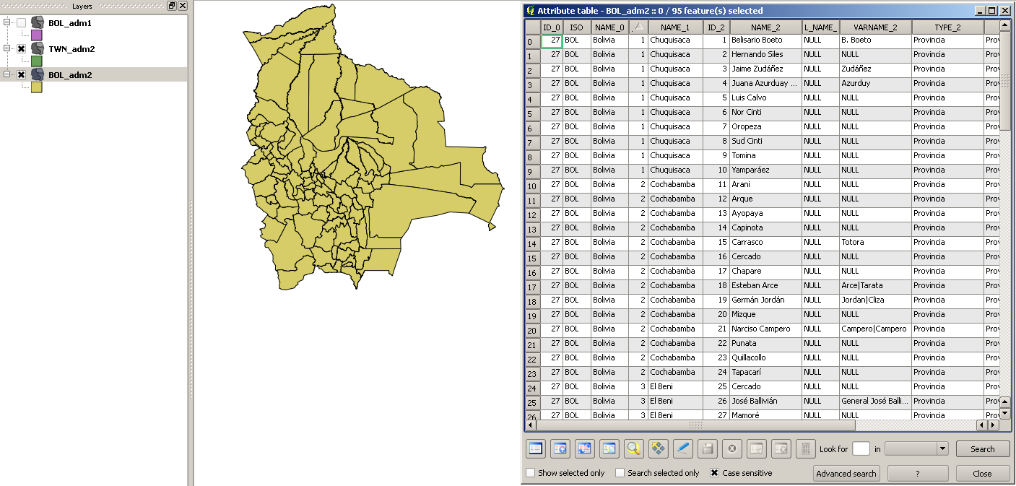

Figure 2‑8 Map and attribute layer of administrative units in Bolivia

When you use an existing shape file or create a new one, there are other 3 files automatically associated with the vector layer. These files are:

* .shp file containing the geometry of the shape
* .shx file containing the shape index file, an index of the geometry
* .dbf file containing the attributes database of the layer’s features

Additionally, also the following files sometimes exist:

* .prj file containing the projections of the layer
* .sbn and .sbx files containing the spatial index of the features
* .shp.xml file containing the XML metadata[4]
* .qpj file containing the layer’s projections created by QGIS

The following exercises will teach you how:

1. to create a sub-selection based on attributes from a vector layer;
2. to create a selection by drawing a polygon around a feature from a vector layer.

### Exercise: how to create a sub-selection from a vector layer based on its attributes

To create a selection from a vector layer, we will be using the FAO Digital Soil Map of the World (DSMW), a global map collecting information on the most occurring types of soil at the global scale. From this map we will create a clip to select only soils occurring in a selected number of countries. This for example might be the case when the hydrological analysis of a river basin is transboundary (the same river flows in different countries).

For this exercise we will use as an example the selection of soil types in the bordering countries of Indonesia (IND) and Papua New Guinea (PNG). By following the same procedure, the user can equally perform the same actions for his/her basin of reference.

With this exercise you will learn to use the following QGIS tools and/or functions:

* create a new vector layer from a selection of an existing layer;
* use the CRS selection to set a new coordinate reference system;
* use the *Union* tool to merge vector data from different vector layers

To achieve our final objective, perform the following instructions:

1. Run QGIS;
2. Create a new project and name it *Data preparation*;
3. Import the administrative layer of your country to the project;
4. Import the Digital Soil Map of the World (DSMW) layer (in 04.Data/Soil data;
5. Move the administrative layer on top of the DSMW layer to visualize the overlapping;
6. Open the attribute table of the DSMW layer by right clicking on the layers name;
7. From the DSMW layer, make a selection for your country/ies based on its/their reference country code/s (e.g. in our example 101 for Indonesia and 168 for Papua New Guinea). To perform step g you should:
   * Insert in the Look for box at the bottom of the Attribute table window the name of the country, or the code of the country whose soils you want to visualize(be aware that the search function is case sensitive);
   * Select the field in which QGIS should perform the search;
   * (optional) select the box *Show selected only*;
8. Create a new map layer containing only the soil selection for your country by using the *Save selection as* function by right clicking on the DSMW layer on your map legend box as showed in Figure 2‑9. Name the layer DSMW Soils [country code name] (e.g. DSMW Soils IND).

Follow the same procedure to create the second soil layer for the other riparian country in your basin (e.g. in this case a layer called *DSMW Soils PNG* to represents soils in Papua New Guinea).





 

Figure 2‑9 Use of the Save selection as function

While saving the file, choose as format the ESRI Shapefile (default output format is Keyhole Markup Language (KML)).

To keep track of the maps you will be developing during this workshop it is strongly advised to create a new folder called *My maps* or *Data preparation* in which to save your newly created maps. This will help you not to confuse the input dataset maps with the ones you will create. Always save your new maps in this folder.

In addition it is useful to include the projection in the newly created filename. Save your new vector layer therefore as *DSMW Indonesia – LL.shp* (LL stands for Latitude-Longitude used for the WGS84 projection). Having clear reference about the projection system of a layer is particularly helpful when using raster maps.

Before saving your newly created file, you can opt for QGIS to automatically upload the new map among the maps currently in use. For this option, you have to select the box *Upload map to canvas* located in the bottom left corner of the *Save selection as* window. At this point you can remove the *DSMW* global map layer, and just work with the soil map for the area of your interest.

Finally, by using the *Union tool* from the *Vector ->Geoprocessing* tools menu, you can create a new layer containing only the soil maps of the countries you have selected (e.g. in our example Indonesia and Papua New Guinea). Use one of the layers as Union Layer and the other one as Input vector layer. Provide the new layer a new name (i.e. Soils *DSMW Indonesia+PNG – LL).* Click yes when you are asked if you would like to add the new layer to the map legend. Close the Union tool window.

**

For our example, the resulting soil map for Indonesia and Papua New Guinea will look as follows:

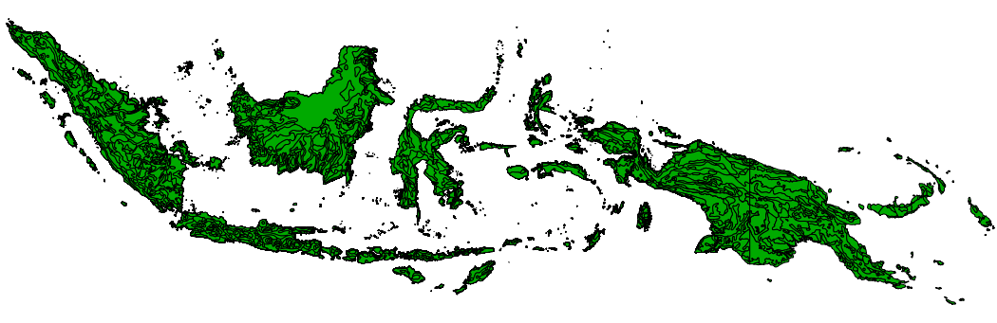

### Exercise: how to re-project a vector layer

The hydrological model W-Flow requires all input maps to be in raster format. Moreover, we also need to have these maps in the same coordinate reference system. In this manual we chose for the UTM system to be our reference coordinate system. In this exercise you will learn how to re-project the selection of soils of your country layer (in our case the Indonesia layer) from the WGS84 CRS to the UTM CRS projection.

From your soil layer ( i.e. *DSMW Indonesia– LL*)right click and select the option *Save as* as shown in Figure 2‑10. Change the CRS to the UTM projection used for your catchment (e.g. UTM 54S for the Papua Province of Indonesia) via the browse button (red rectangle in Figure 2-10) and Save the new shape file including the projection in the filename (e.g. DSMW Indonesia – UTM54S.shp), then click OK.

To know the UTM code/s applying to your basin, make use of country level information obtainable either through the internet (i.e. http://en.wikipedia.org/wiki/Universal_Transverse_Mercator_coordinate_system) or through technical offices (e.g. Hydrological institute or Ministry of Environment).

When a river basin falls within multiple UTM zones, choose the UTM zone code that has higher percentage coverage over your basin area.

To finalize the coordinates conversion, click on OK.



Figure 2‑10 Use of the Save as function

To check if the coordinate conversion for the vector layer has been successful, import the newly created UTM soil layer into your project and check – by comparing with the original layer – if the new projection in UTM has been correctly processed. It appears that the imported layer is not visible? We will explain you why.

Try to visualize the original (WGS) and new (UTM) layers. Perform this by right clicking on the layer. You can check if your map has been projected in the new CRS by inspecting the values of the coordinates showing on the bottom-right Coordinate bar.



***Remember***! A layer projected in UTM shows the coordinate system in metric units, while a layer projected in a WGS84 system geo-references points in a map in a lat/long (latitude longitude) projection.

**Attention**! If you are not able to visualize the layers even when the system tells you they are on the same CRS projections, check if the option *Enable on the fly CRS transformation* is deactivated. If not, deselect the option.

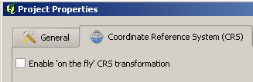

## Working with raster layers

A raster layer is a digital map containing information organized in grid cells. Depending on its resolution – which represents the size of each grid cell - a raster layer is made up of a varying number of cells. The higher the resolution, the greater the number of cells (or pixels) forming the grid. In a similar way, the lower the resolution, the coarser the detail of the information and the lower the number of grid cells in the layer.

In a raster, each cell is associated with a value describing the attribute of the layer (i.e. elevation). Yet, differently from other applications, in Q-GIS is not possible to visualize the attribute table of a raster layer, Yet, a raster layer can be linked to a shape file having the attribute table, and hence providing a higher degree of detail on the data being visualized. This is for example the case for the *Harmonized World Soil Database (HWSD)* dataset, where soil information is provided at a global scale in a raster environment, and then the linkage to soil physical characteristics is accessible from a connected vector dataset accessible through the HWD Viewer tool. The tool can be downloaded from: <http://www.iiasa.ac.at/Research/LUC/External-World-soil-database/HTML/index.html>.

The raster layers we will be using during this workshop are:

* Elevation (SRTM);
* Precipitation (TRMM) and Potential Evapotranspiration (CGIAR);
* Land cover (GlobCover).

To render the data processing and management in QGIS faster, for each of the above-mentioned global datasets we need to work with selections representing only the areas of interest for our research. This means that we will perform a selection on the global raster datasets and create new datasets only covering a specific selected country or region. From these new layers we will then make a subsequent selection to select only the spatial extent related to one or more specific river catchments.

Selection of land cover and land use types from the global GlobCover map is described in Chapter 4 while precipitation data can be sourced from the Tropical Rainfall Monitoring Mission (TRMM) dataset of NASA. In the following exercise we will make a raster selection using the SRTM elevation map. The example provided makes reference to a large river basin in Indonesia called Einlanden-Digul-Bikuma (thereafter referred to as EDB catchment), and located in the south-east province of Papua. This catchment has been selected as an example to carry out this exercise because, due to its dimension, the selection of the elevation data for the area of the catchment requires the performance of 2 steps:

1. the combination of 4 neighbouring SRTM raster layers into a single layer;
2. the selection of the elevation in the catchment based on the catchment boundaries;

If your river catchment or area of interest is covered by only one SRTM layer, then you can directly proceed with step b.

Follow the instruction provided in this example to produce the SRTM delineation of your own catchment.

General information on SRTM data can be found at: <http://www2.jpl.nasa.gov/srtm/>.

To download SRTM data use the JRC ftp: <ftp://xftp.jrc.it//pub/srtmV4/arcasci/>

You can choose from either ArcInfoAscii or GeoTiff. However, be aware that some tiles are missing in the asc folder. Tiff folder is complete.

The latest version of the dataset is SRTM version 4.1.

The kmz file provided by King’s College London (<http://www.ambiotek.com/srtm>) is useful to quickly determine which tile you need.

More information on SRTM can be found here: <http://srtm.csi.cgiar.org>

### Exercise: how to visualize a raster layer

Before creating a selection from the elevation raster layer for the selected catchment, we are first going to import and visualize the SRTM tiles for your catchment in QGIS. In presenting these examples, reference will be made mainly to the Indonesian EDB catchment previously used as an example. When you are working on a different catchment, follow the same procedure described below simply making reference to the input data for your catchment.

Import the SRTM layer(s) covering the geographic area of your river catchment. Use the references provided above to know which SRT cells provide geographic coverage for your study area.

Right after having selected the raster layer to import, you will have to choose the coordinate projection system to use for the visualization of your layer. When prompted for the projections window, choose WGS84 in the geographic coordinate systems as shown in the screenshot below:

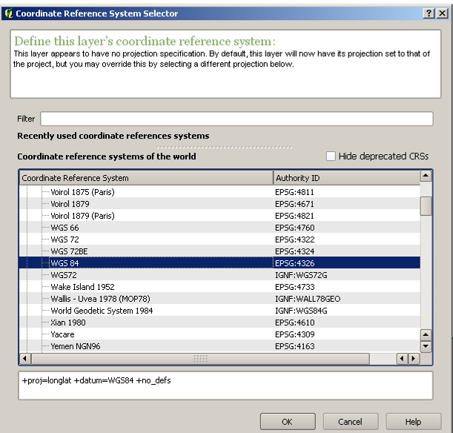

At this point import your river catchment layer and overlay it to the SRTM layers. The resulting visualization in the map canvas for the EDB catchment is the following (raster SRTM layers are in grey, basin vector layer is in green):

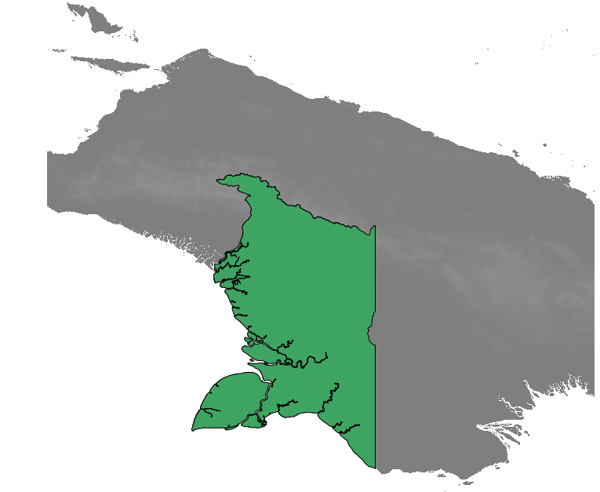

To better visualize the elevation difference in the projected area, we are now going to change the layout of the layers by modifying the colour settings. For each layer, change the colour form from grey to the freak out format. You can do this from the layer’s right click selection *Properties -> Style*.

Now change the visualization of the WS EDB map from *Simple fill* to *Simple line* from the Style menu of the layer’s Properties tab as shown below.

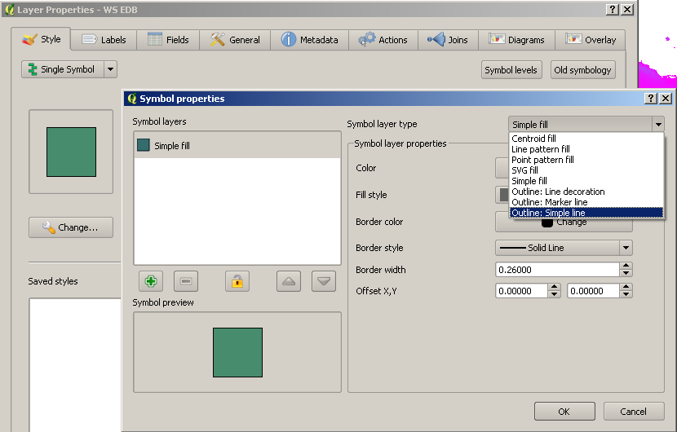

This operation will allow you to visualize the boundary conditions of the WS EDB and comparing them with the overlaying SRTM layers. After these changes, the result should be the following (thin blue line identifies the boundary condition of the catchment:

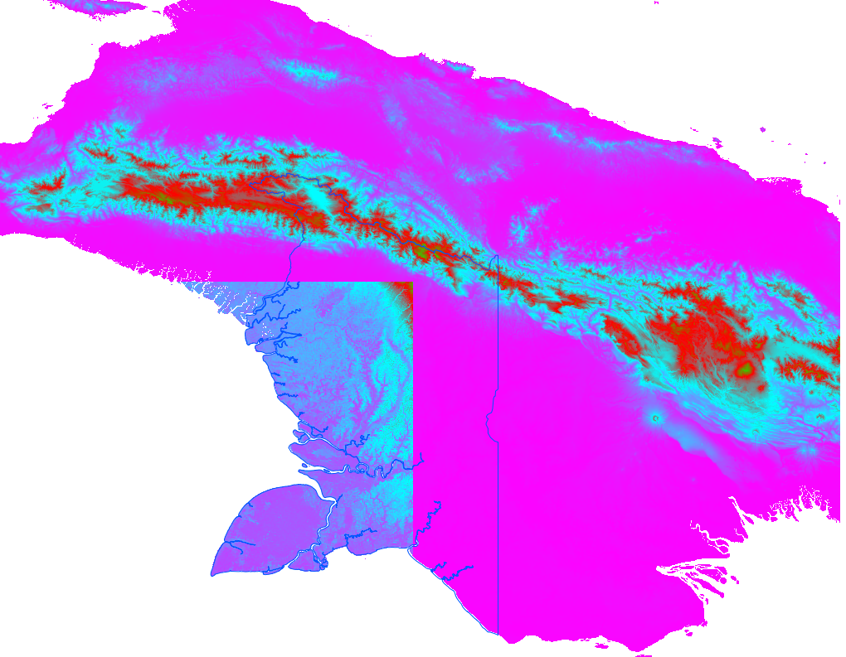

By looking at the map layers, you will notice that, one of the 4 SRTM layers (bottom left) has something wrong with it. What is it?

To find your answer recall that for the SRTM layers different colours correspond to different elevation ranges. You might come to the conclusion that the elevation ranges for the 4 layers are not the same. To ensure homogenization of the SRTM data, we need to set a same reference scale for all of the 4 layers.

### Exercise: how to homogenize the view settings of different layers to a common format

With this exercise you will learn how to create a map visualization style to be used as a default for each of the different layers that need the same formatting style. In this example, the exercise will focus on the formatting of the elevation ranges of the SRTM layers to a common color and range scales that can be used for the different SRTM layers selected for our catchment area.

From the layer’s *Properties, Style tab,* select *Color Map*. Move to the *Color Map* tab and define a range of colors by selecting 20 as the number of entries from the *generate new color map* tab. Once you have created the 20 ranges, assign to each of them a value to them to highlight the elevation differences especially for the low and high elevation areas. You can change the values of the ranges by double clicking directly on the value shown in the Colormap table as shown in the picture to the right. Click on *Apply.*



Once you have defined your ranges (and, if you wish, the color scale to be used), select the *Save Style* command and give the name *srtm.qml*to the style you have just created (the .qml extent is automatically assigned, you do not need to type it).

For the other SRTM maps, you can just use the same style by opening the layer’s properties function and select the *srtm.qml* style from the *Load Style* tab.

**Note!** Please pay attention to which layer you are creating the elevation ranges. If you work on a layer where the elevation ranges from 0 to 3,500 meters and you create the range classes based on these ranges, all the other times you will upload this style for other layers, the [0-3,500] meters range will be the one used. This also means that if in a neighboring layer your elevation range is for example [0-4,000], the elevation range from 3,500 – 4,000 m will not be visible.

### Exercise: how to merge different raster layers into one raster

Sometimes your catchment covers different SRTM raster layers. This is also the case for our example catchment EDB (which is covered by 4 individual SRTM tiles). Before we make a selection from these individual raster layers we will need to merge them first into one raster.

In this exercise you will learn how to use the *Merge* tool (this tool provides a similar end result as the *Union* tool used during our previous exercise in Section 2.3.1 with vector layers).

Merging of the 4 raster layers is accomplished via *Raster -> Miscellaneous -> Merge*.



Once you have opened the *Merge* function from the Raster menu, select the SRTM layers to be merged, give the name to the new output file (e.g. *SRTM EDB_merged*), and select *Load into canvas* when finished. Close the Merge window when finished and inspect the result. Remove the individual SRTM tiles from your project.



**Note!** you will need to carry out the merge on the original SRTM tiles with the WGS84 projection. If you merge re-projected SRTM tiles it is possible that the edges of the individual tiles consist of missing data values which will be included in the merged raster. This is not desirable.

### Exercise: determining the resolution of a raster layer

Resolution can be defined as the minimum linear dimension of the smallest unit of a geographic space for which data are recorded. In a raster environment, these units have generally a rectangular shape (occasionally systems have used hexagons or triangles) and they are known as cells or pixels. When a layer has a high resolution, it means that its cells are of small dimensions. High resolution layers have a higher degree of detail, and have therefore a larger dimension[5].

The resolution of your SRTM raster layer can be found by right clicking on the raster layer and select *Properties*. Navigate to the *Metadata* tab and look for the *Pixel Size*.

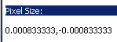

What is the linear measure equivalent to this angular cell size?

Answer: to determine what the corresponding cell size in meters of the SRTM elevation raster is, you need to use the information provided in Section 2.2 on the computation of angular measurements. The values you visualize in the Pixel size information window are expressed in degrees.

Computation: 40,075.017 km * 0.00083333 degrees / 360 degrees = 0.0927 km

Another way to find out the resolution of the raster cells in meters is too reproject the raster file to UTM. This will be done in the next exercise.

### Exercise: how to reproject a raster layer

Reprojection is possible within QGIS although the program is not able to reproject ArcInfoAscii files. For this reason, we first have to convert the ArcInfoAscii (.asc) files into GeoTIFF (.tif). This is done via *Raster – Conversion – Translate (convert format)* as shown in the screenshots below.



Figure 2‑11 Conversion of raster formats.

Choose as filetype the [GDAL] GeoTIFF format.



Figure 2‑12 Select the correct data format for your raster.

Select the *Load into canvas when finished* option so the converted file is automatically shown on the map.



Figure 2‑13 Conversion of raster format from ArcInfoAscii to GeoTIFF.

Select the WGS84 projection when prompted, and remove from the project the *SRTM* basin layer projected in lat-long.

**Note!** If you have multiple tiles you need to convert you could also opt for the Batch mode option.

Prior to reprojecting your unclipped SRTM file from WGS84 into the UTM projection you need to know in which UTM zone your catchment is located. Use the references above provided to know which UTM reprojection to select.

Reprojection is done via *Raster – Projections – Warp (reproject)*.



Figure 2‑14 Reprojection of raster.

Set the source SRS (WGS 84 or EPSG:4326) and target SRS (in our EDB catchment example: UTM 54S or EPSG:32754). Save the Output file as *SRTM basin name_merged_ UTM54S*, and select *Load into canvas* when finished, then click OK.



Figure 2‑15 Reprojection of raster from WGS84 to UTM54S using Warp function.

When finished zoom to the layer and inspect if the coordinates in your status bar are now in meters instead of degrees. What is the resolution of your grid cell?

If you haven’t done so already make sure you also have a reprojected catchment shape. Refer to the exercise in Section 2.3.2 on how to do this. Import the reprojected catchment file into QGIS.

Remove the *SRTM* layers projected in long lat from your project.

### Exercise: how to create a sub-selection from a raster layer using a vector file (clipping)

In this exercise you will make a selection (or clipping) from the merged and UTM reprojected SRTM elevation raster layer created in the previous exercise using your UTM reprojected catchment boundary vector layer. Use the instruction provided for the Indonesian EDB basin as a reference for computation of your river basin of interest.

In this exercise you will learn how to use the *Clipper* tool.

Before we clip we need to determine the extent of your catchment vector layer by right clicking on the layer and choosing *Properties*. You will find the corner coordinates under the Metadata tab (Figure 2.10).



Figure 2‑16 Layer properties of the WS EDB – UTM54S.shp

Write down (or alternatively copy it to your clipboard) thexMin, yMin, xMax and yMax coordinates.

Note that these corner coordinate valuescontain a lot of digits. It is to be preferred to use coordinates without any digits and rounded to the nearest 1000 m. Before we are going to clip we are therefore going to use other corner coordinates. Make sure that the extent does not become smaller than the original map. So Xmin_new en Ymin_new should be less than Xmin and Ymin and Xmax_new and Ymax_new should be greater! In the example shown in Figure 2.10 the new corner coordinates become:

Xmin = 130333.44 becomes Xmin_new = 131,000

Xmax = 499875.95 becomes Xmax_new = 500,000

Ymin = 8990448.64 becomes Ymin_new = 8,991,000

Ymax = 9587159.43 becomes Ymax_new = 9,588,000

Select the Clipper tool via *Raster -> Extraction -> Clipper* (Figure 2.11).



Figure 2‑17 Clipping a raster.

In the clipping mode include the new coordinates. Once all of the 4 coordinates are provided, QGIS will visualize them on the layer map (as shown by the red rectangle in Figure 2.18). This way you can verify if the input you provided is correct.

Double check if you provided the correct coordinate reference values, give the new layer the name *SRTM [basin name] clipped –UTM*, select to *Load into canvas when finished*, and click OK. When finished close the Clipper window.



Figure 2‑18 Clipping your raster using a predefined extent which is shown as the red rectangle on the map.

With this operation you have just created a selection based on catchment boundaries from the merged and reprojected SRTM raster layer. By directly using this new layer, you will be able to speed up computation during your data processing given that the current SRTM layers dimension is much smaller than the original 4 layers inputs.

### Exercise: how to convert a vector layer to a raster layer

To present this exercise, we will use the Indonesia province of Kalimantan (in the island of Borneo) to provide an example of conversion from vector to raster layer. A zooming on Borneo of the vector layer representing the DSMW soil map is shown below:

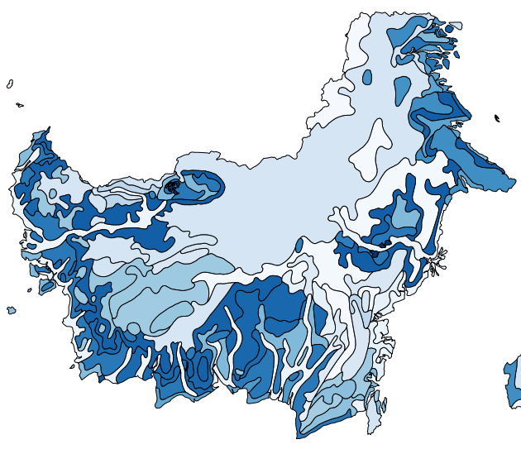

Figure 2‑19 The DSMW map for Borneo in a vector format

During the preparation of the soil data for the analysis you will have to convert your soil vector map into a raster map to prepare the input for WFlow. The conversion of a vector to a raster layer is performed with the *Translate* function accessible from the *Raster menu -> Conversion -> Rasterize (vector to raster)*.

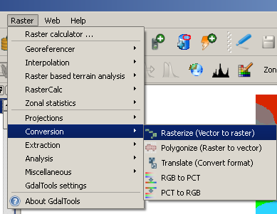

Figure 2‑20 Selection of the Vector to Raster function

Once you made this selection, the following screen will pop-up:

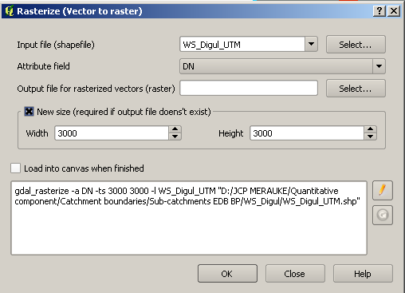

Figure 2‑21 Definition of the Rasterize function

For your input file select your vector layer (i.e. DSMW soils Indonesia). To select your output file, you first have to create an empty raster file (.tif format), and give it a name (i.e. DSMW soil Indonesia). You can give the new raster map the same name as the vector layer, because you will be able to distinguish between them by the extension (.shp or .tif) of the file.

When creating the new raster layer, you always have to select the *New size* option to allow QGIS generate the new map. At this point you have to options: either to leave the default width and height values generated by QGIS, or to define these values based on your computation of the raster grid cell size (determined by the resolution) that will be used for the creation of all the input maps for WFlow.

In our example, we will not define the width and length values because we are working on the Soil map of Indonesia, and not on the SRTM or catchment maps.

The new raster map of the selected layer will appear as follow from the example taken on the zooming to Borneo (the visualization of the colours depends on the range values defined in the colour map).

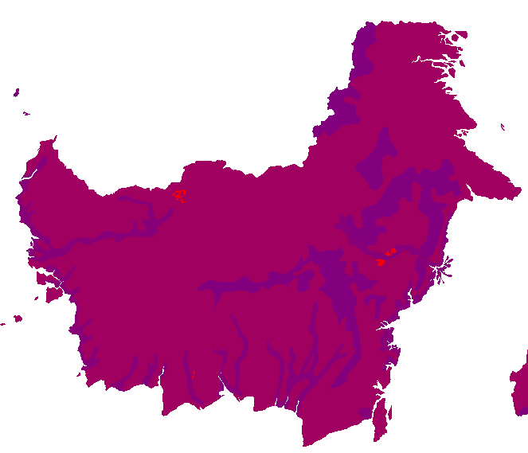

Figure 2‑22 The raster visualization of the DMSW for Borneo

Once you have converted the soil map to a raster format, you will have to re-projected it based on the UTM projection corresponding to your catchment area. How to perform this operation has been described in Exercise 2.3.2 of this chapter.

# Topographic data

## General description, typology and use

The SRTM data set (Shuttle Radar Topography Missions) provides elevation data at a global scale and is used to derive stream directions. These stream directions are subsequently applied at the required resolution of the hydrological model.

An elevation source which is often being referred to and used is SRTM (Shuttle Radar Topography Mission, 1999). The Shuttle Radar Topography Mission used the SIR-C and X-SAR radar antennas to collect information in C-band (5.6 cm, 5.3 GHz) and X-band (3.1 cm, 9.6 GHz) wavelengths. The C-band data were processed at the NASA Jet Propulsion Laboratory (JPL) and released to the public at a resolution of 1-arc second (30 m) within the United States and 3 arc seconds (90 m) elsewhere (Hensley et al., 2000). Absolute vertical accuracy for the C-band DEM was specified as <16 m globally, with relative accuracies of <6 m in any 225 km × 225 km area (Rabus et al., 2003). Because of the short wavelength of the SRTM C-band sensor, the height response over vegetated terrain is influenced by integrated scattering from leaves, branches, and stems, measuring a phase centre height that is higher than the underlying bare-Earth surface in vegetated areas.

**Note!** SRTM is not a true surface elevation model but rather a canopy elevation model. In steep areas the SRTM describes the surface elevation ok, but for lowland modeling you can not directly use these data. You need to filter out the vegetation first. The vertical resolution of SRTM is 1 meter, whereas the vertical error is up to 16 meters, for detailed flood modeling this is not enough and other sources, such as LiDAR need to be used instead. For a quick hydrological assessment however, working with SRTM is sufficient.

## Preparing topographic data as input for WFlow

The SRTM elevation data (or alternative open sources options) can be downloaded from the internet as described in Section 2.4. For SRTM input, the format provided is ArcInfoAscii (.asc) and the projection is WGS84. In the exercises of Section 2.4 you have already clipped and reprojected the SRTM raster layer to your catchment area.

### Exercise: how to change the resolution of a raster layer (resampling)

Resampling the different input raster layers to a common resolution is an operation needed to ensure that the input maps used by PCRaster/WFlow have the same spatial unit of measure. If input maps are used with different resolutions (cell size), WFlow will not be able to carry out the computations.

During this workshop, the WFlow model will be prepared to run on a 270 m resolution (3 x 3 SRTM raster cells). This resolution is chosen for performance reasons, but it is arbitrary, and can be freely chosen by the user. Running the model on a higher resolution (e.g. 90 m) will require more computation time.

Prior to resampling you need to determine the extent of your catchment layer map in meters. Inspect the Properties of the *SRTM [catchment name] clipped – UTM.tif* layer and note them down on a piece of paper.



Figure 3‑1 Properties of the SRTM WS EDB clipped – UTM54S.tif

The width and height of the raster can be determined from the difference between respectively Xmax and Xmin and Ymax and Ymin.

In the example of Figure 3.1 the width is:

499928.8115164801129140 - 130926.4996017097728327 = 369002.3119147710 meter

and the height:

9588022.9828356783837080 - 8990990.7208509854972363 = 597032.2619846890 meter

Determine the number of 270 meter cells which fit in the x- and y-direction by dividing the width and height by 270 meter.

369002.3119147710 / 270 = 1366.7 cells

597032.2619846890 / 270 = 2211.2 cells

Since we can not resample to incomplete cells we need to use a complete number of cells. The number of cells for the resampled 270 m raster becomes 1367 x 2212 cells.

Resampling is done via *Raster – Projections – Warp (Reproject)*.

Save the output file as *SRTM [catchment name] clipped resampled 270m - UTM.tif* and provide the number of 270 m cells (width and height) which you just calculated. Select *Load into canvas when finished* and click OK.



Figure 3‑2 Resampling a raster file using the Warp function.

Close the Warp (Reproject) window and inspect your resampled SRTM map. Delete the *SRTM [catchment name] clipped – UTM.tif* from your project.

### Exercise: convert your resampled map to ArcInfoAscii format

Now that you have resampled your SRTM map you need to convert it to the ArcInfoAscii format via the *Raster – Conversion – Translate* menu (Figure 3.3).

Choose the ArcInfoAscii format (cf. Figure 2.6) and choose -9999 as the No data value (default value is 0). Select *Load into canvas when finished* and click OK (Figure 3.3).



Figure 3‑3 Convert the resampled 270 m SRTM raster from GeoTIFF to ArcInfoAscii format.

At this stage of the conversion you might get a warning stating:

*Warning 1: Producing a Golden Surfer style file with DX and DY instead of CELLSIZE since the input pixels are non-square. Use the FORCE_CELLSIZE=TRUE creation option to force use of DX even though this will be distorted. Most ASCII Grid readers (ArcGIS included) do not support the DX and DY parameters.*

This warning has to do with the irregular cell size of the grid cells. When you inspect the header of the ArcInfoAscii file you just created in a text editor (Figure 3.4) you will see that the dx and dy are indeed not the same.



Figure 3‑4 Header of the SRTM WS EDB clipped resampled 270 m– UTM54S.asc

### Exercise: change the cell size of your ArcInfoAscii grid

Since WFlow expects a regular cell size we need to manipulate the resampled ArcInfoAscii grid a little bit. Change the dx and dy values (Figure 3.4) to 270 m and also round the xllcorner and yllcorner coordinates to the nearest meter. Save the file as *SRTM [catchment name] clipped resampled 270 m adjusted – UTM.asc*. The resulting ArcInfoAscii file should look as follows:



Figure 3‑5 Adjusted header of theSRTM WS EDB clipped resampled 270 m adjusted – UTM54S.asc

Remove the *SRTM [catchment name] clipped resampled 270 m– UTM.asc* from your project.

### Exercise: convert the ArcInfoAscii grid to PCRaster format

Import the *SRTM [catchment name] clipped resampled 270 m adjusted – UTM.asc*. Select the proper projection when prompted (UTM54S in the case of EDB). Convert the ArcInfoAscii grid with the adjusted header (Figure 3.5) to PCRaster format, similarly to the exercise of Section 3.2.2.

# Land use and land cover data

## General description, typology and use

Information on land use and land cover (LULC) is required in hydrological modeling to define the patterns of water interception by canopy cover, and the patterns of water infiltration and surface flow according to soil saturation rates and land cover type. Currently, LULC information is available through satellite images at different resolutions, and often field measurements are used to validate satellite data. Land use is classified according to the vegetative cover (i.e. forest, desert, ice cap, water bodies, grassland or cultivated land). Depending on the detail of the images, these categories are further classified in sub-categories according to their specific vegetation type (i.e. evergreen forest, broad leaves forest, deciduous forest).

Acquisition of information to detect land cover and land use type is often carried out making use of remote sensing Landsat data. Since the 1970’s, Landsat data have been rendered available through the Landsat Program (<http://landsat.gsfc.nasa.gov/>) which embraces a number of Earth-observing satellite missions jointly managed by the National Aeronautic and Space Administration (NASA) and the United States of America. Throughout its history, there have been 7 Landsat satellite projects, the latest being the Landsat 7, sent on orbit in 1999. At present, all Landsat Earth-observation data are freely available to the public through the USGS since January 2009.

Nowadays there exist several online sources of land use data. Some of these sources are:

* NASA LCLUC - Land Cover and Land Use Change Program: which contains information on, for example, land cover conversion, land use intensification, and land degradation in arid and semi-arid environments (Knivila M. 2004);
* FAO Global Land Cover Network (<http://www.glcn.org/index_en.jsp>);
* FAO FAOSTAT for agricultural land cover types;
* FAO FORIS for forest cover and inland water data at the country level;
* GlobCover, from the European spatial Agency (ESA)
* NationalUniversity of Singapore (CRISP)

The underlying assumption of processing land use data in this workshop is that current land cover types have not significantly changed over time since the period of their measurement (2009). This assumption results from the simplification required by the limited time availability to carry out an in-depth land cover research and analysis for short time steps (i.e. year). In an in-depth analysis, and supposing that relevant data are available, variation in land cover should be accounted for during the computation of the discharge series.

For its completeness in terms of data availability, and for its satisfactory degree of spatial resolution, the European Space Agency (ESA) GlobCover data will be used in this workshop. GlobCover data have been collected by the Envisat environmental satellite, with the aim to produce a global land cover map to a resolution three times sharper than any previous satellite map[6]. In the 2.3.2009 version, the provided resolution for land cover images is of 300 meters. Data are available in a raster format and provide full coverage for all of Indonesia.

The Centre for Remote Imaging, Sensing and Processing (CRISP) of the National University of Singapore also provide a good alternative LULC data source to GlobCover. Unfortunately though, satellite images from this dataset are not available for the Eastern provinces of Indonesia, and therefore they do not guarantee complete national coverage for our analysis. Yet, for data retrieval from provinces where observations are available, CRISP data for the years 2000, 2007 and 2010 are provided on the USB stick of this workshop including some publications on them.

Table 4.1 Sources of land cover data for Indonesia.

|  |  |  |
| --- | --- | --- |
| Source | ESAIoniaGlobCover | CRISP |
| Webpage | <http://ionia1.esrin.esa.int/> | <http://www.eorc.jaxa.jp/SAFE/LC_MAP/> |
| Format | Raster file (GeoTIFF) | GeoTIFF |
| Resolution | 300 m | 250 m |
| Version | 2.3 2009 (V2.3) | 2000, 2007, 2010 |
| Comment | Available for all of Indonesia | Black strip over PapuaProvince due to missing satellite image |

## GlobCover (ESA)*[7]*

As for the majority of remote sensing data interpretation, the principle behind the production of land cover maps (such as GlobCover) is the classification of land cover type based on the reflectance of the Earth surface to solar radiation. Land cover and land use types are classified based on the different types of solar ray interaction with Earth features that can occur, namely transmission, absorption, reflection, scattering and emittance. Moreover, before final mapping, a correction of the image interpretation is performed, by taking into account disturbance factors such as for example cloud and haze cover.

The most updated ESAGlobCover data refer to the observation period of January-December 2009. 2009 data have been generated from MERIS (Medium Resolution Imaging Spectrometer Instrument) and the final product is delivered with a spatial resolution of 300 meters.

For additional information on the characteristics of the dataset, the reader is referred to the validation report (Bontemps et al., 2011) included on the USB stick.

GlobCover provides two main sources of data: version 2.2 and version 2.3. Version 2.2 contains a global and regional dataset. The regional dataset contains more classification categories to reflect the regional character of land cover types. The global dataset contains more general categories which allow for world-wide usage.

The global 2.3 version of GlobCover has 22 land cover classes defined in accordance with the UN Land Cover Classification System (LCCS) (Bontemps S. et al., 2011). These classes are listed in Table 4.2 below. Since the number of these categories already provides the degree of detail for LULC classification, for the scope of our analysis we will use this dataset in our analysis.

Table 4.2 GlobCover global v2.3 version with 22 land classification categories (from Bontemps et al. 2011)

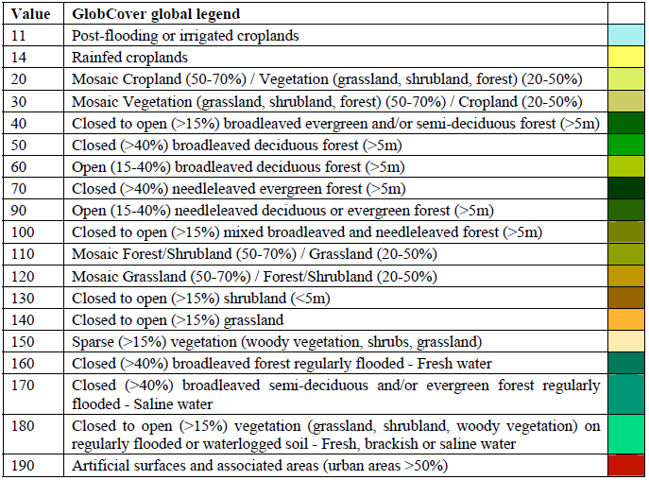

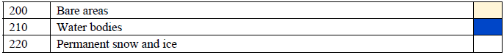

A screenshot of the GlobCover map for Indonesia is shown below:

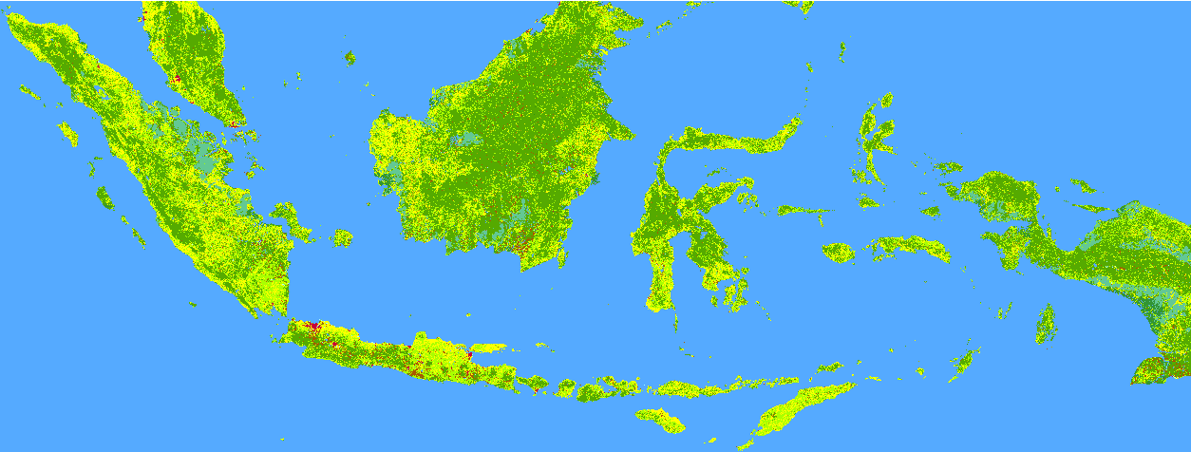

## Preparing land use and land cover data as input for WFlow

GlobCover data can be downloaded from <http://ionia1.esrin.esa.int/>. The file to be downloaded is the zip file [Globcover2009_V2.3_Global_.zip](http://globcover.s3.amazonaws.com/LandCover2009/Globcover2009_V2.3_Global_.zip). For simplicity, this file has been included on the USB stick. Unzip the file and read the Read Me pdf file.

Open your river basin project in QGIS. Identify the format of the land cover map and import the file using the correct selection tool in the menu toolbar. If you are unable to visualize the available files in the GlobCover folder, select from the *Files of type* bar the *All files(*)* option as shown below.

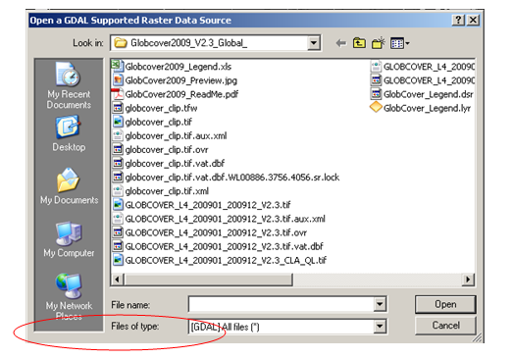

To learn on how to perform location specific selections in a raster environment, and to reduce the computation time and the size of our project, we will now create a selection of the GlobCover map for Indonesia first, and for each of our catchments thereafter. The process on how to make a selection from a raster layer has already been explained in Section 2.4.6, refer to this section for the instruction on how to perform the selection

Please note that when you import the GlobCover layer on your QGIS project, the colour map will not be automatically uploaded as it appears from the previous snapshot. If you want to visualize a coloured map of the land cover map to see what the distribution of land cover types in Indonesia is, you need to change the colour settings from the layer’s properties. Based on the legend coloured classes in Table 4.2 and by accessing the layer’s properties tab from the layer’s menu, change the GlobCover map or Indonesia from the layer’s Properties -> Style -> Colour Map.

Table 4.2 shows that the GlobCover version 2.3 global land cover types are classified in 22 land categories. These classes already give quite some information on the type of land cover existing in our catchment.

In WFlow the user can freely define the number of categories (s)he wants to include in the reclassification table. Since WFlow requires to define a soil depth for each land use type used, the greater the number of categories, the greater the amount of information required. For matters of simplicity, in our analysis we will reclassify the existing 22 categories into 6 general classes as listed in Table 4.3below.

Table 4.3 Selected land cover categories for WFlow.

|  |  |
| --- | --- |
| **Class number** | **Category** |
| 1 | Irrigated Agriculture |
| 2 | Rainfed Agriculture |
| 3 | Forest |
| 4 | Grassland/Shrubland |
| 5 | Open Water |
| 6 | Paved/bare areas |

### Exercise: prepare a land cover reclassification table

In Excel, create a reclassification table listing in which the 22 global land cover categories fit in our 6 land cover classes defined for WFlow.

### Exercise: associate land cover class with soil depth

Once your reclassification table is ready the land cover classes need to be associated with soil depth since this is a required input parameter for WFlow. For this we will use rooting depth as this is intrinsically related to soil depth (the soil is at least as deep as its rooting depth). The *International Satellite Land-Surface Climatology Project, Initiative II (ISLSCP II)* of NASA (<http://daac.ornl.gov/ISLSCP_II/guides/ecosystem_roots_1deg.html>) provides information at a 1 degree (approx. 100 km) resolution concerning the relation between rooting depth and above ground land cover types. We will use these rooting depth data to estimate our soil depth for the 6 land cover categories selected for WFlow.

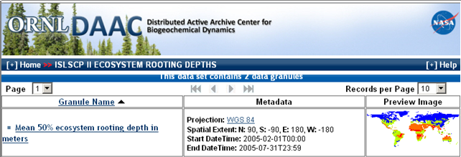

The ISLSCP rooting depth layers are in an ESRI ASCII GRID format. The dataset contains 3 files, namely[8]:

1. **50ecosys_rootdepth_1d.asc** [wcs50]: Mean 50% ecosystem rooting depth in meters. This is an estimation of the rooting depth that contains 50% of all roots. "1d" implies a 1-degree spatial resolution (lat/long) – file name *wcs50*;
2. **95ecosys_rootdepth_1d.asc** [wcs95]: Mean 95% ecosystem rooting depth in meters. This is an estimation of the rooting depth that contains 95% of all roots. "1d" implies a 1-degree spatial resolution (lat/long) – file name *wcs95*;
3. **ecosys_rootdepth_1d.dif** : A table of the values in 1) and 2) that have been replaced and/or modified so that the original files match the land/water mask used in this data collection. This file can be used with 1) and 2) to reproduce the original data collected by the investigators.

Since we are interested in detecting the maximum soil depth, which of the above files should we use?

Once you access the data, you are prompt to a selection window where you can customize your data selection from the global dataset. The screen will appear as follows:

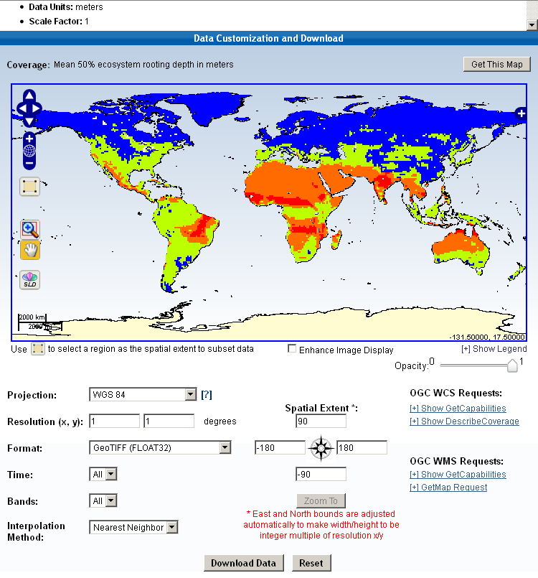

By using the zooming and legend options provided in the screen, you can make an extent selection for Indonesia, and you can visualize the (20) soil depth categories from the legend. After the selection, the screen will appear as follows:

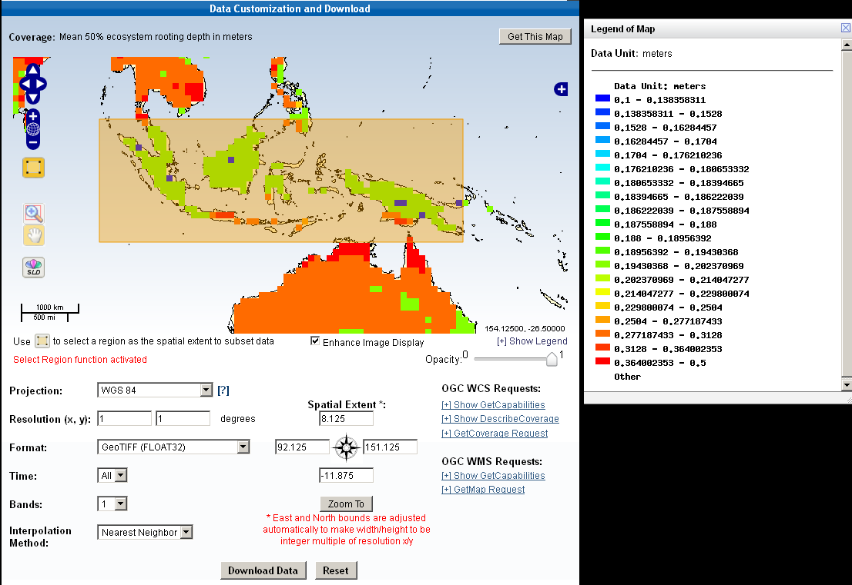

Once you have defined your selection parameters, you have to click on the *Download Data* button. We have saved all the required downloaded files in the *Land Cover folder* on your USB. Access the directory and import in QGIS the right *wcs* file. After the import, you will visualize the layer as follows:

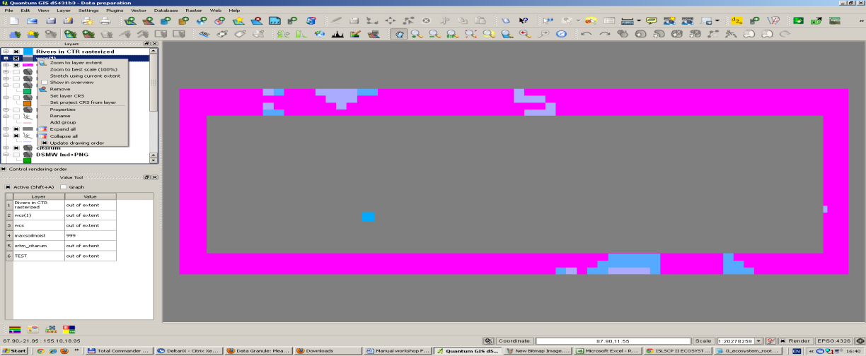

This is because the rooting depth categories have not been categorized based on the depth ranges. The legend map for the land cover-rooting depth map is the following:

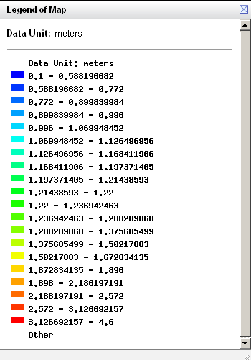

A closer look at the map tells you what the variation in rooting depth is. Within the provided range (0.1 to 4.6 meters) create 5 categories of rooting depth from the properties layer and visualize the results on the screen. Based on the ranges you have defined, you should be able to get an overview similar to that of Figure 4.1 below (please note, the legend above does not correspond to the color map in Figure 4.1below). Zoom to your catchment area and determine what the variation in rooting depth is.

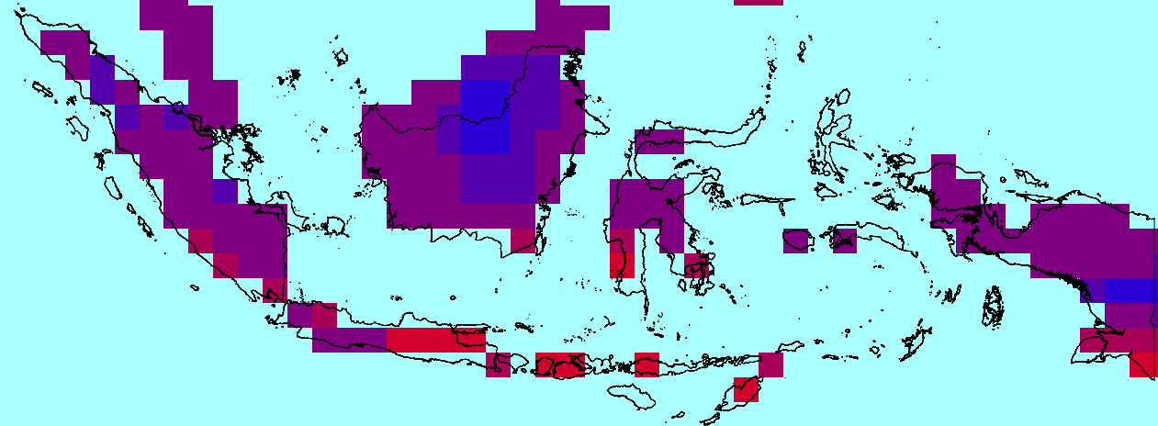

Figure 4‑1 Overview of rooting depth based on Land Cover (blue 0.8m, purple 1.5m, red 3.5 m).

You will soon realize that the detail of information available from the *ISLSCP II* database is actually too coarse to prepare a relation table between the land cover type and the soil depth. Why is that?

An important check that was not performed when we referred to the ISLSCP database was to have a look at the spatial resolution of the database. The raster size of the *ISLSCP II* dataset is 1 * 1 degrees. Following the computation procedure explained in Section 2.2, you can easily calculate the spatial metrical grid dimension of the dataset.

### Exercise: estimate soil depth for land cover categories based on rooting depth

With this exercise you will estimate the rooting depth associated with each land cover type based on the information provided by the rooting depth map, and based on your groups best judgments.

Tip: look at the maximum rooting depth information provided by FAO for different crops and fruit plants at: <http://www.fao.org/docrep/X0490E/x0490e0e.htm#chapter%208%20%20%20etc%20under%20soil%20water%20stress%20conditions>. This information will guide you in the creation of the ranges for the 6 selected categories.

The *SMAX Word version* file, contained in the following directory: *Soil data -> FAO Soil Moisture Content -> FAO Soil Moisture* gives indications about the maximum rooting soil depth that can be expected for agricultural land. Refer also to this source to make your estimates.

The last step is the preparation of the text file containing the land cover type and the associated soil depth. Name the file *Land Cover Soil depth.txt* and give a brief description of the data contained in the file to facilitate other users in reading its content. An overview of the file is given below.

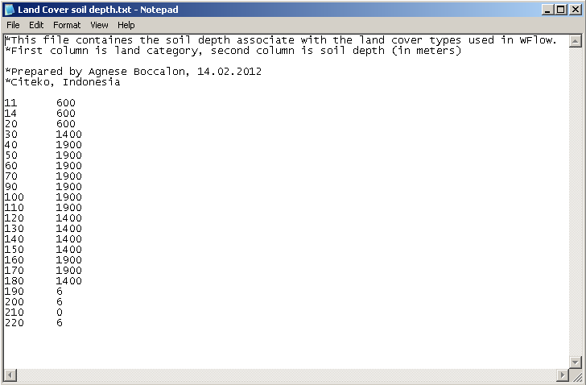

This is the last step of the preparation of your land cover data as input for WFlow.

# Soil data

## General description, typology and use

Soils have important production and conservation functions via their capacity to store nutrients, and for their hydrological property of transporting and retaining water. For hydrological analysis, information about soil types helps define in more detail the patterns of subsurface and overland flow in saturated and unsaturated layers.

Different types of soils have different depth and varying storage capacity. Soil water storage capacity depends on soil depth and porosity. Porosity is defined as the extent of space in between soil particles that is not filled with solid matter. Void space can either be filled with air or water. The higher the density of particles in the soil, the lower the porosity, and the lower the volume of water that can fill the air gaps between the particles. Figure 5.1 shows an example of different porosity types in soils.



Figure 5‑1 Porosity for different soil types.

Source:http://www.amiadini.com/NewsletterArchive

Information on soil water retention properties and nutrients composition is also valuable to determine the potential productivity of land. Yet, when coupled with information on, for example, topography and land cover, the analysis of soil characteristics can equally identify factors such as risk of land degradation and exposure to soil erosion.

Knowledge about the soil composition and their location is therefore a valuable input for both hydrological modeling and for studies related to the estimation of land productivity for agricultural production and food security investigation.

Digital maps on soil type, soil properties and soil degradation rates are available from several international and national research institutes that work with land resources. Information is available at different scales and resolutions, and are either area specific (i.e. soil map at regional level) or have a worldwide coverage.

The Land and Water Division of the Food and Agriculture Organization of the United Nations (FAO) in collaboration with UNESCO has developed a digital world map of soils known as the *Digital Soil Map of the World (DSMW)*. The latest updated version is Version 3.6, which was completed in January 2003, and further revised in February 2007. This digital soil map is available in a vector format.

A more recent and refined source of information on soils mapping at the global scale is the FAO-IIASA (International Institute for Applied System Analysis) *Harmonized World Soil Database* (HWSD). The database was released in March 2009 and it uses the information provided by the DSMW and integrates them with updated national and regional soil information collected from national institutes. This new database resulted from the recognized need to update the global agro-ecological zones study of FAO, and provides a more detailed information base for soil-related studies at a regional scale.

This new FAO-IIASA database was achieved in partnership with ISRIC (World Soil Information independent knowledge centre), the European Soil Bureau Network (ESBN) and the Institute of Soil Science of the ChineseAcademy of Science. The HWSD soil dataset is available in a raster environment. A so-called *HWSD Viewer* available when downloading the HWSD datasets provides a link between the raster database and a shape file describing soil type categories, occurrence and physical characteristics.

For the simplicity in handling soil vector data as compared to the HWSD raster data, this workshop will make use of the DSMW datasets for the data preparation process for the hydrological analysis with WFlow. However, for those users who are more familiar with GIS applications and data management from raster layers, the use of the HWSD dataset can also be considered for future soil-related GIS analysis.

*Some explanation about the nomenclature*

To be able to read the information contained in the FAO Digital Soil Map of the World, it is useful to recall the meaning of the following terms:

FAOSOIL or Soil Mapping Unit (SMU) symbol: Af14-3c

SNUM or Soil Mapping Unit (SMU) number: 1

DOMSOI or Dominant Soil Unit: Af Ferric Acrisols

Soil class: A Acrisols

An example of how you can find this information when using the DSMW soil layer is provided below:

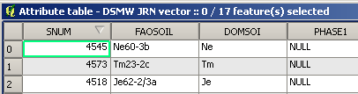

In the DSWM file, the SMU number is found also with the nomenclature SNUM. As shown in the example above, a SNUM code is a reference numerical code associated to each FAOSOIL type. In the above example, SNUM 4545 corresponds to the FAOSOIL type Ne60-3b.

In general terms the components of a FAOSOIL type are explained as follows:

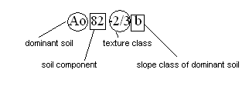

The DSMW file *SoilData*helps reading the above nomenclature.

In Table 5.1 below the correspondence between the code used in the SMU symbol and the related value of the texture and slope class is given.

Table 5.1 Slope code specification for each texture class.

|  |  |  |  |  |
| --- | --- | --- | --- | --- |
| **Texture class** | **Meaning** | **Slope code** | **Meaning** | **Corresponding value (% slope)** |
| 1 | Coarse | a | Flat | 0-8 |
| 2 | Medium | b | Undulating | 8-30 |
| 3 | Fine | c | Hilly | > 30 |

## Digital Soil Map of the World (FAO)

|  |  |  |
| --- | --- | --- |
| Source | FAO Harmonized World Soil Database (HWSD) | FAO Digital Soil Map of the World (DSMW) |
| Webpage | <http://www.fao.org/nr/land/soils/harmonized-world-soil-database/en/>  http://www.iiasa.ac.at/Research/LUC/External-World-soil-database/HTML/index.html | http://www.fao.org/geonetwork/srv/en/metadata.show?id=14116 |
| Format | Raster file (.bil) linked to attribute database in Microsoft Access format | Vector data (ESRI shapefile, Erdas format, IDRISI format) |
| Scale | not applicable | 1 : 5.000.000 |
| Resolution | 1 km (30 arc seconds by 30 arc seconds) | not applicable |
| Projection | (longitude, latitude) | latitude – longitude |
| Version | 1.1 (March 2009) | 3.6 (Feb 2007) |
| Details | Improved reliability of data for SE Asia | Available for all of Indonesia |

The FAO Digital Soil Map of the World (DSMW) dataset contains nearly 7,000 soil mapping units (SMU). All these units are classified according to their dominant soil types, texture, occurrence and major physical and chemical parameters.

When you download the FAO DSMW dataset and unzip the downloaded file, you will find the following files inside the directory:

1. the *DSMW shape* file containing the vector layer with the digitized soil map for the entire world;
2. the *SoilData* file, giving a general overview of the content of the other files in the directory, and describes the meaning of the codes used for the description of FAO Soil types (i.e. content of nomenclature example above);
3. the *SU_Info Excel* file describing, for each type of soil, selected chemical and physical parameters;
4. the *WORLD764* Excel file, containing information on the Soil Mapping Unit Composition (i.e. percentages of dominant soil);
5. the *Generalized_SU_Info*file containing information on how data on soil units have been collected and processed;
6. the *BasicFilesSc* file, describing soil mapping units dominant textures and occurrence based on topography;

the *DSMW* dbf file, functioning as the attribute table for the soil vector layer.

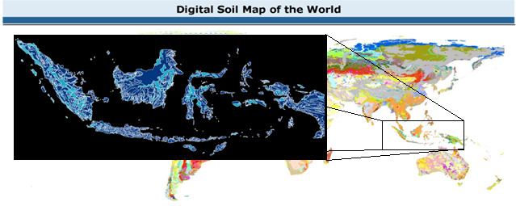

Figure 5‑2 Overview of the FAO Digital Soil Map of the World, with a zoom to Indonesia.

To get a better overview of the type of data you are working with and the amount of information that this dataset contains, please have a look at the above mentioned files.

## Preparing soil data as input for WFlow

In WFlow, the soil is represented using a simple bucket model (comparable to the TOPOG SBM model) that assumes an exponential decay of the soil hydraulic conductivity (Ksat) with depth. Lateral subsurface flow is modeled using the Darcy equation. Soil depth is specified for different land-use type and subsequently scaled using the Topographic Wetness Index.

WFlow computation of evapotranspiration is also based on soil water depth. We need therefore to prepare, for each identified soil type, a table containing information on soil physical parameters and soil depth. This is simply done by relating the identified soil types for Indonesia to the parameters table defined through exercises described in the next Sections.

The exercises described in the following sections will guide you through:

* the reclassification of soil types based on soil categories existing in Indonesia;
* the definition of the soil physical parameters required as input for WFlow;
* the preparation of the input map raster file for WFlow from the soil vector layer.

At a later stage, you will also:

* clip the DSMW of Indonesia to your catchment;
* relate the existing soil types in your catchment with the soil reclassification table previously prepared;

For specific use for WFlow, the two outputs you will have generated at the end of this exercise are:

1. the DSMW rasterized clip for your catchment;
2. the text format file containing the reclassification table and the soil parameters.

### Exercise: preparing the soil reclassification table

In the exercise described in Section 2.3.1 you already created a clip of the DSMW on Indonesia and PNG (layer *DSMW Indonesia+PNG – LL*).

You are now going to reclassify the existing soil types within Indonesia. It is important to mention that the reclassification can also be done with the QGIS GRASS tool, but we will not discuss the use of this tool here. The reclassification process we will describe, is made of different steps. You can choose your own way to reclassify the soils. However, the way suggested in this manual comprises the following steps:

1. open the attribute table of the *DSMW Indonesia+PNG – LL* layer, and click on the header of the attribute name DOMSOI first, and on that of FAOSOI later. You will see that QGIS will automatically sort the data based on your selected attributes (DOMSOI and FAOSOI);
2. make a selection of all the attributes in the table by making use of the menu tools at the bottom of the table (*Select All* command). Once all the attributes are selected, choose the *Copy selected rows to clipboard* tool. This operation allows you to paste your selection in an empty Excel file. Alternatively, you can also directly import the .dbf file (database file) into Excel.

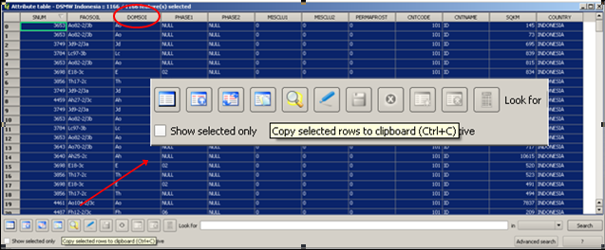

You are now ready to prepare the soil reclassification using Excel.

1. Open Excel and paste the copied contents of the attribute table to an empty Excel sheet. Produce a table containing only the SNUM, FAOSOI and DOMSOI attributes, and delete all the other attribute columns in the sheet that are not relevant for our reclassification. Sort the selected data in the following order: DOMSOI, FAOSOI, SNUM;

The DOMSOI column classifies the soils based on their dominant soil type. The *Nd* DOMSOI nomenclature for example corresponds to the *DistricNitosols* dominant soil category.

As previously explained, in the dominant soil type, the first (capital) letter of each DOMSOI identifies the soil class to which the dominant soil belongs. In our example, *N* corresponds to the soil category of *Nitosols.*

The correspondence between the dominant soil type and its soil class is provided by FAO and it can easily be visualized in the DSMW legend of the map. The following screenshot provides an overview of the soil classes and their dominant soil types. A copy of the Legend is provided on your USB stick in the Soil data sub-directory.

Create a classification of the DOMSOI existing in Indonesia, and associate each unique DOMSOI with the corresponding SNUM codes.

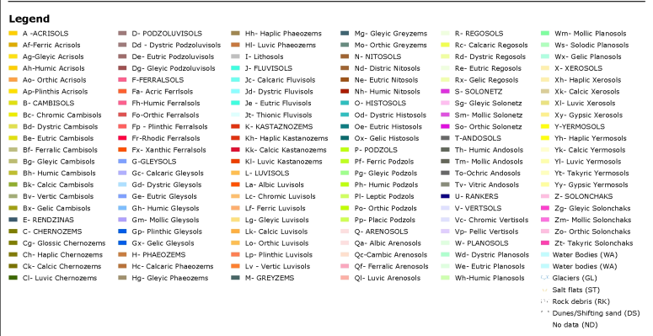

### Exercise: determine how many DOMSOI categories exist in Indonesia

Classify the identified DOMSOI of Indonesia based on their Soil Class. You can find the full name of the soil class from the DSMW legend.

Example: DOMSOI Af (Ferric Acrisol) belongs to the Soil Class A of Acrisols.

### Exercise: determine how many soil classes exist in Indonesia

You have now reached the point where you can identify the existing soil classes describing soil characteristics in Indonesia, since you know the correspondence between the Soil Class, and the SNUM codes belonging to each of these classes.

The last step for this soil reclassification is the creation of 2 tables summarizing the work done so far. In a new Excel sheet to be named *Reclass Table* create a table containing the following information (the one provided is only an example to show how to start the reclassification):

|  |  |  |  |  |  |  |  |  |
| --- | --- | --- | --- | --- | --- | --- | --- | --- |
| Dominant Soil | Soil Class | Dominant Soil name | SNUM | | | | | |
| Af | A | Ferric Acrisols | 4446 | 4448 | 4449 |  |  |  |
| Ag | A | GleyicAcrisols | 4455 |  |  |  |  |  |
| Ah | A | HumicAcrisols | 3640 | 4457 | … |  |  |  |
| … | … | … | … | … |  |  |  |  |

The second table to be created needs to show a 1-to-1 correspondence between the Soil class and a reference number. Order the soil classes in alphabetical order, and assign each class a number starting with 1. This table will have the following headings:

|  |  |  |
| --- | --- | --- |
| **Reference soil class num** | **Soil class** | **Soil Class Name** |

You will now proceed with the computation of the soil parameters required by the WFlow model.

*Definition of soil parameters*

We now have 16 soil classes. For each class, the 13 soil parameters that are required as input for WFlow are enumerated and briefly described in Table 5.2 below:

Table 5.2 Soil parameters required for WFlow.

|  |  |  |  |  |
| --- | --- | --- | --- | --- |
| **Parameter num ref** | **PARAMETERS** | **Unit of Measure** | **SYMBOL** | **DESCRIPTION** |
| 1 | Average soil depth | m | - | Average depth of the soil |
| 2 | First Zone Capacity | mm/m | - | Maximum capacity of the saturated store. |
| 3 | First Zone KsatVer | Mm/timestep | Ksat | Saturated conductivity of the store at the surface. The M parameter determines how this decreases with depth. |
| 4 | First Zone Min Capacity | mm/m | - | Minimum capacity of the saturated store |
| 5 | Infilt Cap Path | Mm/timestep | - | Infiltration capacity of the compacted soil (or paved area) fraction of each gridcell |
| 6 | Infilt Cap Soil | Mm/timestep | - | Infiltration capacity of the non-compacted soil fraction (unpaved area) of each gridcell |
| 7 | M | **-** | **M** | Soil parameter determining the decrease of saturated conductivity with depth. Range: [20-2000] |
| 8 | N | **-** | **N** | Manning N parameter for the Kinematic wave function. Higher values dampen the discharge peak. |
| 9 | Nrivers |  | NRiver |
| 10 | Path Frac | % | - | Fraction of compacted area per gridcell, range [0-1] |
| 11 | Rooting Depth | m | - | Rooting depth of the vegetation. |
| 12 | Theta R | - | ΘR | Residual water content. |
| 13 | Theta S | - | ΘS | Water content at saturation. |

In order to find the best estimate values for these parameters, you need to carry out an extensive literature review or use own or existing locally available soil measurements. An example is provided in the text box.

**Computation of rooting depth**

Tree roots do not occur in significant quantities at substantial depths (e.g. > 2 m) in the soil profile. However, there are cases where isolated roots have been found at depths much greater than this in deep and loose soils (Gilman, 1990), but typically between 90 and 99 % of a tree’s total root length occurs in the upper 1 m of soil.

Source: Crow P., 2005

The information included in this manual is the result of such a review. Given your knowledge of Indonesian local institutions working in the sector, knowledge you have acquired in the field or from your peers, you can refine the data provided to produce a better representation of reality for those catchments that will be the focus of your future analysis.

In the computation sections that follow, the physical parameters for our soil categories will be computed/estimated for each of the 8 soil categories identified in the SMAX Word version file. This file is provided in the following directory: *Soils -> FAO Soil Moisture content -> FAO Soil* Moisture). The link between the latter and our 16 soil categories can also be derived by reading the content of this document.

### Exercise: computation of water storage capacity of soils

Parameters 2 and 4, corresponding to the maximum and minimum water storage capacity of the saturated layer have been sourced by referring to the information contained in the SMAX data preparation description file. This file is provided in the *Soil data -> FAO Soil Moisture Content* directory available on the USB stick. The relevant information sourced from this file is described below.

The *FAO Soil Moisture Storage Capacity* dataset estimates soil moisture content (Smax) based on soil properties and on soil types. For their physical properties, in this dataset FAO makes a classification of soil types in 8 different families, and for each of these, the Smax and the Easily Available Water (EAV) ranges are provided. Moreover, FAO suggests that for tropical soils (Ferralsols, Acrisols, Nitisols, FerralicCambisols and Ferric Luvisols) the value of Smax is decreased by 10% as compared to similar textural classes for other soils[9].

The value of Easily Available Water can be interpreted as the minimum soil water content capacity parameter, and therefore be used to estimate parameter 4 of Table 5.2. Table 5.3 summarizes the FAO Soil Moisture data.

Table 5.3 FAO soil moisture data.

|  |  |  |  |  |
| --- | --- | --- | --- | --- |
| **Class name** | **EAV range** | **Smax range** | **Soil class name** | **Properties** |
|  | 4 | 2 |  |  |
| W (wetlands) | Not applicable | Not applicable | Histosol, Fluvisol, Gleysols (all consiedred as Wetland) | soils strongly influenced by groundwater or which are seasonally or permanently flooded. These soils groups are considered as wetlands |
| A | > 120 mm | > 200 mm | Andosols | soils developed from volcanic material, generally have very high soil moisture retention capacity at both field capacity and wilting point. This partly limits the soils' storage capacity |
| B | 100-120 mm | 150-200 mm | vertisols | fine texture soils dominated by clay minerals |
| C | 60-100 mm | 100-150 mm | Lithosols | have very limited soil depth |
| D | 40-60 mm | 60-100 mm | Rendzinas, Rankers | shallow soil depths |
| E | 20-40 mm | 20-60 mm | Solonchaks, Regosols, Podzols, Cambisols, Arenosols, Vitric Andosols, Greyzems and the non-luvic soil units of the Xerosols, Yermosols, Kastanozems, Chernozems and Phaeozems | soil groups with no implied clay increase with depth |
| F | < 20 mm | < 20 mm | Solonetz, Podzoluvisols, Nitisols, Acrisols, Ferralsols and luvic units of the Xerosols, Yermosols, Kastanozems, Chernozems and Phaeozems | soil groups with an implied clay increase with depth |
| ? | ? | ? | Planosols | fine texture subasoil, regardless of the txture of the topsoils |

***Note!*** FAO states: “Water availability to plants grown on Histosols, Gleysols and Fluvisols is mainly a function of groundwater or surface water levels and flooding. Although an Smax value can be deduced for these soils, this is largely irrelevant for practical purposes. Hence these soil groups are considered here as "wetlands" and no Smax is determined for them.”

Based on this information the Min and Max Soil Water Storage Capacity values for Histosols, Gleysols and Fluvisols have been assumed to be comparables to those of peatland. Average values of water content for peat soils have been estimated from the measurements provided in [Katimon and Melling, 2007].

### Exercise: computation of infiltration capacity parameters

Values for the infiltration capacity of different types of soils are difficult to find. Information is either not available, or difficult to access. Yet, to provide soil infiltration estimates for our WFlow computation, we can combine a set of information and tools available through common paper and online resources. The tools provided here are the Infiltration Capacity Curve provided by [Critchley and Siegert, 1991] and the FAO texture composition of the soil classes (from the USB stick). You will make use of these tools and of the information contained in the *Soil data* directory to find the infiltration rates for the compacted and non-compacted fractions of our soil types.

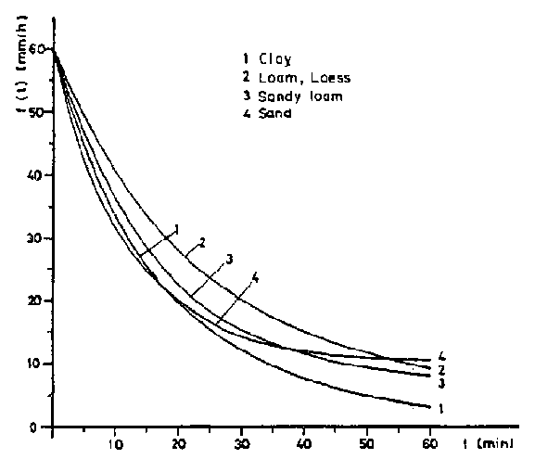

Figure 5‑3 Infiltration Capacity Curve for Different Soil Types[10]

The suggested procedure to estimate the infiltration capacity – measured in mm/day - of soils is the following:

* 1. define the dominant soil type content for each of the 8 categories of soils as described by FAO;
  2. from Figure 5.3 create an 1-hr infiltration capacity table for the 4 identified soil types, for both compacted and non compacted soils;
  3. Assume an average number of hours of rainfall per day, and compute the daily infiltration capacity for both compacted and non-compacted fractions;
  4. Make reasoned judgments about your computations considering how soil texture influences the infiltration capacity of soils;
  5. By using the correspondence between our 16 soil categories and the 8 FAO soil categories, assign to each of the latter an infiltration capacity value for the two infiltration capacity criteria InfiltCapPath and InfiltCapSoil.

### Exercise: computation of the saturated hydraulic conductivity Ks

Saturated hydraulic conductivity (Ks) is a quantitative measure of a saturated soil's ability to transmit water when subjected to a hydraulic gradient. It can be thought of as the ease with which pores of a saturated soil permit water movement[11]. Saturated hydraulic conductivity is measured in µm/s (or any multiple of it). For the estimation of the Ks for our soil types, we will use the information provided in Figure 5.4 and Table 5.3.

[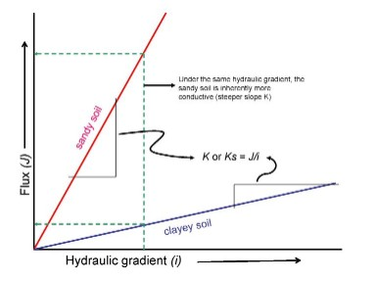](http://soils.usda.gov/technical/technotes/note6)

Figure 5‑4 Saturated hydraulic conductivity for different soil types.

The Environmental Science Division (ESD) of the United States Department of Energy provides some good literature review about computation of saturated hydraulic conductivity based on soil type and soil texture. For more reference access the following webpage: <http://web.ead.anl.gov/resrad/datacoll/conuct.htm>. Table 5.4 below comes from the ESD and provides us with a tool to estimate Ks for our soil types.

Based on Table 5.4 estimate the Ks values (in mm/day) for our 16 soil categories.

Table 5.4 Representative values of Ksat for different soil textures.

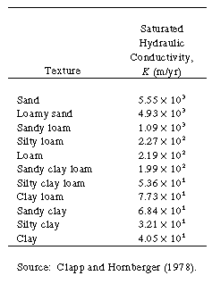

### Exercise: computation of the fraction of compacted area per grid cell

The computation of this soil parameter is based on best estimate taking into account dominant soil class and the degree of soil degradation. Define this parameter according to you best knowledge.

### Exercise: computation of rooting depth

The estimation of the rooting depth for the FAO 8 categories of soil types should take into account the rooting depth associated with the vegetative cover (computed in Chapter 4), and the soil characteristics of the 8 soil categories. A thorough analysis would first have a look at what type of vegetative cover is usually associated with a certain soil category, and subsequently estimate rooting depth based on the combination of predominant vegetative cover and physical soil characteristics.

During this workshop we will estimate the rooting depth for the soils based on the information so far collected through the SMAX Word Version file and the other mentioned documents.

Based on the sources above mentioned, make an estimate of the rooting depth (m) for the different soil categories we are analyzing.

# Precipitation and potential evapotranspiration data

**Precipitation**

* Data source: ftp://trmmopen.gsfc.nasa.gov//pub/merged/mergeIRMicro/
* filetype: bin, projection: geographic, WGS1984
* parameter: rainfall intensity every 3 hours.

The TRMM data is corrected for the bias following the method described in Vernimmen et al. (2012).

**Potential evapotranspiration**

Potential Evapotranspiration (Global-PET) can be downloaded from theCGIAR-CSIGeoPortal (<http://www.csi.cgiar.org>).

## Preparing meteorological data as input for WFlow

Steps to make precipitation and evaporation input maps with as example the Citarum catchment in Java are described in this chapter.

On your USB stick daily TRMM precipitation grid data for Indonesia for the year 2009 are provided. This data is in PCRaster format (.map). The file TRMM_3B42RT_DailyCorrected_20090101.map represents precipitation for 1 January 2009 for every grid cell in mm/day, see map below (Style: freak out colors, with a standard deviation of 0.8). The projection of this dataset is WGS84.

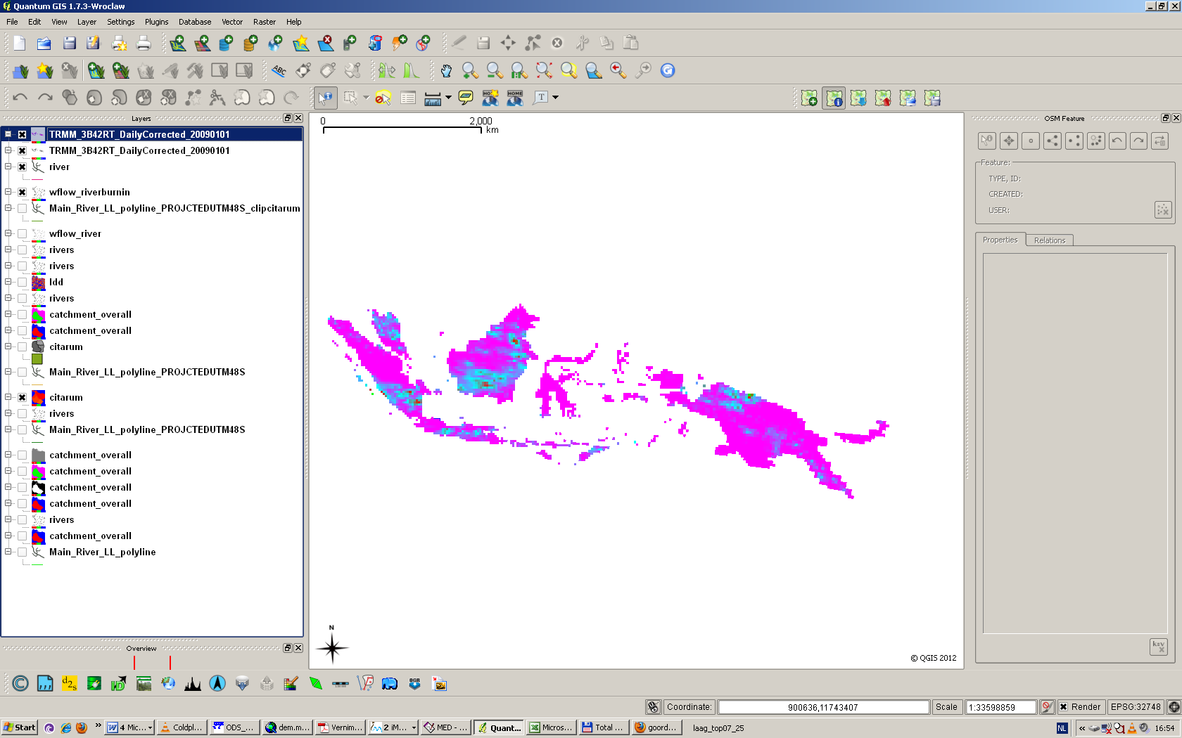

Figure 6‑1 Precipitation (based on corrected TRMM 3B42RT) on 1 Jjanuary 2009 for Indonesia.

For the potential evapotranspiration monthly data is available from CGIAR-PET. The format of the files is in ArcInfoAscii (.asc). The steps to make WFlow maps are for both precipitation and evapotranspiration data the same. However the potential evapotranspiration are monthly data. You have to convert them to daily data. You can do this with the raster calculator in QGIS.

### Exercise: convert format of TRMM precipitation maps and reproject

You first have to convert the precipitation maps to GeoTIFF (.tif) format, because you can notreproject from WGS84 to UTM when your maps are in .asc or .map. Click in QGIS on the menu Raster; Conversion; Translate. Now this box appears:

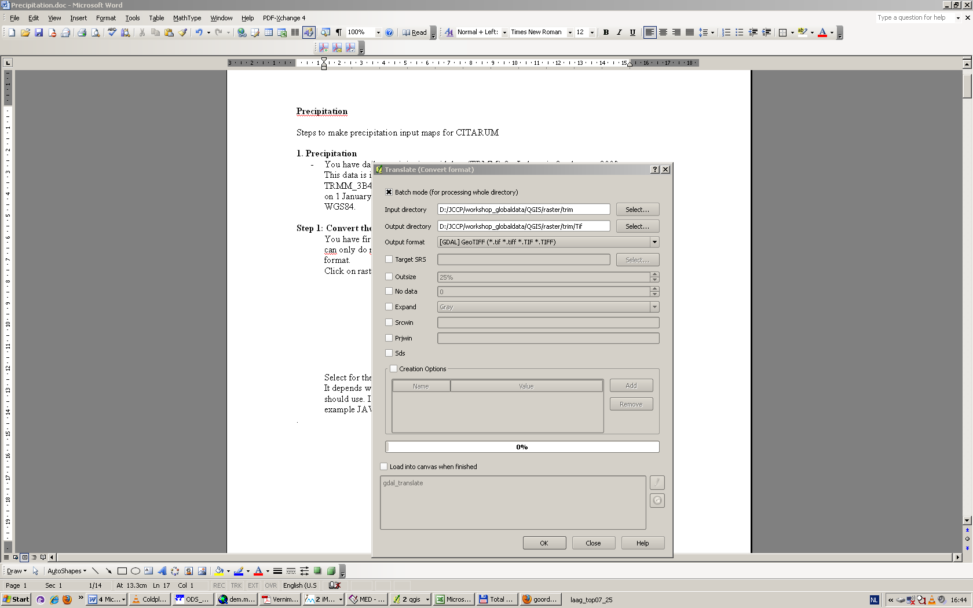

Figure 6‑2 Convert precipitation data in PCRaster format (.map) to GeoTIFF (.tif).

Select the batch option. With this option you can do the same conversion on all the maps in one folder at once.

Now select as input directory the map where you have stored all the TRMM data. Select as output directory a new folder called: Tif where you can store all the precipitation files in TIFF format. Choose as output format GeoTIFF.

If you have followed this procedure you can view in your TIFF folder new precipitation files are created in the TIFF format. You can open one map and one TIFF precipitation file to check if the same value is in both maps (this is just a conversion to another format, nothing in the values should be changed!!!).

Once all your precipitation maps are converted to .tif you can reproject them to the UTM zone of your catchment (see exercise in Section 2.4.5).

**Note!** Don’t forget to tick the batch option to reproject your files all at once.

### Exercise: clip the meteorological maps to your catchment

You have to make a clip bigger than the catchment, because the TRMM cells have a resolution of approximately 28 km and are crossing the boundary of your catchment.

Import a reprojectedTRMM map (created in exercise of Section 6.1.1) in your project. Import as well the reprojected catchment layer (*WS EDB – UTM54S* layer created in exercise of Section 2.3.2 or Section 2.4.5)

Now you have to choose your extent big enough for your catchment. Click on your precipitation map and define your xmin,ymin,xmax and ymax by running your cursor over the TRMM map and reading the coordinates in the right bottom of the QGIS window.

**Note!** You can better pick a much greater window than your catchment so you are not loosing any cells as in the example below. The clip window is here in red and the TRMM cells remaining are colored. You can see that in the south and east cells are missing! Because the clip window was too small there!



Figure 6‑3 Wrong clip of theTRMM precipitation data.

Open the menu: Raster; Extraction; Clipper and fill in your extent. You can now see if you have chosen the right extent. Click on the close button if your extent is correct.

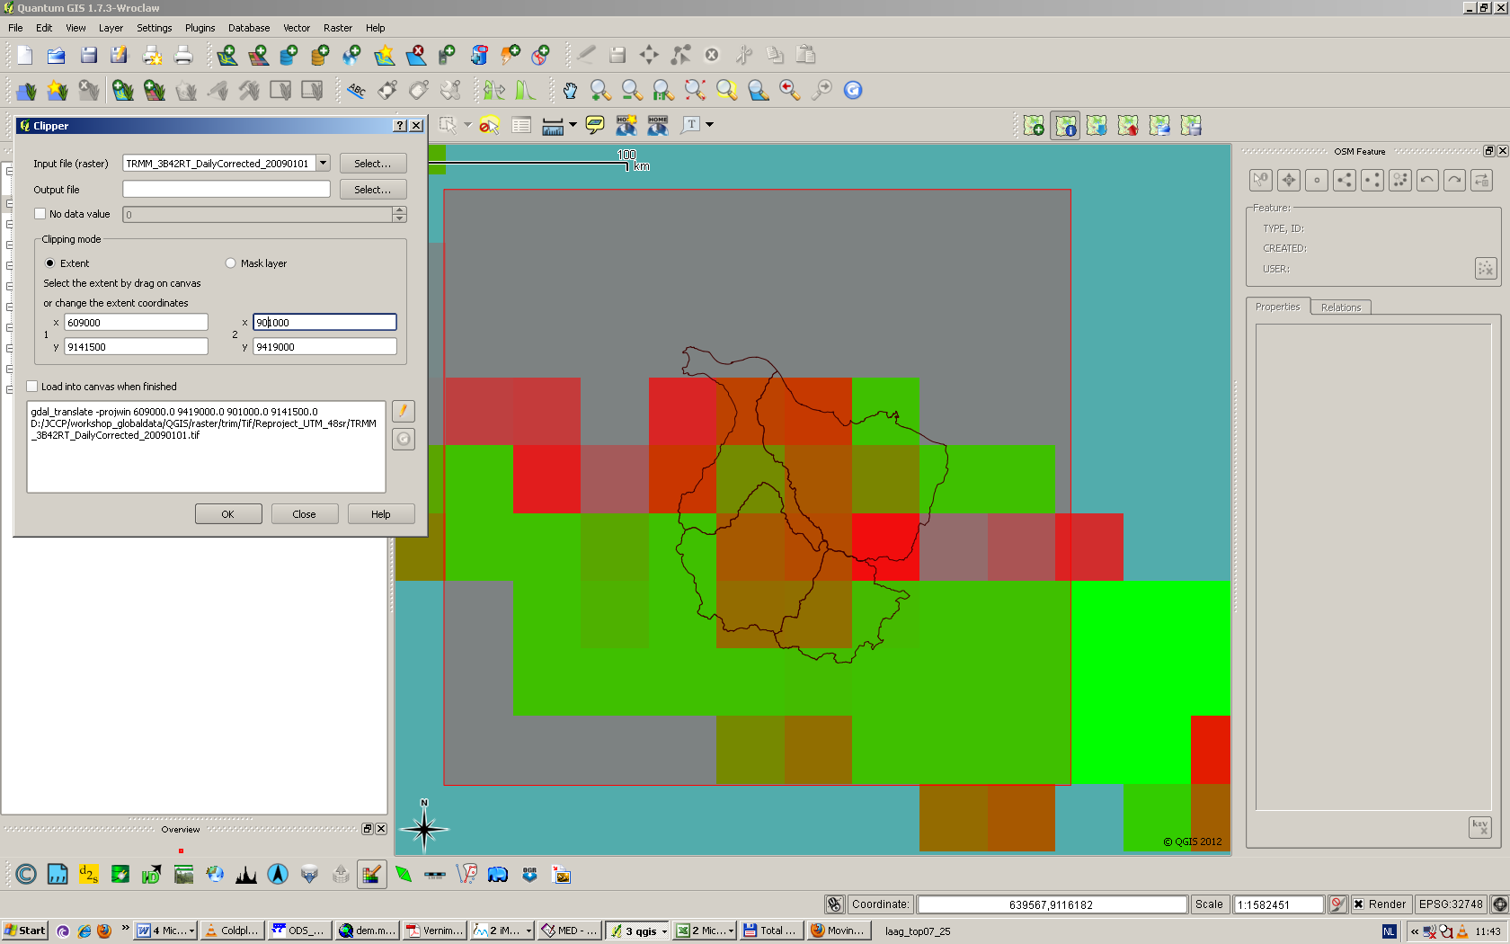

Figure 6‑4 Example of the clipper functionality of the TRMM data for the Citarum catchment

Clip all the TRMM files on the extent you have chosen with the Translate function.

* Click on the Menu: Raster; Conversion; Translate
* Click on batch mode
* Input directory is the map where the projected UTM TRMM files are saved
* Name the output directory: First_clip
* Output Format is GeoTIFF
* Click on nodata: 0
* The Prjwin are the coordinates you have defined. You should fill them in the following order: XminYmaxXmaxYmin
* Click on ok

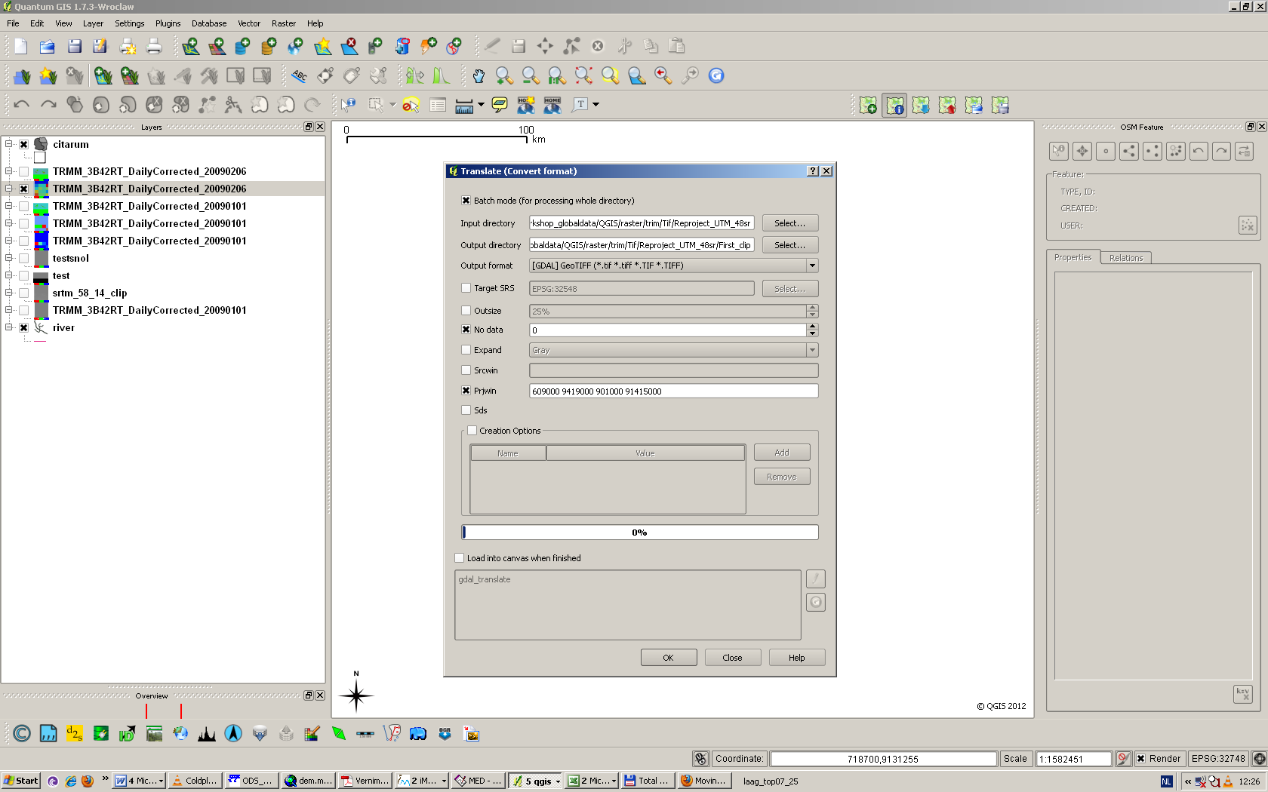

Figure 6‑5 Clip the TRMM data with Translate

Resample your precipitation data to a 270 x 270 m grid resolution.

* Doubleclick on your First Clipped TRMM grid and go to metadata.
* Go to metadata and copy the layer extent to Excel. In the Citarum case: 578548.2512440974824131, 9141899.7944292277097702 : 862061.1167209064587951, 9425412.6599060371518135. These numbers present: XMIN, YMIN,XMAX,YMAX
* Now calculate in excel how many cells of 270m. fit in your window. The same method you used for the catchment. In the Citarum case: 1050 cells with a size of 270x270m fit in the x and y- direction of the grid.
* Go to Raster;Projections;Reproject

Click on the batch option, because you have to clip all precipitation files for 2009.

And choose resize.

The height is equal to the number of rows you have calculated in the previous step and is for Citarum 1050. The number of columns equals the width and is for Citarum 1050.

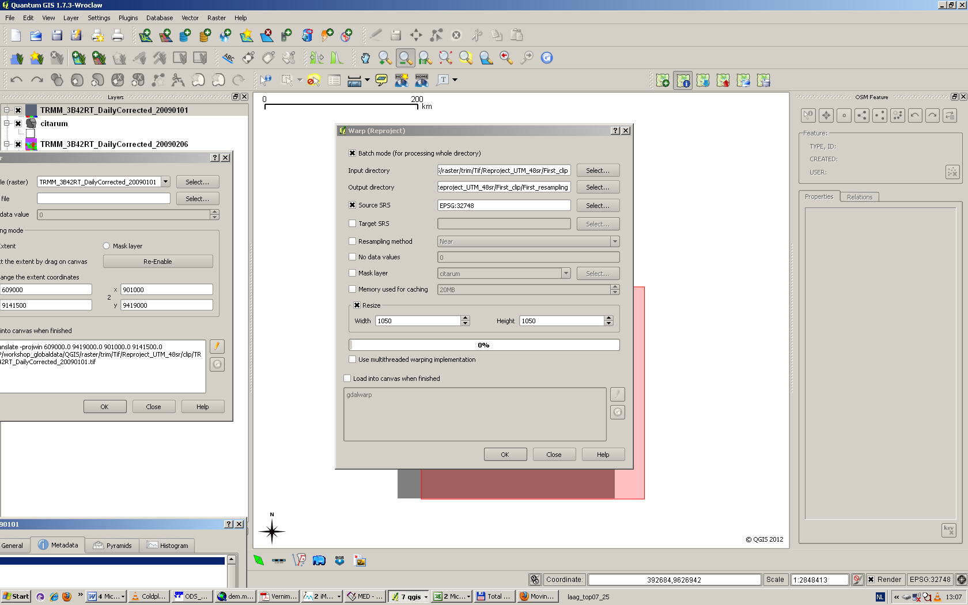

Figure 6‑6 Resample your precipitation data with the warp function

Clip the extent of your precipitation data on the coordinates defined for your catchment.

* Select the menu Raster, Conversion, Translate
* Select the Batch mode
* Select as input directory the dir where you created your rescaled clipped TRMM grids
* Choose as output dir: TIFF_WFLOW_precipitation_catchment_…….(fill in your catchment name at the dots)
* Select as output format: GEOTIFF
* Select as project window the coordinates you had already defined for your catchment. (ALSO used to clip SRTM)

Click on ok.

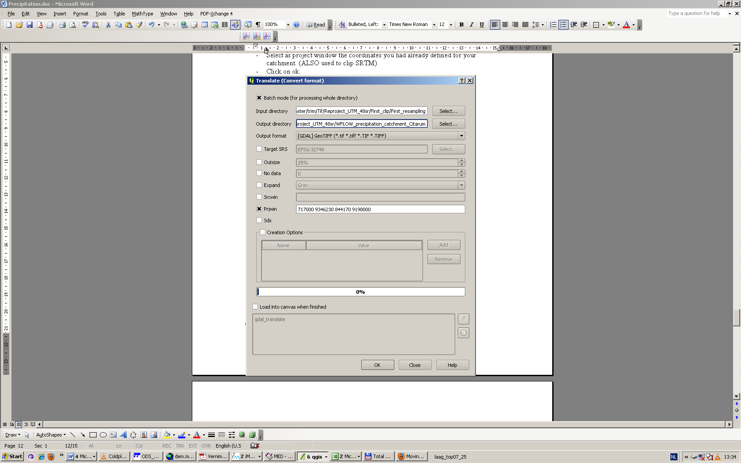

Figure 6‑7 Clip your TRMM data with the prjwin in Translate

The result for Citarum precipitation grid at 6 February 2009 is as follows:

Check also your own precipitation grid!!!

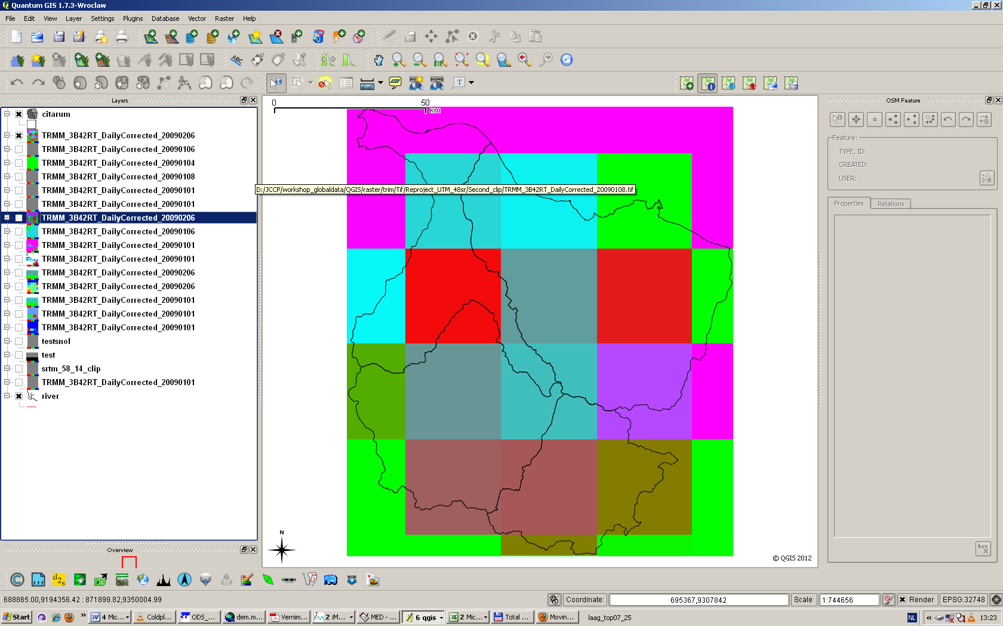

Figure 6‑8 Check of the clip of your TRMM grid.

Convert your precipitation grids to asciigrids.

* Click on menu: Raster, Conversion, Translate
* Choose batch option
* Choose as input dir: TIFF_WFLOW_precipitation_catchment_…….
* Choose as output dir: ASC_WFLOW_precipitation_catchment_…….
* Choose as output_format Arc/info AsciiGrid
* Choose as nodata: -9999

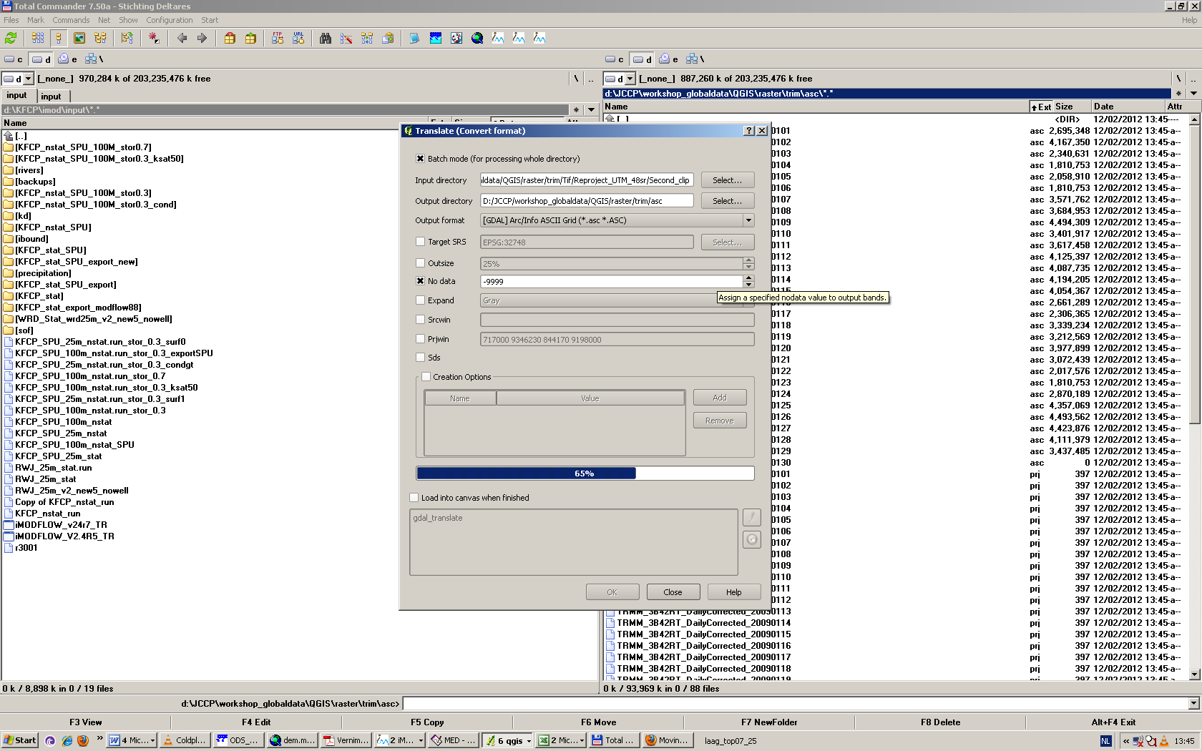

Figure 6‑9 Save your file as ASCII grid with Translate

Change the Xmin en Ymin coordinates and the dx and dy of the asciigrid.

QGIS does not take the exact Xmin and Ymin you have choosen to clip on. It gives a decimal number. We do not want this decimal number because all your grid extents should be exactly the same for the WFlow model.

* Open for the first ten days of February (1-2-2009 – 10-2-2009) with your text editor.
* Change in the asciigrid the Xllcorner and Yllcorener to the exact values you have calculated in step 7. (xmin_new=717000, ymin_new=9198000
* Change in the ASCIIGRID the cellsize to 270 (dx and dy)

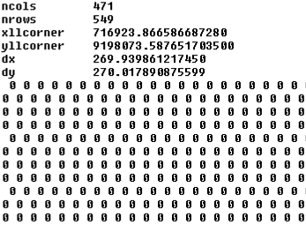

Change the xllcorner and yllcorner and cell size

Figure 6‑10 Example of the AsciigridTRMM file you have to change.

Convert the SRTM asciigrid to map file.

Convert the asciigrid to map file with: Raster;Conversion,Translate Choose as output file format: PCRaster Raster file (*.map).

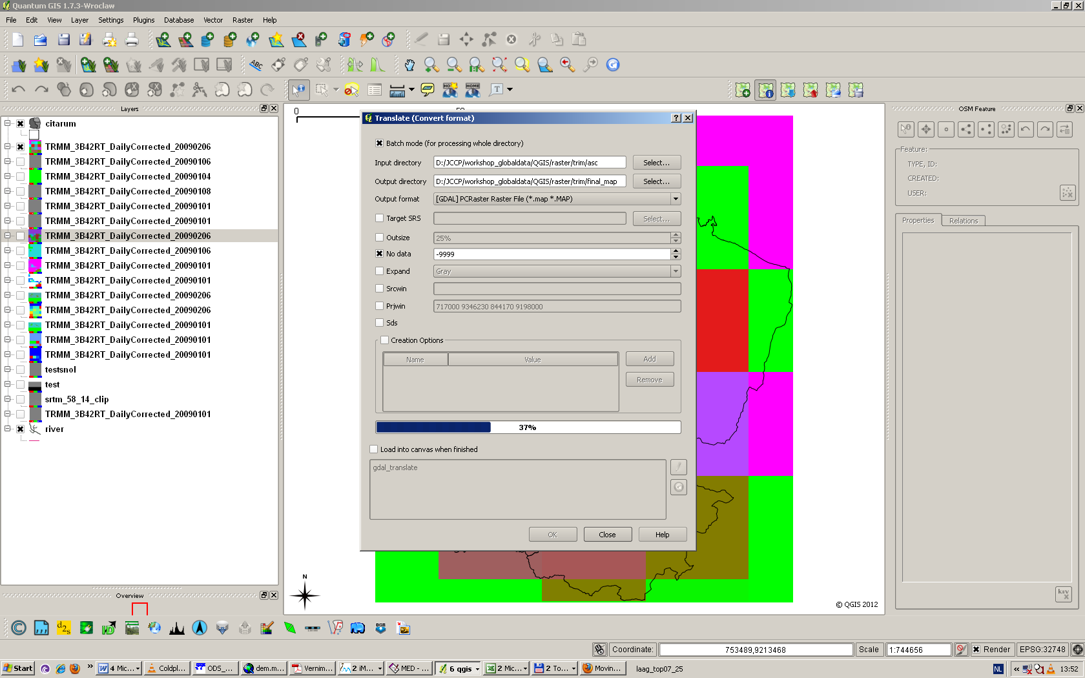

Figure 6‑11 Convert the ascii grid to map format with the Translate function in QGIS

This step should only be executed for the potential evapotranspiration, because this data is monthly and you have to have daily data for WFLOW.

Go to Raster; Raster calculator and double click at raster bands on your Evapotranspiration file. Then divide it by clicking on the sign: / ,and type in the number of days you want to divide your monthly evapotranspiration. For example September should be divided by 30, because September has 30 days. Then click on current layer extent and check if this is the same as the SRTM extent. If not change it!!!! Then click on ok.

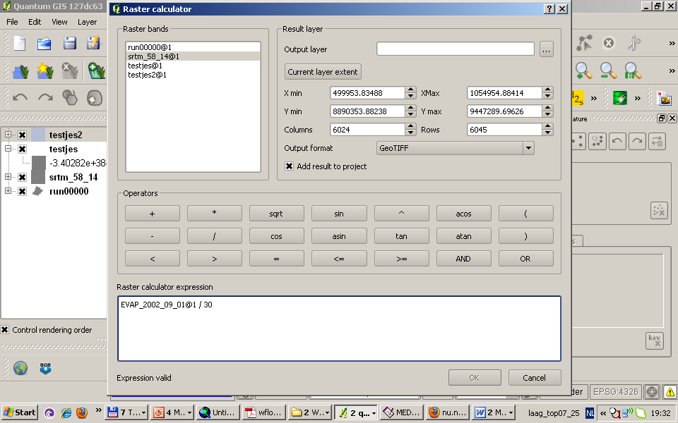

Figure 6‑12 Use the raster calculator to calculate daily potentional evapotranspiration maps

Now you have your daily epotential evapotranspiration map. You should make for every day you want to run WFLOW a separate potentional evapotranspiration map and rename it as follows:

Potentional_evapotranspiration of day 0 =>PET00000.000

Potentional_evapotranspiration of day 1 => PET00000.001

Potentional_evapotranspiration of day 2 => PET00000.002

Potentional_evapotranspiration of day 3 => PET00000.003

Potentional_evapotranspiration of day 4 => PET00000.004

Potentional_evapotranspiration of day 5 => PET00000.005

Potentional_evapotranspiration of day 6 => PET00000.006

Potentional_evapotranspiration of day 7 => PET00000.007

Potentional_evapotranspiration of day 8 => PET00000.008

Potentional_evapotranspiration of day 9 => PET00000.009

Potentional_evapotranspiration of day 10 => PET00000.010

Potentional_evapotranspiration of day 11=> PET00000.011

Etc…..(The format of the name of the file should not have more than 12 characters. Therefore at timestep 100 => PET00000.100)

The rain maps should be renamed as follows:

TRMM of day 0 => P00000.000

TRMM of day 1 => P00000.001

TRMM of day 2 => P00000.002

TRMM of day 3 => P00000.003

TRMM of day 4 => P00000.004

TRMM of day 5 => P00000.005

TRMM of day 6 => P00000.006

TRMM of day 7 => P00000.007

TRMM of day 8 => P00000.008

TRMM of day 9 => P00000.009

TRMM of day 10 => P00000.010

TRMM of day 11=> P00000.011

Etc..

# Extra exercises

## Preparing input data for WFLOW with QGIS for Bian and Citarum

This section will guide you through the steps to be performed to prepare part of the input maps required to run WFlow. The data preparation is run for the Bian and for the Citarum catchments, at a 270 and 1080 m cell size resolution.

We will analyze the steps to produce land cover, soil and elevation maps for the year 2008. Precipitation and evapo-transpiration maps will be provided by the trainers.

The exercises included in this section are a repetition of the work performed during the previous workshop, therefore explanation about the procedure to perform them will be synthetic and to the point. Refer back to the appropriate sections of the manual if you have any further doubts.

During this workshop and therefore during the map preparation phase we will work in UTM projections. Therefore you always have to make sure that your reference coordinate system is set to this projection. If this is not the case, then you should re-project your layers to the UTM grid corresponding to your catchment, or change the CRS from the project settings. The UTM reference grids that apply to your catchment are:

Citarum catchment: UTM 48S

Bian catchment: UTM 54S

The exercises we will perform are the following:

Exercise 1: Identification of the extent for the clipping of the maps

Exercise 2: Clipping of the DEM, land cover and soil maps

Exercise 3: Re-projection of the DEM, land cover and soil maps to UTM

Exercise 4: Resizing of the maps to 270 and 1080 m resolution

Exercise 5: Conversion of the input maps into .map WFlow format

Each exercise will provide instruction for both catchments. Follow only the instruction for your assigned catchment.

For the preparation of the new layersand for the correct naming of the files you will be producing during the exercises, please use the nomenclature reported below.

Final output maps:

1. Elevation maps
   1. SRTM_270_Bian (.tif );
   2. SRTM_270_Bian (.map);
   3. SRTM_1080_Citarum (.tif);
   4. SRTM_ 1080_Citarum (.map);
2. Land cover maps
   1. LC_270_Bian (.shp );
   2. LC_270_Bian (.map);
   3. LC_1080_Citarum (.shp);
   4. LC_ 1080_Citarum (.map);
3. Soil maps
   1. Soils_270_Bian (.tif );
   2. Soils_270_Bian (.map);
   3. Soils_1080_Citarum (.tif);
   4. Soils_ 1080_Citarum (.map)

Exercise 1: Identification of the extent for the clipping of the maps

The identification of the extent for the clipping of the maps is required to delimit the area of analysis and abstract the required data from the global or regional maps. In order to correctly run WFlow, all the input maps need to have the same extent. We will first define the extent of the clipping around the hypothetical area of the river catchment, and then proceed with the clipping of the input maps.

Ideally, you should be able to define the right extent of the clipping by taking into consideration the DEM and the river layer. If other information is available, you can use it to make your clipping selection more accurate.

An alternative way of proceeding is to identify which are the provinces or districts where the river is flowing, and use an administrative boundary layer to identify the clipping extent. In the following exercises we will proceed following this reference mp (the administrative layer), although you can also choose to give priority to the DEM, or combine information from the latter with the administrative boundary layer.

Procedure:

1. Open Q-GIS and create a new project called *Workshop_Bogor*;
2. import to your project the administrative boundary layer from the *Admin boundaries folder;*

The Citarum catchment is located in Jawa barat province, while the Bian catchment is located between the Merauke and Boven Digoul kabupaten in Papua province.

1. Identify the administrative units above mentioned and create a polygon around this area.

To create the polygon from a vector layer select: Layer -> New -> New shape layer. This exercise has already been described in section 2.3 of the manual.

When the new screen pops-up you have to define the characteristics of the layer (for Type select Polygon, for Type in the New Attribute selection select whole number, give the name of the new attribute poly and then select add to attribute list, click ok). Save the layer with name Bian_ polygon or Citarum_polygon. Leave the CRS to the WGS 84. The layer will appear in your layers map. Right click on the layer’s name and select Toggle Editing to start editing your feature based on your criteria of selection.

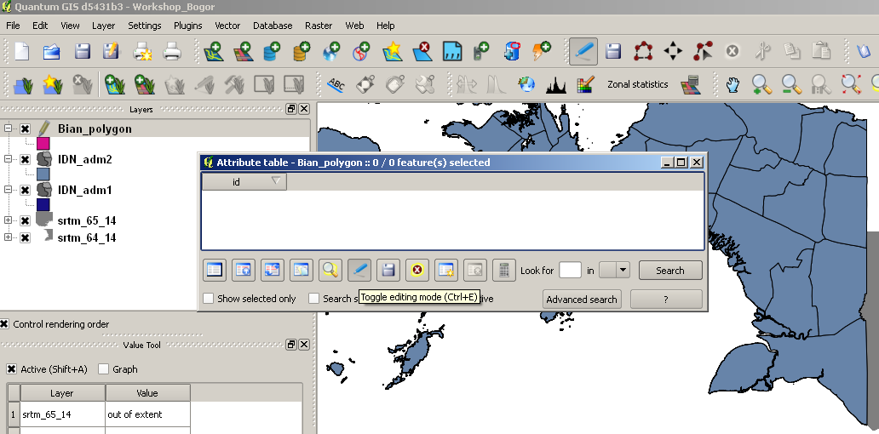

Figure 7.1 Example new attribute table for Bian

Start creating your polygon around the identified administrative boundary by clicking around the contour of the corresponding polygons. When you have finalized your editing, right click with the mouse to stop the toggling and save the file. If you still see a pencil icon on your layer icon on the Map Legend, this means that you have not closed the Toggle Editing function in the layer. Close the editing function if you see this icon.

1. Note down the extent of the clip and round it to the nearest integer;

You can perform this action by right click on the layer and read the coordinate from the *properties* header. This is the extent that you will be using to clip all the input maps for your catchment.

Exercise 2: Clipping of the DEM, land cover and soil maps

1. import the SRTM, soils and land cover layers;

For the groups working on the Bian catchment this step requires the merging of two SRTM maps. Perform the merge first, and then use the merged layer for the clipping.

1. clip the above mentioned maps on the polygon extent identified in step 4;

To perform this operation you could clip the input maps one by one or you can chose to speed the clipping process by using the *batch* option. This option is available from the following path: *Raster -> Conversion -> Translate*.

The *batch* function gives you the possibility to perform the same operation (in our case the clipping) on files and layers contained in a same folder. Therefore it I needed that all the input layers you want to clip are contained in the same folder.

Move the 3 input layers you want to clip (SRTM, land cover an soils) to a new directory to be named *Clipping Folder*, and perform the clipping operation from the *Conversion -> Translate* path.

To complete the operation you need to specify a (previously created) output directory, and the right extension of the clipping area from the Prjwin selection. Remember that the order of input for the coordinates in the Prjwin field is different from the input order of the coordinate system from the *Properties* window of the vector layer. The coordinates in the Prjwin field have the following order: Xa, Ya, Xb, Yb (XMIN YMax,XMax,YMIN).

A

B

Pay attention to this different order to define the right extent of your clipping area.

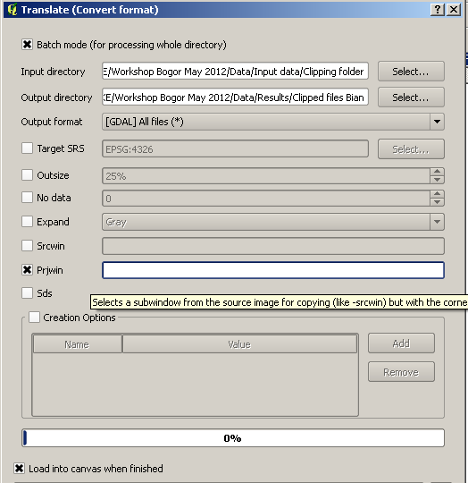

Figure 7.2Clipping with translate

Check your results. The clipped maps for soil, land cover and SRTM should include all of the area of the polygon you created. If for example the results of the clipping lead to a results such as the one showed in Figure X below, you should redefine the extent of the clipping area to include those parts of the polygon that are lefts outside of the clipping selection.

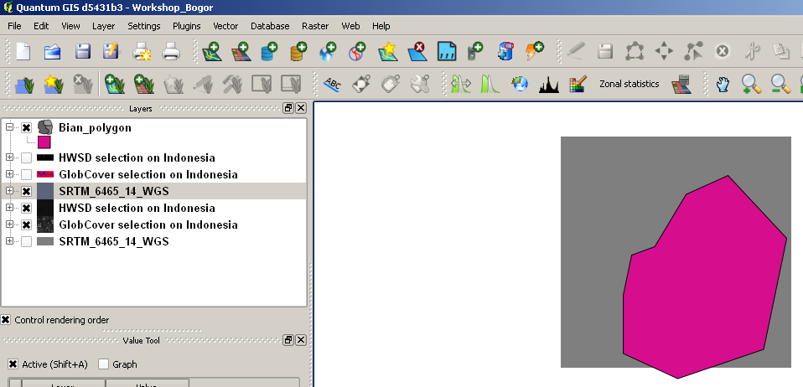

Figure 7.3Clipped area outside map

After the review of the clipping extent your clipped maps should look like in Figure X2 below.

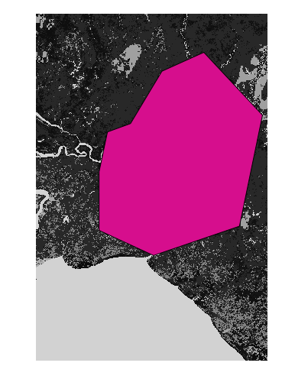

Figure 7.4Result polygon for Bian

Note down the coordinates of one of the clipped layers (SRTM, land cover or soil map). You will need this information later on to define the exact extent of the ASCII maps to be used to create the WFlow .map input layers.

Exercise 3: Re-projection of the DEM, land cover and soil maps to UTM

Identify the UTM zone for the re-projection of your input maps. Once you have found it, use the *Warp*  function and the *batch* mode to re-project the input maps from WGS to UTM.

Check the results of your conversion from the *properties* option of the new layers.

Exercise 4: Resizing of the maps to 270 and 1080 m resolution

The procedure for the resizing exercise has already been dealt with during the first workshop. You can find reference to the procedure to be used in Section 6.1 of the Manual (page 70).

You have to adjust your computations to obtain a resolution of 270*270 and 1080*1080m respectively.

Perform the following procedure:

1. open the layer properties of your 3 input layers, copy their coordinates (Xmin, Xmax, Ymin, Ymax) in an excel sheet and compute the X and Y dimensions of the layer as follows:
   1. X dimension: Xmax – Xmin
   2. Y dimension: Ymax -Ymin
2. determine the number of columns and rows representing respectively the width and height of the new resized layer;
3. go to *Raster -> Projections -> Warp* select the batch mode, select the input directory and insert the width and height data in the *resize* field;

The resized files are still in a .tif format. In order to ensure that we will use the same extent for all the input maps we have to manually modify the Xmin and Ymin coordinated. This is doable by operating on ASCII files. You need therefore to convert the resized layers from .tif to .asc by using the *Translate* function. Use the *batch* mode to convert all the input layers.

Change the Xmin en Ymin coordinates and the dx and dy of the asciigrid.

QGIS does not take the exact Xmin and Ymin you have chosen to clip on. It gives a decimal number. We do not want this decimal number because all your grid extents should be exactly the same for the WFlow model.

* Open your input maps with the text editor;
* Change in the asciigrid the Xllcorner and Yllcorner to the exact X and Y coordinate values of the catchment polygon you have created at the end of Exercise 1.2;
* Change in the ASCIIGRID the cellsize to 270 or 1080 (dx and dy)

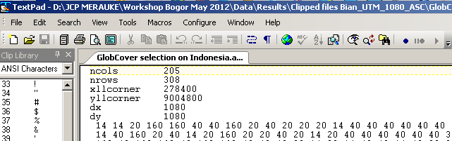

Figure 7.5 Example header asciigrid

Exercise 5: Conversion of the input maps into .map WFlow format

The last step is to convert the layers from ASC to MAP format. You can do this by making use of the *Translate* function.

Your elevation, land cover and soil maps are now ready to be used in WFlow since:

* they are on the same projection;
* the y have the same resolution;
* they have the same coordinates extent

WFlow also requires the precipitation and ET maps as an input to run the simulation. Contrary to the previous one, these maps are not static maps, as their values change day by day. The procedure to generate these maps has already been presented during the previous workshop (use of the *batch* mode).

In order to ensure homogeneity in the data preparation phase, we will provide you with all the required input. This exercise was meant to make you review the main tools and functions that you need to know to perform the data preparation before running WFlow.

# Hydrological modelling with WFlow

This section describes the functioning of the Hydrological model WFlow, and provides the required background information on the GIS environment PCRaster.

WFlow is a distributed Hydrological model which has been built using a dynamic GIS language called PCRaster. The PCRaster version used in WFlow is a beta version that allows for programming in Python language. The PCRaster main software can be downloaded from <http://pcraster.geo.uu.nl/>. This webpage also contains information about the program, its development and its functionalities.

WFlow has already been used in the Citarum catchment to model one drought pilot project, and in 2011 for a flood risk study carried out by Deltares. Information about the latter is provided in the USB stick, in the WFlow directory.

There exist two versions of WFlow, one based on the HBV model, and another based on the TOPOG SBM (Australian) model. The version we will be using during this workshop is the one based on the TOPOG SBM model. This is because this version also computes subsurface lateral flow. In order to run WFlow, both PCRaster and Python version 2.5 needed to be installed.

## Basics of WFLOW model functioning

WFlow is a distributed[12] hydrological model developed by Jaap Schellekens from Deltares. The model is derived from the CQFlow model (Kohlet et al., 2006) which has been used in different countries (most notably Central America). The model is programmed in a dynamic GIS environment with PCRaster. The PCRaster version used in this version of WFLOW is a beta version which allows for programming with Python language. Through the latter it is possible to create scripts that execute given computation in bundles. In order to run the model, version 2.5 for both PCRaster and Python is needed.

WFlow models the processes of the hydrological cycle. They are schematized in figure Figure 8.1 Processes in the hydrological cycle The processes of the hydrological cycle are modelled with a combination of sub-models which are nested in the program. The sub-models are:

1. **Rainfall interception** (schematized by the Gash model)
2. **Rivers(channel) and overland flow** modeled with the kinematic wave reservoir

(fast runoff reservoir)

1. **Soil processes** schematized by the TOPOG_SBM model

These principles of these three hydrological sub-models in WFLOW are in the following three chapters explained

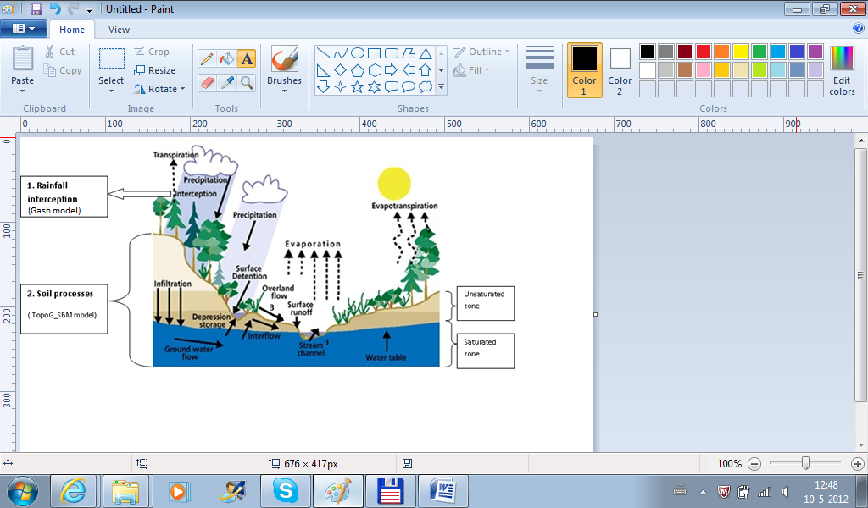

Figure 8.1 Processes in the hydrological cycle

### Rainfall Interception

**Interception** 13[13] refers to [precipitation](http://en.wikipedia.org/wiki/Precipitation_(meteorology)) that does not reach the soil, but is instead intercepted by the leaves and branches of plants and the forest floor. It occurs in the [canopy](http://en.wikipedia.org/wiki/Canopy_(forest)) and in the [forest floor](http://en.wikipedia.org/wiki/Forest_floor) or litter. Because of [evaporation](http://en.wikipedia.org/wiki/Evaporation), interception of liquid water generally leads to loss of that precipitation for the [drainage basin](http://en.wikipedia.org/wiki/Drainage_basin), *except for cases such as fog interception.*

Figure 8.2 Interception

Interception (precipitation) is modelled with the Gash model, which allows modelling with daily precipitation time steps (when running the model with sub-daily time steps, an adapted version of the Gash model is used).

The analytical Gash model of rainfall interception is based on Rutter’s numerical model. The model calculates the amount of rainfall needed to reach saturation of the canopy

The Gash model is a model for rainfall interception by trees in a forest. It gives a formula for the threshold value necessary to saturate the canopy:

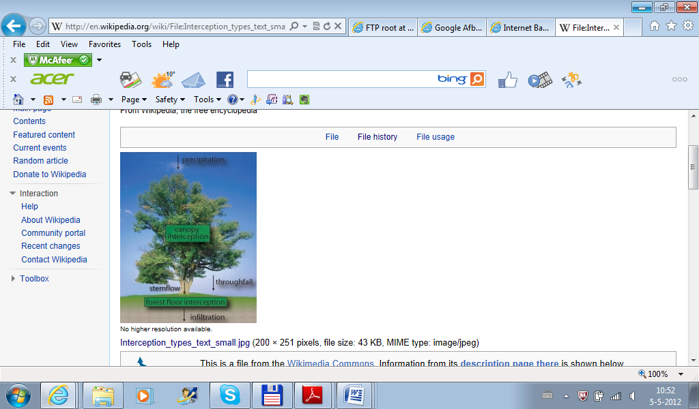

$$P^{'}=-\frac{\overline{R}S}{\overline{E}}\ln\left[1-\frac{\overline{E}}{\overline{R}\left(1-p-p_{t}\right)}\right]$$

Wherein $P^{'}=$ 
 threshold value necessary to saturate the canopy $\overline{R}=$ 
averageprecipitation intensity on a saturated canopy $\overline{E}=$ 
averageevaporation from the wet canopy $S=$ 
canopy capacity $p=$ 
directthroughfall coefficient $p_{t}=$ 
proportion of the rainfall diverted to stemflow

Figure 8.3 Processes Canopy

### River and overland flow

Water which not infiltrates in the subsoil is fed to the open water. Also when the subsoil is fully saturated, the surplus of water is fed to the surface water. The water flow of the open water is computed by the kinematic wave equation.

Kinematic waves will not be accelerating appreciably and the flow will remain approximately uniform along the channel. No visible surface wave will be noticeable and an observer on a bank will see the flow as an apparently uniform rise and fall in the water surface elevation over a relatively long period of time with respect to the size of the specific subbasin being analyzed. Therefore kinematic waves are often classified as uniform unsteady flow.

Wflow uses for the kinematic wave we use the Manning equation which is expressed below.

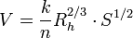

Wherein:

|  |  |
| --- | --- |
| *V* | is the cross-sectional average velocity ([L](http://en.wikipedia.org/wiki/Length)/[T](http://en.wikipedia.org/wiki/Time)) |
| *k* | is a conversion factor of 1 ([L](http://en.wikipedia.org/wiki/Length)1/3/[T](http://en.wikipedia.org/wiki/Time), m1/3/s) |
| *n* | is the **Gauckler–Manning coefficient**, it is unitless |
| *Rh* | is the hydraulic radius (m) |
| *S* | is the slope of the water surface or the linear [hydraulic head](http://en.wikipedia.org/wiki/Hydraulic_head) loss (L/L) |

### Soil processes in WFLOW

For the soil water component, WFlow embeds the TOPOG_SBM model developed by Vertessy and Elsenbeer (1999). In this model, the soil is considered as a bucket with a certain depth (zt), divided into a saturated (S) and an unsaturated (U) store, the magnitudes of which are measured in units of depth.

Netto Precipitation

(without interception)

Interaction Open water

Evapotranspi-ration

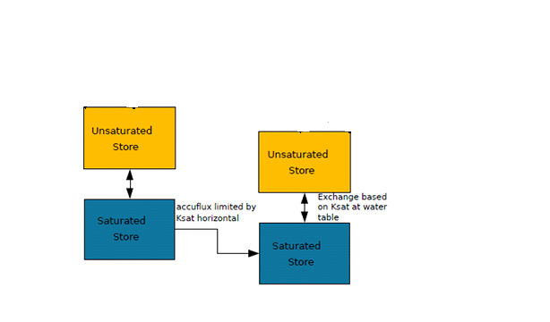

**Soil**

**Schematization**

Figure 8.4 Soil processes modeled in WFLOW

Within WFlow, water movements in the soil are modelled as follows: Water for transpiration is first taken from the unsaturated store U.Transpiration is the loss of water vapor from parts of vegetation especially in leaves but also in stems. Evapotranspiration is modelled from the potential evapotranspiration which is refined based on soil water content and vegetation type.

If the U store cannot satisfy the demand for water, the saturated store S is used if the pseudo water level is not below the rooting depth.

Precipitation (minus interception) is added to the unsaturated store. Any surplus is fed into the open water schematized by fast runoff reservoir (calculated with kinematic wave). Water infiltrates from the unsaturated to the saturated store according to the value of the saturated hydraulic conductivity

Lateral subsurface flow is modelled using the Darcy equation, which describes the patterns of water flow formulation and velocity in a porous medium. In Darcy’s law, the discharge Q (m3/s) is calculated as the ratio between the hydraulic conductivity coefficient k (m2/day), the cross-section of the area A (m2) for which the discharge is calculated, and the difference in porous pressure exercised (Pb-Pa) on the one hand, and the product between viscosity µ (Pa s ) and the length L (m) of the area over which the change in hydraulic pressure takes place.

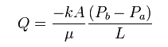

The negative sign in the equation is required to counterbalance the negative value that may arise when calculating pressure differences;

**Equations of the vertical transfer between unsaturated and saturated zone**

The top of the saturated store S forms a pseudo-water table at depth zi such that the value of S at any point in time is given by the following equation:

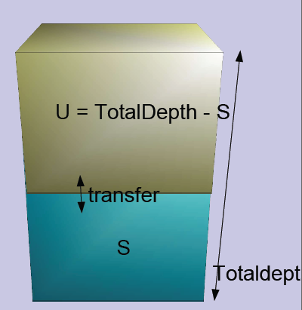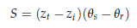

where θs and θr represent the saturated and residual soil water content respectively.

On the other hand, the unsaturated store U is subdivided into two sub-buckets of storage (Us) and deficit (Ud) which are again expressed in units of depth:

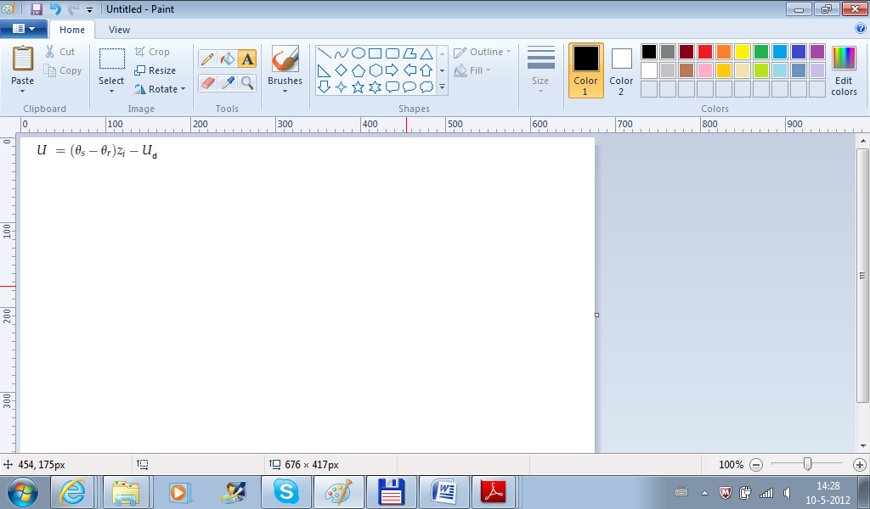

with:

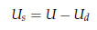

The saturation deficit (Sd) for the soil profile as a whole is defined as:

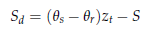

WFlow assumes an exponential decay of the saturated hydraulic conductivity of soils (Ksat) depending on soil depth.

In the model, the rate of saturated hydraulic conductivity exponentially decreases with depth according to the following relation:

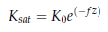

where:

*K0* is the saturated conductivity at the soil surface, measured in [m d-1]

*f* is the scaling parameter defined based on the ratio between the difference of (θs - θr) and a model parameter M. The *f* parameter is measured in [m-1].

Saturation conditions are assumed to occur when rainfall intensity exceeds a given threshold. Often the 0.5 mm/hr threshold is used for computation.

**Calibration**

If existing discharge measures are available, WFlow allows for calibration of the modeled results to the field measurements. This is done by filling in a .tss file format from the U command.

Calibration is mainly carried out by modifying the M parameter, which is a model parameter that determines the value of the *f* factor when computing the saturated hydraulic conductivity *Ksat* from the saturated conductivity at the soil surface *K0*

Required input data to run the model are stored in a *case*, which also includes a subdirectory where all the results of the model’s run are saved. When the user wants to preserve existing model results, he/she needs to specify a distinct ID run for the new simulation. If not differently defined by the user, WFlow generates a default case where to source and store data. The model only works with a case at a time.

## Input data for WFLOW

WFlow requires the following input data to run:

1. Static data
   1. DEM
   2. Soil depth
   3. Soil physical parameters
   4. Land Cover/Land Use map
2. Dynamic data
   1. Precipitation
   2. Potential evapotranspiration

These two categories of input data are contained in the Staticmaps and Inmaps directories respectively. The static maps are all in a .map raster format, and can be directly produced in GQIS or with available scripts. WFlow uses these input maps to generate the discharge series for the identified catchments.

## Delineate the catchment and create the static maps

The delineation of your catchment can be done by a prepare script which also makes your other static maps in the right extent automatically. A python script is available that can perform the delineation of your catchment and resizes your static maps in the same extent and resolution needed for WFLOW.

The script does the catchment delineation by doing a terrain analyses. It calculates the slope of your DEM and calculates the direction of your flow by the slope of your DEM within taking into account the geographical location of your gauges and the rivers. The rivers are at burned in the DEM with a depth of 200m. When water flows into the river, the water can not get out of the river, because water can not stream to a higher altitude. You have to choose the location of your gauging point yourself. You have to think thoroughly about what is the best location. Therefore look at the DEM and your rivers and think: Where will the water flow to and from which catchment do I want to know the runoff. Always choose your gauging point on a cell with a river!



Figure 8.5 Calculation of the direction of your flow over the DEM

In order to run the script, both PCRaster and Python 2.5 and the following data needs to be present:

* a DEM in arc/ascii or PCRaster format
* a land use map in arc/ascii or PCRaster format. If the resolution is different from the DEM the script will resample this map to match the DEM (or the DEM cutout).
* The locations of the gauges. The first gauge should be the catchment outlet.
* The extent and cellsize of the out maps.

### Exercise: Catchment delineation

* Step1: Install the programs if you did not install it the previous workshop. In order to run the script, both PCRaster and Python 2.7 must be installed: Open the folder: step1_install python and PCRaster and click on installall.bat All the programs you need to determine the catchment deliniation will be installed.
* Step2: Open the wflow_prepare.ini and look in the file. This is initial file read by the script that is making the catchment delineation which you will be running with the batch file: create_maps.bat. The python script needs the wflow_prepare.ini file to know which DEM, landuse map and locations of the gauges it has to use. The format of this file is in txt and you can edit it easily in your txt editor.

Before you edit the file you should copy your SRTM map to the same folder as the prepare.ini and the create_maps.bat and rename it to dem.map.

Masterdem=dem_scalar (You should not change this name!!!)

Landuse=………....=> (we are not going to use this map now)

Soil=………....=> (we are not going to use this map now)

river=………....=> (write here your path and name of your river shape)

gauges_y = [……..]=> (write here your y coordinate of your catchment outlet)

gauges_x = [……..]=> (write here your x coordinate of your catchment outlet)

Yul = …….=>(Write here your upper left Y coordinate of the output map)

Xul = …….=>(Write here your upper left X coordinate of the output map)

Ylr =……...=> (Write here your lower right Y coordinate of the output map)

Xlr =………=> (Write here your lower right X coordinate of the output map)

cellsize = ...=>(Write here your Cellsize of your output map)

Choose as cellsize and the extent (YUL, XUL, XLr and YLr) for your output map the SRTM map (you have created this morning). You can view the cellsize and extent of your SRTM map in QGIS (right mouse click on your map, properties, metadata). Save the wflow_prepare.ini in the same map your scripts are in.

* Step3: Double click on create_maps.bat and the script for the catchment delineation starts running,once the python script has finished successfully the following maps are created in the step2
* wflow_landuse.map
* wflow_subcatch.map
* wflow_gauges.map
* wflow_catchment.map
* wflow_river.map
* wflow_streamorder.map
* wflow_dem.map
* wflow_ldd.map
* catchment_cut.map
* wflow_riverlength_cut.map
* wflow_riverburnin.map
* cutout.map

The ldd.mapstands for local drainage direction map. This map shows the direction of the runoff. You can open this map with your aguilla viewer. The aguila viewer is in the directory where you installed PCRasterin the folder apps (c:\Program Files\PCRaster\apps\aguila.exe). From the calculation of the local drainage direction WFLOW defines the catchment. The other maps you can also view in QGIS. Look at you DEM map and your rivers and then check if your defined catchment is ok!

Open the wflow_river.map and the wflow_DEM.map and the catchment map you have produced in QGIS. Do you think the catchment map looks good that the program produced and why or why not?

Open the step2\wflow_catchment.map and the step2\wflow_subcatch.map. Compare the maps. What is the difference and why?

Open QGIS and open the created maps: step1\streamorderrive.map and the step2\wflow_river.map. What is the difference between both maps? Do you understand what the numbers stand for?

### Exercise: making static and instate maps

For WFLOW you need staticmaps. The static maps can be produced by the script which you also used in the previous exercise about catchment delineation.

* With the catchment delineation you can also define the extent of your model. Open the wflow_catchment.map in QGIS and write the upper left x and y coordinates and the lower right X and Y coordinate down. Don’t choose your model too large, otherwise the calculation time will be very high. So not choose it smaller than your catchment otherwise you loose water. Fill the new extent of your maps in

1. Run the create_maps.bat.Rename the folder step2 to staticmaps_1.

Open the wflow_subcatch.map and the wflow_river.mapin QGIS from the staticmaps_1.

1. Open the wflow_prepare.ini file and put a # before the river. This means the rivers are not used by creating the catchment. After running the script again, rename the folder step2 to stacmaps_noriv. And open the wflow_subcatch.map in QGIS. Compare this catchment map with the previous made one. Do you see difference and why?
2. Open QGIS and look at the wflow_river.map. Choose an extra gauging point upstream in your catchment exactly on a river cell. Write down the x and y coordinates of this gauging point. Open again the wflow_prepare.ini file and remove the # before the river. Now go to gauges_y=[…] and put a comma behind the first y-coordinate and fill in your y-coordinate. Do this also for your x-coordinate. Now run the create_maps.bat again and open step2\wflow_subcatch.map in QGIS. What is the difference with the other catchments?

### Exercise: Run WFLOW model

To run the wflow model we will use the modelof theBian and Citarum provided on the usb-stick. Now double click on therun_Bian_1080.bat, run_Bian_270.bat, run_Citarum_270 or run_Citarum_1080.bat and WFLOW starts running. Look in the batch file: For Bian:

bin-wflow\wflow_sbm.exe -C Bian_1080 -T 3562 -s 86400 -R result

The first term is the executable which runs your WFLOW model. The rest is input for WFLOW to run. –C gives the name of the case and input data directory you are running –T gives the total timesteps, -s gives the number of seconds for one timestep, -R gives the name of the result directory.

Open the wflow_sbm.ini (you can find it in the input data directory) in your text editor. Make sure the sizeinmetres is set to 1, otherwise WFLOW thinks your maps are in lat long (degrees). The output maps are given in maps [Ouputmaps] and in daily timeseries [outputtss]. If you write a # on the start of your line it means WFLOW will not read this line. Open in your wflow model directory (Bian/Citarum) result\run.tss with your text-editor. This is the averagedaily runoff for your catchment WFLOW calculatesin m3/s. You see more columns because you get the runoff for every sub-catchment. If you have for example 2 catchments you see in the tss-file 2 columns. For each catchment 1 column. Do you know which catchment belongs to which column?

Copy the runoff from the tss file in excel and make a graph. What do you think your initial state for the water level was? (Tip: Look in your runoff graph at timestep zero).

Open the instate folder and copy the maps from the result\outstate directory to this folder. Why do you think we do this?

Run the wflow model again with the .bat file and look and copy the runoff from the tss file again to excel. Compare this runoff to the previous modelled runoff. What is the difference?

The output maps are in \result\outmaps. The extent of the output map is a number which shows the timestep of your output.

## Create the parameter tables for WFLOW

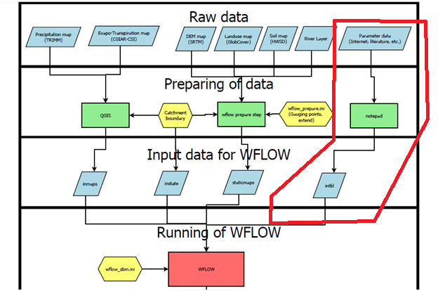The parameter tables are one of the input directories for WFLOW. It contains the values for the parameters used in the model. The number of parameters

Figure 8.6 The preparation of the parameter tables in the bigger picture for the use of WFLOW.

varies with the version of the model. This version has 18 different parameter tables.

The first and most time consuming part is getting the parameter data (upper right in the scheme) to base the values on. When the values are estimated it has to be put in the right format for wflow to read, using notepad (upper right green in the scheme) or another basic text editor. This is in a table with the extension .tbl which is part of the directory intbl for WFLOW (the right blue box in the scheme).

### Parameter data

In theory the parameters are linked to the soil map, the landuse map and to the subcatchment map (produced based on the gauging points) (all part of the staticmaps). Probably the parameters won’t change much per subcatchment so practically there are three kinds of parameters; parameters dependent on the kind of soil, parameters dependent on the landuse and parameters with only one value, not dependent on anything.

|  |  |  |
| --- | --- | --- |
| Value in the maps | FAO classification | Texture class |
| **4448** | Af55-3b | Clay |
| **4469** | Ap27-2a | Loam |
| **4513** | I-Od-U-1c | Sandy Loam |

**Reclassification**

It will be difficult to find information about exactly the kinds of landuse and soil in the maps. Therefore before searching the internet it is good to make a reclassification yourself.

Figure 8.5 Calculation of the direction of your flow over the DEM Reclassification of some soils.

For the soil it is very useful to make a classification based on the texture, an example for some kinds of soils is in

|  |  |  |
| --- | --- | --- |
| Value in the maps | FAO classification | Texture class |
| **4448** | Af55-3b | Clay |
| **4469** | Ap27-2a | Loam |
| **4513** | I-Od-U-1c | Sandy Loam |

. Information about the texture (including some other information) of the soils can be found with the HWSD viewer (in the directory ‘Harmonized world soil database’ in the stick in the Tuesday directory).  
For the landuse just make an easy understandable classification, for example making use of descriptions like; deciduous forest, shrubland, wetland, crops, open water, etc.

### Sources

It is good to have in mind that the values that will be finally chosen always remain estimates. It is probably not possible to make measurements yourself in the area to determine the values of the parameters but on the other hand some research about the parameters is necessary to get a more reliable model.  
Depending on the amount of time that can be spend on the research, the estimates can be more solid and in more detail. Sources to think about (from more generally to more detailed) are:

* Wikipedia
* Other internet sources
* Books/articles about standard values (e.g. FAO, US department of Agriculture)
* Experts (e.g. colleagues, Dinas Pertanahan, BWS)
* Measurements (e.g. Bakosurtanal)
* Scientific articles with measurements of comparable areas

In Tabel 8‑1 is an overview of the parameters with a description, dimension, possible sources and normal values.

Tabel 8‑1 The parameters with a description, dimension, sources and normal values.

|  |  |  |  |  |  |
| --- | --- | --- | --- | --- | --- |
| **Name** | **Dimension** | **Normal value range** | **Related to** | **Possible Source** | **Description** |
| **Albedo** | - | 0-1 | Land use | (Wikipedia) (Lutz Breuer, 2003) | The reflecting power of a surface. |
| **Beta** | - | 0.6 | Single value | (Schellekens, 2011) | Used in the kinematic wave function. |
| **CanopyGapFraction** | - | 0-1 | Land use | (Schellekens, 2011) | Fraction of the surface which is not covered by a canopy. |
| **EoverR** | - | 0-1 | Single value | (Schellekens, 2011) | Ratio of average wet canopy evaporation rate over average precipitation rate. |
| **FirstZoneCapacity** | mm | 0-20000 | Single value | (Schellekens, 2011) | Maximum capacity of the saturated store. |
| **FirstZoneKsatVer** | mm/day | 0-10000 | Soil | (Natural Resources Conservation Service) | Saturated conductivity of the store at the surface. |
| **FirstZoneMinCapacity** | mm | 0-400 | Soil | (Decagon Devices, 2012) | Minimum capacity of the saturated store. |

|  |  |  |  |  |  |
| --- | --- | --- | --- | --- | --- |
| **Name** | **Dimension** | **Normal value range** | **Related to** | **Possible source** | **Description** |
| **InfiltCapPath** | mm/day | 5 | Single value | (Schellekens, 2011) | Infiltration rate of the compacted soil (or paved area) fraction of each gridcell. |
| **InfiltCapSoil** | mm/day | 25-750 | Soil | (Brouwer, 1990) | Infiltration capacity of the non-compacted soil fraction (unpaved area) of each gridcell. |
| **LeafAreaIndex** | - | 0-10 | Land use | (Lutz Breuer, 2003) | One half the total green leaf area per unit ground surface area. |
| **M** | - | 20-2000 | Single value | (Schellekens, 2011) (Brooks, Boll, & McDaniel, 2004) | Soil parameter determining the decrease of saturated conductivity with depth. |
| **MaxCanopyStorage** | mm | 0-10 | Land use | (Lutz Breuer, 2003) | The maximum canopy storage. |
| **N** | - | 0.01-0.4 | Land use | (Alfred J. Kalyanapu1, 2009) | Manning roughness parameter. |
| **N_River** | - | 0.02-0.15 | Single value | (Schellekens, 2011) | Manning parameter for the river. |
| **PathFrac** | - | 0-1 | Land use | (AMEZQUITA Edgar) | Path frac is compacted area per grid cell. |
| **RootingDepth** | mm | 0-5000 | Land use | (Kazuhito Ichii, 2009) | Rooting depth of the vegetation. |
| **thetaR** | - | 0.001-0.1 | Soil | (Wikipedia) (Fisher, 2000) | Theta R is residual water content. |
| **thetaS** | - | 0.2-0.5 | Soil | (Wikipedia) (Fisher, 2000) | Theta S is water content at saturation. |

### Making the input table with the text editor

Now the values are determined but they have to be in the right format for WFLOW. For example the N table:

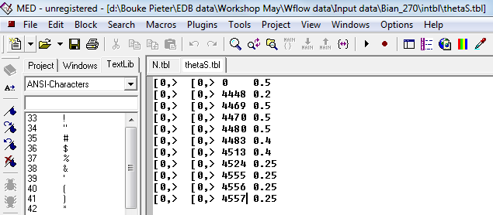

The values have to be put into a normal text-file and get the extension .tbl. This kind of file can be made by a basic text editor like MED or notepad. The first column stands for the landuse, the second the sub-catchment, the third the soil and the fourth the parameter value. It should always consist of four columns! The values in the first and third column, so for the landuse and soil, should contain exactly the values as they are in the landuse and soil maps. The second column, the sub-catchment, which refers to the map wflow_subcatch which is one of the staticmaps will not be used.  
[0,> means values equal or larger then zero will have the same parameter value. This option makes it possible to link a range of values to the same parameter value.

As described before the files have to be saved as <parametername>.tbl and put in the folder intbl in the wflow case directory.

### Exercises with the tables

Execute these Exercises with your group, do it for the catchment assigned to your group. Read first the exercise together and split tasks. If you don’t know how to perform the exercise read again the pages before where it is explained.

1. Find the kind of soils that are present in your catchment. An easy method to do it is to open your prepared soil map based on FAO values with aguila.

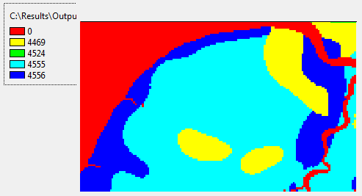

Figure 8.7 soil map viewed with aquila

1. Find the soil texture for the soils in your catchment (with HWSD viewer as described three pages up under reclassification), the texture is presented with sand, silt and clay fractions. Determine the texture class of all the kinds of soil in your catchment (to find a classification search for soil texture triangle in google).

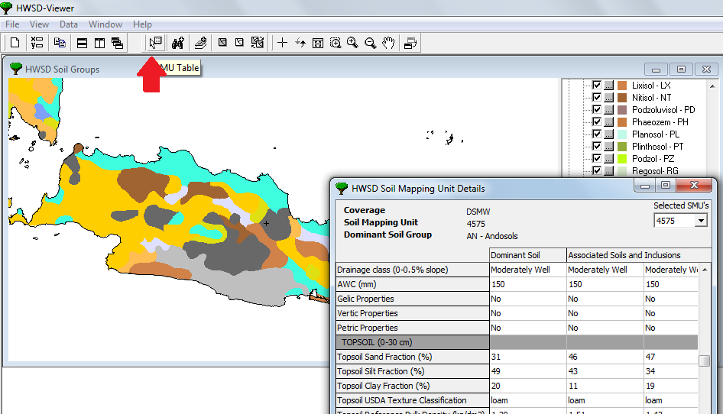

Figure 8.8 Soil texture map with HWSD viewer

1. Find the kind of landuses in your catchment. Also here you can use aguila.Think of a classification of the kind of landuses in your catchment. You can find a legend of the Globcover in the directory of Globcover.
2. Find values for your catchment for the parameter FirstZoneKsatVer and make the input table for WFLOW as explained two pages up.(see Table 5 for explanation about this variable) . Tip: Use the internet to find the parametervalue
3. Find values for your catchment for the parameter InfiltCapSoil and make the input table for WFLOW as explained two pages up (see Table 6 for explanation about this variable) . Tip Use the internet to find the parametervalue.
4. Find values for your catchment for the parameter N and make the input table for WFLOW as explained two pages up (see Table 7 for explanation about this variable) . Tip Use the internet to find the parametervalue

# Water Balance

Now that the WFlow is working it is time to have a look at the output that is generated. A first interpretation of the output is to set up a water balance. A water balance is a calculation of the amount of water in our catchment by balancing the inflows (precipitation) with all the outflows (discharge, evapo-transpiration, interception, deep percolation, storage).

To perform the water balance analysis we need to use the WFlow results produced from the running of the model as shown in Figure Figure 9.1.

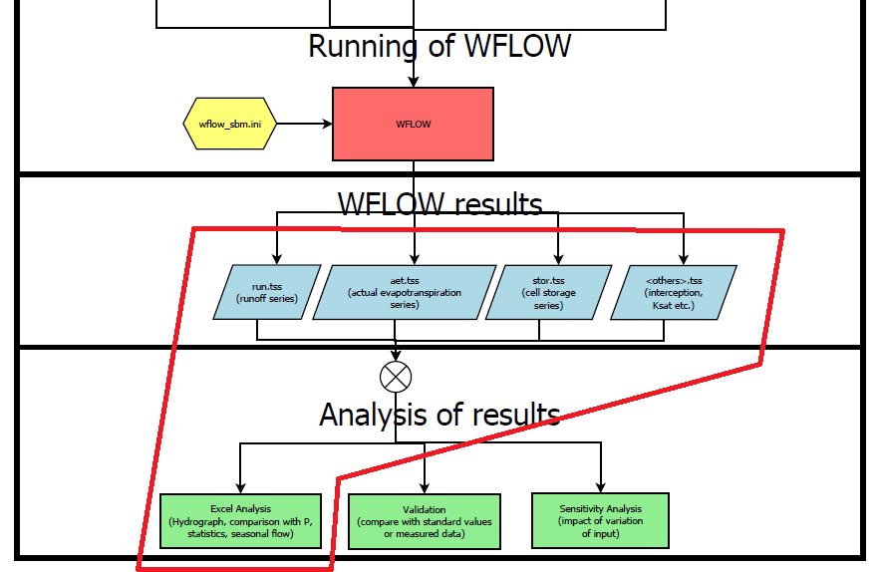

Figure 9‑1 Area of focus for the water balance analysis

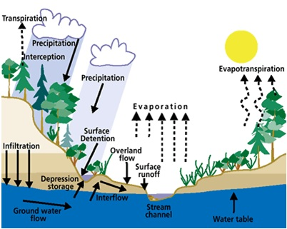This chapter will deal with a first analysis of the WFLOW results.

You will first retrieve the data from the model (the blue boxes in Figure 9.1) and then you will analyze them with Excel (Figure 9.1 green box). This chapter will start with a short explanation of the theory behind the water balance, and will then show you the correspondence between the water balance elements and their representation in WFlow. After the theoretical part, it will be discussed how to retrieve the water balance data from the model and how to perform the computation. Figure 9‑2 Illustration of the water cycle

## Theoretical background on the water balance

The general equation of the water mass balance for a river catchment is the following:

Inflow – Outflow = ∆Storage

Figure 9.3 shows this general concept of the mass balance equation. A bucket is filled with water at timestep=t with 30 m3 of water. This means the storage at timestep=t in the bucket is 30 m3 At the following timestep: t=t+1, the storage of water is increased to 40m3. This is because the inflow has increased with 10m3, while the outflow remains the same, Therefore 10m3 of water is stored extra in the bucket.

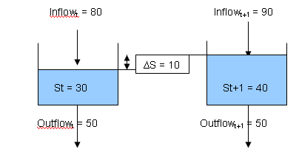

Figure 9‑3 Example of the water mass balance

Taking into account the main elements of the water balance for the catchment, the above equation can be represented as:

Precipitation - Evapo-transpiration – river discharge -Deep Percolation = ∆Storage

The equation can also be written in term of discharge:

Discharge = Precipitation – Evapotranspiration – Deep percolation - ∆Storage

In WFlow, interception by canopy cover is not directly part of the evapo-transpiration map. Therefore you have to account for the cumulative effect of interception and evapotranspiration to represent the whole of the evapo-transpiration component.

At the catchment scale, precipitation represents the main inflow of water in the water balance equation. Other input sources may be groundwater lateral flow from neighbouring catchments, or for example, snow melt from glaciers. The outflow component in the water balance is represented by a number of components. Evaporation of water from soil surface and transpiration by plants is the first component. These two factors together are referred to as evapo-transpiration. The other outflow elements of the water balance are the river discharge, the soil water storage and the deep percolation to the groundwater table (contributing to groundwater recharge).

An illustration of the water cycle and the water balance elements is provided in Figure Figure 9.2 and Figure 9.4.

In our catchment the sum of the inflow minus the sum of the outflow is not zero because the water that infiltrates the soil also contributes to storage, mainly a storage in the groundwater but also to surface storage such for example lakes or reservoirs. This storage components are not directly outputs of WFlow.

Considering the elements of the water balance all together, the water balance equation can be re-written as follows:

∆S = P – Et – Q – SSf – DP + seepage

$S \left(Storage\right)=P \left(Precipitation\right)-Et \left(Evapotranspiration\right)-Qr \left(Riverrunoff\right)-Qg (Groundwaterrunoff)$

Where:

S: Storage

P: Precipitation

ET: Evapo-Transpiration

Q: river discharge

SSf: sub-surface flow

DP: deep percolation

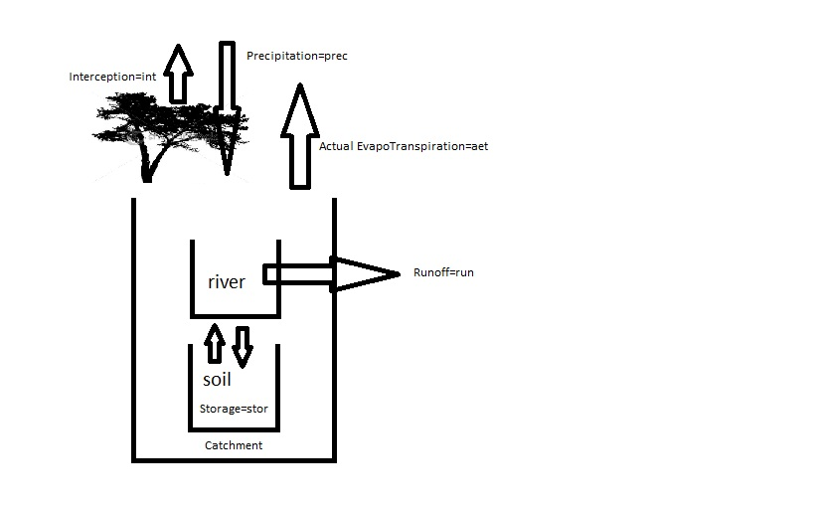

Figure 9.4 represents a scheme of the water flows in a catchment.  
When precipitation falls, part of it is intercepted by the vegetation canopy cover and evaporates before it reaches the ground. When the precipitation reaches the ground, part of it infiltrates into the soil, contributing to soil water storage (which eventually contributes to either groundwater recharge, deep percolation or sub-surface flow) while part of it flows on the soil surface (surface runoff or overland flow) directly contributing to river discharge.

Figure 9.4 Water flows in a catchment

Of the water contained in the soil, part of it will remain in the soil (soil water content), some will move under hydraulic gradient to eventually contribute to river discharge (sub-surface flow), while the remaining part will percolate to the deeper groundwater table or to groundwater areas outside of the surface catchment boundary.

Yet, an evaporation process from open water takes place. This is the evaporation from the river and, if present, from lakes or reservoirs. When vegetation is present in the catchment, transpiration from plants takes place.

## Water balance in WFLOW

The water balance described in the theoretical section is also represented in WFLOW. However, not all the parameters of the water balance are easily retrievable in the model. Since we will use only the main water balance elements of the equation (Q, P,ET, interception), the computation of the water balance for the following exercise will not perfectly sum up to 100% (the water storage map has not been generated and therefore we do not account for this variable).

The parameters that we will retrieve from WFLOW are shown in Figure 40. Water storage in lakes is not taken into account during this simulation, although WFLOW can also compute it. The subsurface flow is calculated but it is hard to retrieve at the catchment scale.

During the model generation of the water balance output components, WFlow will perform a rounding of the generated values.

## Retrieving of the parameters

The four parameters to calculate the water balance (Precipitation, Interception, Actual EvapoTranspiration and Runoff) can all be retrieved from WFLOW as a .tss text file. These are files containing a table with values for each timestep and gauging point.

While runoff is a standard output of WFLOW, for the other output parameters WFLOW has to be told to produce the maps as an output. This is defined in the ini-file (wflow_sbm.ini). In the [outputtss] section, you need to insert the following commands:   
Interception=int  
Precipitation=prec  
CellStorage=stor

ActEvap=aet

The required input typing is shown in Figure 9.5.

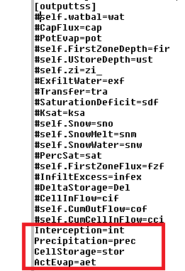

Figure 9‑4 Location of the parameters to be changed

In the [outputtss] section, while typing the names of the maps we want WFlow to generate, you have to pay attention to use the correct typing format: for the description preceding the “=” sign you have to pay attention to the use of capital letters as shown in Figure 5, for the part after the “=” sign you can choose yourself the nomenclature. It is however recommended to use the names as shown in Figure 5.

At this point, after the modification of the ini file, you need to re-run WFlow. Upon completion of the run, in the output directory you will find the following results: run.tss, int.tss, prec.tss, stor.tss and aet.tss can be found.

## Analyzing the values

The values in the .tss files have to be copied in Excel to be analyzed. Just open the .tss files (with Notepad, MED or F3 in Total Commander) and copy their content to Excel. In Excel you can use the *Text to column* function (sub-menu of *Data*) to get the data organized in column. Select the values you need and copy them to another sheet. This procedure should be performed for all the parameters.

The unit of measure for the runoff is m3/s while for the other variables is mm. We can calculate the water balance in terms of volume (Mm3) or depth (m) over a year. This means that every element of the water balance equation needs to be computed in either m3 or m. During this exercise we will work in terms of volume. All the input values are provided per timestep, therefore they are daily values.

To transform the discharge value from cubic meters per second to cubic meters, we need to know the area of our catchment.

### Computing the area of the catchment

The single sub-catchments in your river basin are shown on the map *wflow_subcatch.map*, contained in the *staticmaps* directory. Open this map with QGIS and translate it into ASC format. Then open the ASC with a text-editor and copy the content to Excel (use again *text to column* function). Now use the formula COUNTIF to count the number of cells with the value of your sub-catchment, the right syntax is =COUNTIF(‘range’,’number’). This operation will allow you to compute the areas of the single sub-catchments, by simply using the number of the sub-catchment for which you want to know the area.

Now you have to multiply the amount of counted cells in your sub-catchment by their unit cell size (in our case: 270*270 and 1080*1080 meters respectively). This will give you the area in square meters. With this value the water balance inputs can be recalculated to cubic meters.

### Calculating terms of the water balance

At this point, for every time step in our observation year we can calculate how much different elements contribute to the water balance. You can perform the computation either in terms of depth (m/month) or in terms of volume (m3/month).

Compute – on a monthly base - the precipitation (m/month), evapo-transpiration (m/month), interception (m/month) and discharge (m/month) values. Compare the input (precipitation) with the output and discuss with your group what the main elements of the water balance are, and what their variability is based on the time of the year. Also observe how the evapo-transpiration varies to variations in precipitation, and if a correlation factor can be identified between these variables.

### Exercise 1

Retrieve the precipitation, actual evapo-transpiration, interception, runoff and storage data from WFLOW and copy the values into Excel. During your comparison, only make use of the values of the upper sub-catchment we have defined earlier.

### Exercise 2

Find the area of the upper sub-catchment with Excel. You have to retrieve the information by using the wflow_subcatch.map and Aguila. At this point you can calculate the parameters for each timestep in m3.

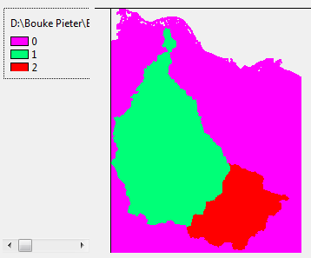

Figure 9‑5 Citarum River catchment in Aguila

### Exercise 3

Exercise on the analysis of the different water balance elements by taking into consideration the month to month variation, and the relation existing between the different elements of the water balance at the same time step.

# 10. Precipitation and discharge analysis

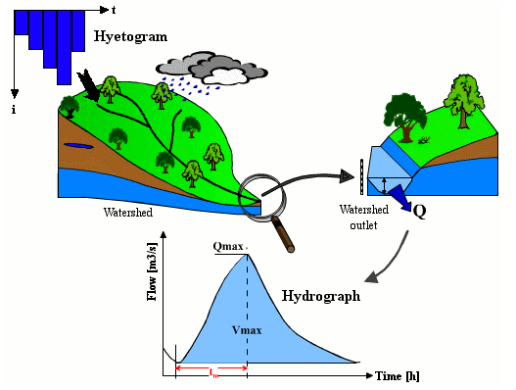

Figure 10.1 Representation of the rainfall to runoff transformation

Source: [Musy, 2011]

This section contains a short theoretical background and the practical exercises to carry out a precipitation and river discharge analysis, along with its validation and sensitivity analysis.

The structure of this chapter is the following:

Precipitation analysis

1. Monthly, annual, dry and wet season average precipitation

Discharge analysis

1. General aspects
2. Monthly, annual, dry and wet season average discharge

Temporal comparison of hyetograph and hydrograph

Comparison between modelled and measured discharge data

No non-sense validation

1. Runoff coefficient
2. Computation of expected discharge

For each section, one or more exercises will be provided.

The yellow boxes that you will encounter during the execution of the exercises contain questions that help you developing a critical thinking about the data you are observing. Please discuss them with your group members and bring your considerations and findings up during the group presentations.

The idea of presenting the discharge analysis approach is that you can later apply it to your WFlow results. However, given that we have run WFlow only for one year, we cannot perform a statistical analysis by making use of only one year modelled data. For the only scope of showing how the analysis should be performed, we will now make use of other sources of data for which we have enough data (measured and modelled) available.

## Precipitation analysis

A precipitation analysis is needed to identify variation in seasonal rainfall patterns, and to identify periods of high and low input during the year. Knowledge about precipitation patterns defines - among other - seeding time of crops, while influencing crop growing stages. As an example, Figure 10.2 provides an illustration of the influence played by rainfall on agricultural water demand. When precipitation rates are lower (violet line), irrigation water requirements (violet bar chart) are also higher.

Figure 10.2 Comparison of precipitation and Irrigation Water Requirements in the Rhine basin

Among other uses, precipitation analysis is also performed to forecast drought periods, or to determine rainfall intensity values to be used in flood simulation and flood forecasting.

### Exercise: Determine monthly, annual, dry and wet season average precipitation in your catchment

To compute this exercise we need precipitation time series long enough to be statistically significant for the identification of the seasonal precipitation patterns. The minimum suggested time period for analysis is 30 years. You can source these information from either historical datasets, or from simulated model time series if the former are not available.

Should you not be able to work with datasets equal or larger than 30 years, you can still perform the computation on a smaller time span dataset but you should bear in mind that the statistical significance of your computation might be affected by the short time span of the dataset considered.

If your precipitation input dataset (in out case TRMM) is long enough for the statistical computation, you can make the use of the precipitation data used for W-Flow to run the statistical analysis for the precipitation patterns.

The instructions provided in the following procedure make reference to precipitation data provided in a USB stick. If for your catchment you are making use of a different set of precipitation inputs, ignore the reference made to the USB stick data folders, use the precipitation data available to you and follow the instructions as provided below:

Procedure:

1. Access the precipitation sheet for your catchment;
2. Make a copy of the original input data sheet to a new sheet and start working on the latter (DO NOT start working on the original sheet, cause you might involuntarily modify the input);
3. For the given time period to be analyzed, compute in Excel the following output:
   1. Average annual precipitation value (mm/year);
   2. Average monthly precipitation values (mm/month);
   3. Draw a column chart showing the monthly composition of annual precipitation for the considered time period of analysis;

An example of the graph you have to produce for step 3 is provided in Figure 10.3.

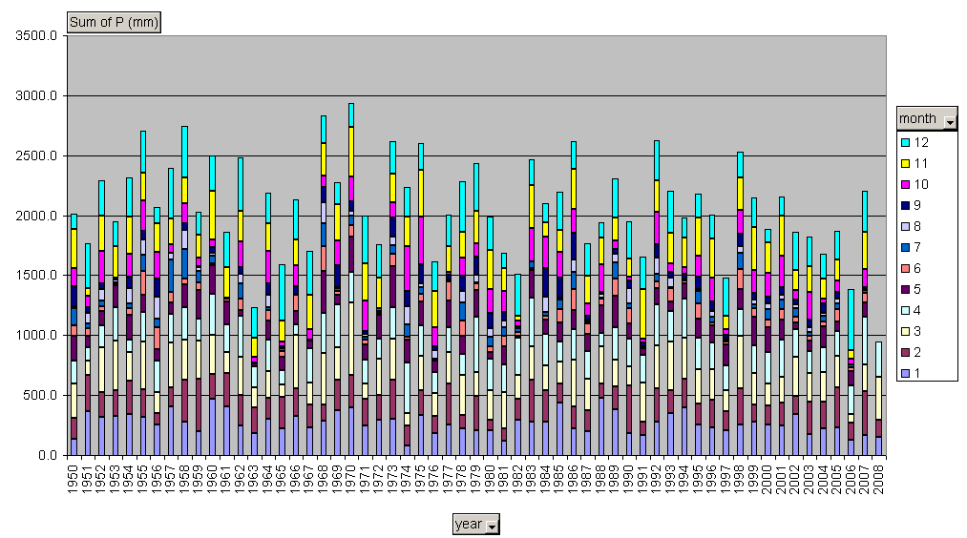

Figure 10.3 Monthly composition of annual precipitation for the Citarum river basin (Indonesia) 1950-2008

* 1. Draw a column chart of the average monthly precipitation trend over the time period of analysis;

An example of the graph you have to produce is provided in Figure 10.4.

Figure 10.4 Annual distribution of rainfall by month in an hyphotetical tropical river basin

1. Discuss with your team members the results of your first charts

Please address the following questions:

* 1. What can you tell about monthly and annual variability of rainfall?
  2. Can you observe any temporal trend in the precipitation patterns?
  3. What can you tell about the seasonal distribution of rainfall?

*Definition of dry and wet season*

When observing the precipitation patterns for a given basin, region or country, it is often useful to identify when the wet and the dry season occur within a year. Precipitation is an atmospheric event that varies over time, and definition of seasonal precipitation is never a fixed definition. However, observations of long time series values can help identify indicative seasonal patterns of wet and dry season periods.

To compute the wet and dry season period and average precipitation you can use different methods. Among the simplest ones you can:

* + - Observe the annual distribution of rainfall (i.e. Figure 10.4) and identify a monthly precipitation threshold separating dry and wet season;
    - Use statistical tools to identify precipitation percentage values and their occurrence

We will use this last method to identify the dry and wet seasons for our catchments.

The occurrence of a certain (hourly, daily, monthly or annual) precipitation value over an observation time period can be computed with percentiles.

The computation of a 40th monthly precipitation percentile over a given time period (i.e. 20 years), provides the value of rainfall (mm/month) that occurs in 60% of the observations. The use of pre-defined percentile values variables, and depends on the type of study being processed, the geographic location of the study area and the variability of the rainfall patterns.

As an example, we will apply NOAA (National Oceanic and Atmospheric Administration Agency) indications to define a dry and wet month, by respectively applying a 25th and 75th percentile to the rainfall observation datasets we are working with.

1. Compute the 25th and 75th monthly percentiles for the rainfall dataset of your catchment. Based on these values, define the average dry and wet season periods

To perform this exercise you have to make use of the percentile function in Excel, and compute it over the average monthly value of your observation period. Figure 10.5 shows an example of the computation of the monthly wet and dry season percentile values for the given observation period. The threshold values have been computed by simply averaging the wet and dry season monthly percentile values, to obtain the annual average value.

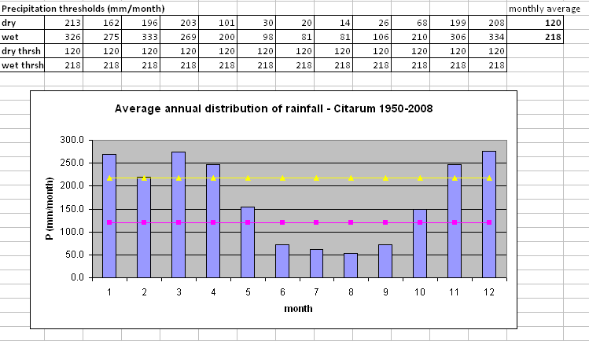

Figure 10.5 Average monthly rainfall distribution with the average precipitation of the dry (pink) and wet (yellow) seasons

With this exercise you have now concluded the rainfall analysis, and you have identified the wet and dry season periods in your catchment.

Please bear in mind that, the larger your observation dataset, the higher the reliability of your computation in statistical terms, and vice versa.

## Discharge analysis

A discharge analysis provides an overview of the patterns of river discharge over a given period of time for a given location. River discharge analysis is performed for both measured and modelled data. Figure 10.6 provides an example of hydrograph for a hypothetical river.

For this workshop a river discharge analysis is carried out to verify the quality of data generated with our hydrological model WFlow. What we want to verify is if the input provided to WFlow, and the distributed model functioning incorporated in the model do provide a reliable representation of actual river discharges.

When simulating hydrodynamics in a catchment, and when field measurements are available, river discharge analysis is performed by comparing modelled with measured data. However, one should bear in mind that the validity of the comparison is directly proportional to the quality of the measurements. If for example measured discharge series have a long record of missing data, or if the measurements are not recorded during periods of high flow, the bias in the comparison of measured to modelled data can be substantial.

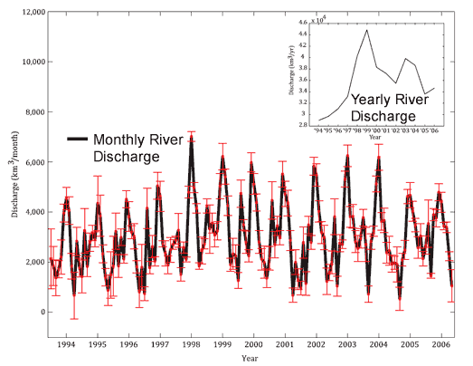

Figure 10.6Example of monthly river discharge hydrograph for a hypothetical river

Yet, another often omitted point of relevance is the comparison of modelled data which represent the natural flow in the river with measured data which also account for water withdrawals when surface water is used for productive or consumptive use.

From the above, it follows that the quality of field data needs always to be evaluated, and in case improved, before comparison with modelled data.

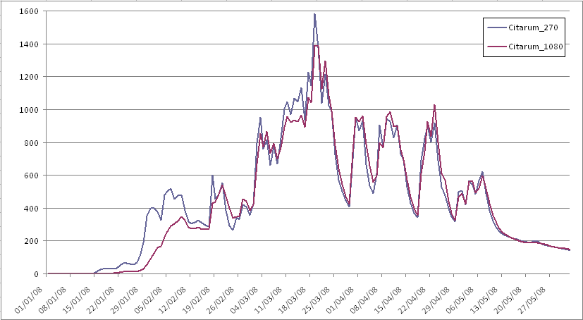

Figure 10.7 Example of comparison of modeled data for different grid cell resolutions

In hydrological analysis, the first term of comparison is the river **hydrograph**, which represents the river discharge at a fix location, projected over a defined time period (usually a year or a multiple of it). As in the example of the precipitation analysis, average annual discharge series computed over long time periods (i.e. 30-50 years) provide a more statistically significant term of comparison when estimating annual or seasonal average discharges, or when computing return periods of peak and low flows.

With reference to the above, the discharge analysis that we will perform during this workshop is meant only to be representative of the possible methods available for modelled data validation. Since during this workshop WFlow has been run only for the year 2008, we will provide with additional input data for the discharge analysis of your assigned catchments. If your analysis makes reference to input data not provided with a workshop USB stick, use your own discharge input data and follow the procedure described below for the analysis.

Please remember that while the illustrated methodology is a possible approach to analyze discharge data, the time series needs to be large enough (i.e. > 30 years) to make the statistical findings of the analysis significant.

### Exercise: Determine monthly, annual, dry and wet season average discharge in your catchment

The procedure to be executed to formulate a preliminary hydrological analysis or river discharge follows the same steps as the one described in the precipitation analysis paragraph. At this stage however, you already know the duration of the dry and wet season in your catchment, and you can try to produce seasonal statistics of discharge specific to these two time periods, as defined from the precipitation analysis.

Procedure:

1. Access the discharge data for your catchment;
2. Make a copy of the original input data sheet to a new sheet and start working on the latter;
3. For the given time period to be analyzed, compute in Excel the following output:
   1. Average annual discharge value (m3/s) and average annual total discharge (Mm3/year);
   2. Average monthly discharge values (m3/s);
   3. Draw the hydrograph of your river catchment:

🡪 by plotting average monthly values for your period of analysis;

🡪 by plotting – for a selected year – the daily values over the year;

An example of yearly hydrograph drawn using daily values is provided in Figure 10.8 below.

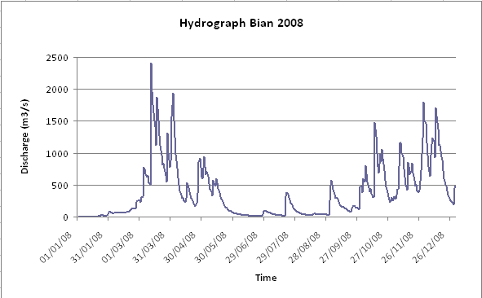

Figure 10.8 Hydrograph for the Bian River (Indonesia) in 2008

* 1. Select a random year in your dataset, and plot the hydrograph for the selected year against the average hydrograph for the observation time period

An example of the outcome of this exercise is provided in Figure 10.9. Discuss with your group what the most striking points you can detect from the comparison are. You can later present and discuss them during the group presentations.

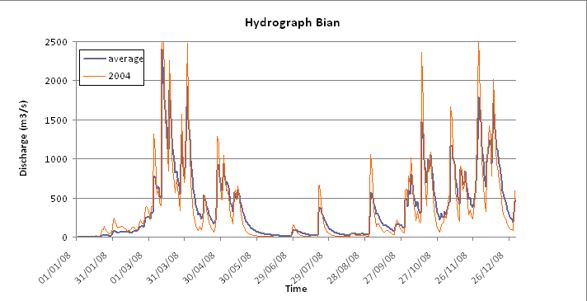

Figure 10.9 Hydrograph comparison between 2004 and average values, Bian River

1. Discuss with your team members the results of your analysis

Please address the following questions:

* 1. What can you tell about monthly and annual variability of discharge?
  2. Can you observe any temporal trend in the discharge patterns?
  3. What can you tell about the seasonal distribution of discharge over an average year?

The last step of the analysis now requires you to have a closer look at the discharge patterns in your river catchment considering the dry and wet season which you have identified in Section 1 (precipitation section).

1. Compute the average and minimum discharge values for the dry season period (m3/s);
2. Compute the average and maximum discharge values for the wet season period (m3/s);

You can perform step 5 and 6 the same way we have used to define the dry and wet season during the precipitation analysis. You can discuss in your group which percentiles you want to choose to identify minimum and maximum discharges.

1. Compare the average dry and wet season discharge values with the yearly average values

Observe the difference in the discharge ranges between the 3 projected hydrographs and discuss it with the members of your group.

What can you tell about the use of yearly average discharge values when you need to retrieve information on dry months?

Are the annual average data good enough to represent the discharge series during the dry season?

**Temporal comparison of hyetograph and hydrograph**

A comparison of the rainfall and discharge patterns helps providing an idea of the rainfall to runoff transformation that occurs in our catchments. It also gives a mean to better understand the hydrological patterns in the basin, and create expectations on the outcome of the modelled results of our analysis.

We will now project the hyetograph against the hydrograph to make considerations about the findings.

### Exercise: For a selected year, plot the hyetograph of your catchment against its corresponding hydrograph

This exercises helps you visualize how precipitation falling on a selected catchment transforms in river discharge for a gauging station located at the most downstream boundary of the catchment. You can perform this action by either taking into account a specific catchment of interest, or you can run the analysis at the whole catchment scale by aggregating the data t the sub-catchment level.

Used the input (P) and output (Q) produced with your W-Flow modelling to run this analysis. Select a specific year, and perform the following steps:

­🡪 plot P and Q daily values, and then plot monthly values

🡪 precipitation should be plotted on the secondary y axis and should be in a form of a bar chart;

🡪 discharge is plotted on the primary y axis in the form of a line;

🡪 select a given year and observe the trend of the bar chart and the line

To perform this exercise you have to select the same time period of observation, and make sure that the precipitation series you are using have a spatial correspondence with the area of the basin for which we are measuring discharge.

To have an overview of the rainfall to runoff transformation in the catchment, the most important comparison is the one projecting the hyetograph with the most downstream gauging point. This is because the latter represents the cumulative discharge of the river from its most upstream points.

Once you have performed the exercise for a specific year, zoom-in in the dry season precipitation and discharge patterns to have a better understanding of the rainfall-runoff transformation during the dry season months.

Figure 10.10 provides an example of how the P-Q graph should look like.

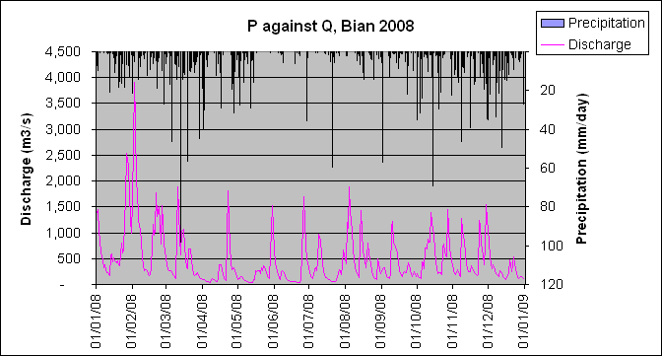

Figure 10.10Hyetograph and hydrograph at comparison for the Bian catchment, 2008

A different method to have an overview of the relationship existing between the discharge of a river and the precipitation that influences it, is to plot discharge against precipitation to verify if there is a linear correspondence between an increase in precipitation and an increase in discharge.

The slope of the trend line of the scatter plot tells you what the rate of discharge increase (or decrease) for a unit increase (or decrease) in precipitation is.

### Exercise: For a selected 10-year time period, provide the scatter plot of the rainfall to runoff relation and make considerations about your findings

A long time series scatter plot of rainfall to discharge helps you analyze the correspondence between a certain rainfall range and the discharge value corresponding to it. The slope of the linear trend in the rainfall-runoff plot gives you a measure of the rate of change in discharge, given a certain rainfall input.

It is recommended to perform this exercise for a large enough time period to provide statistical significance to the comparison. During this workshop, the minimum time step for which we can perform this exercise is one year. You can use this exercise as a pure example of how you can perform this test on a larger time step.

Alternatively, you can make use of the measured and modelled data from the provided datasets to test the rainfall to runoff correspondence for a larger period of time (i.e. 20 years).

First perform the test using the precipitation and runoff data generated with WFlow. This will provide a first good test to spot any inconsistency in the output of the model, if any.

Figure 10.11 provides an illustration of how the scatter plot for the rainfall to runoff relation should look like.

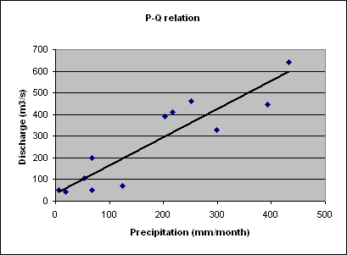

Figure 10.11 Example of rainfall - runoff relation

One should expect a linear trend in the rainfall to runoff relation, meaning that the higher the rainfall range, the higher the expected discharge.

## Validation of discharge series

Once you have performed this preliminary analysis of your modelled data, you can proceed with the validation process. The validation of the modelled discharge series can be carried out in two ways, depending on weather measurements of river discharge from the field are or are not available. When observed discharge series are not available, a no non-sense validation can be carried out.

### Comparison of modelled data with measured data

Comparison of modelled with measured data is the first step to be perform to evaluate the required degree of model calibration. In the absence of field measurements, the next two sections will present river discharge analysis checks that could be performed when measured data are not available.

As a temporal reference for comparison, you can first select a time period of e.g. 10 years, and then focus on a selected year for closer identification of variation between the observed and modelled river discharge series.

The comparison over a number of consecutive years helps you spot variation patterns that might occur repeatedly in the same period of the year (i.e. dry season) or in relation to a specific status of the river hydrograph (i.e. slope of descendent high-peak flows).

#### Exercise 10.3.1: For the given time period, draw the hydrograph of the modelled and observed data using monthly average values for the observation period

You should execute this exercise by first computing the monthly average values from the daily values for both observed and modelled data, and then select a year for the comparison.

With the example provided in Figure 10.12 you can have an overview of how the output of the exercise should look like. Based on the shape of the hydrograph you can also make your considerations about the ability of the model to represent the real discharge situation in the catchment.

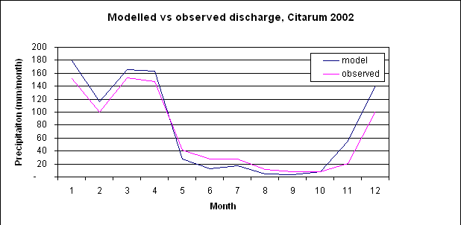

Figure 10.12 Comparison of the Citarum river (Indonesia) hydrograph for observed and modeled data

You can repeat this exercise for other years in the range, or opt to analyze them over the entire observation time period. This way you can verify if you verify if your interpretation of the difference between modelled and observed data equally applies to a different simulation year.

When you are testing your model results against the hydrograph generated with the measured data, it is interesting to observe what the advantage of using different resolutions (i.e. coarse versus fine) is. When comparing it with the hydrograph generated from measured data, if the hydrograph of modelled discharge with a coarse resolution is equivalent to that of a model run with a finer grid, then you might conclude that it is worth using the coarse resolution for your modelling. This will help you save computation time, without forgoing the good fitting of model results with observed measurements.

### No non-sense validation

The no non-sense validation represents the analytical process you have to undergo to analyze modelled discharge series when measured data are not available for comparison.

If for your catchment, measured data are available, it is still worth performing a no non-sense validation to compare results from the previous section with the ones from the current section.

The ratio between the discharge of a river and the contributing rainfall falling in the catchment area where the discharge is generated is called *runoff coefficient*. The runoff coefficient gives an indication of what is the percentage of rainfall that directly transforms into runoff.



The value of the runoff coefficient is determined by a number of different variables, among which the infiltration capacity of the soil and the slope are the most important factors. In turn, the infiltration capacity of soils is determined by the type of land cover and the type of soils present in the catchment. An example of how the runoff coefficient varies according to soil type and slope is provided in Table 10‑3 Runoff coefficient values for cultivated area below:

Table 10‑3 Runoff coefficient values for cultivated area

|  |  |  |  |
| --- | --- | --- | --- |
| Land cover type | Soil type | Flat slope | Steep slope |
| Cultivated land | Clay, loam | 0.50 | 0.60 |
| Cultivated land | Sand, Gravel | 0.25 | 0.35 |

Source: Department of Transportation, Oregon State, US[14]

For the specific case of river basins located in Indonesia, in the 1990s Rob van der Weert carried out an extensive study to analyze and characterize hydrological conditions for Indoensia. The report is called *Hydrological conditions in Indonesia* and it provided with the content of this workshop. In this report you can find reference to the values of the runoff coefficient for Indonesia, based on different annual rainfall ranges, which are location specific.

If your river basin is located in a country different from Indonesia, try to look for studies that have carried out similar research, and use these values as a reference.

Figure 10.13 provides an overview of the relation existing between river runoff and precipitation for river catchments in Indonesia as compared to other countries. THe figure is taken from [van der Weert, 1994] and illustrates the results of his study for the rainfall to runoff relation for the whole of Indonesia. The runoff coefficient can be computed from the curve by dividing the value of runoff by the corresponding value of rainfall specific to the catchment you are analyzing.

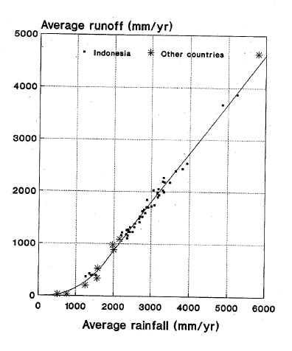

Figure 10.13 Rainfall to runoff relation for Indonesia

Source: R. v. d. Weert, 1994

### Exercise: Compute the runoff coefficient (RC) for your catchment:

* Yearly runoff coefficient
* Wet season runoff coefficient
* Dry season runoff coefficient

In order to compare the discharge with the rainfall, we need to work with the same unit of analysis (i.e. water depth, volume). We will compute the runoff coefficient by using as a unit of measure the depth of rainfall and of the discharge. To compute the discharge in terms of depth, we need to know the area of our catchment.

The procedure to compute the runoff coefficient for your modeled data is the following:

* 1. Compute the total area from the vector map (in m2) [this value has already been computed during the water balance analysis];
  2. get the average (yearly and seasonal) modelled value of Q (m3/s) for your catchment for the selected analysis period (i.e. wet season);
  3. transform the average Q from m3/s to m3/year or to m3/season;
  4. computed the runoff (in meters) as the ratio of discharge to total catchment area (Q/A);
  5. compute the depth of the precipitation (m/year or m/season);
  6. compute the runoff coefficient by dividing the runoff value (m) by the P value (m);
  7. compare the value of the RC you have just computed with the reference value provided ([van der Weert, 1994] for Indonesia or other national reference values for other countries) and draw your conclusions from this comparison.

The computation of the RC can also be performed for the measured data. This would give you a good indication about the quality of the measurements (assuming that the reference values you are using are representative for your catchment).

Observing the value of the runoff coefficient for the different seasons and comparing them with the precipitation total over the observation period, answer the following questions?

1. How can you interpret the variation of the runoff coefficient from the wet to the dry season?
2. What is the meaning of a runoff coefficient close to 1?
3. Which saturated soil conditions (high or low saturation) would you expect to be equivalent to a runoff coefficient of 0.2?
4. What rainfall intensity (high or low) would you expect to be equivalent to a runoff coefficient of 0.9?
5. What correspondence do you think there is between the runoff coefficient and topography?

You can now include the answers to these questions in the group presentation for the morning session.

# Sensitivity analysis

A sensitivity analysis is run to test what is the influence played by model parameters on river discharge. The aim of this analysis is therefore to test how sensible the river flow is to variations in variables such as, for example, the infiltration capacity or the evapo-transpiration.

During this workshop, we are going to test the catchment response to positive and negative variations of the variables contained in Table 11‑1. Please remember that intbl parameters are defined within a [min,max] range, and that, where the parameter value has already been defined at its upper or lower boundary condition, this value can not go beyond its minimum or maximum values.

In order to be able to compare the influence played by the different parameters on the discharge series, we will use the same percentage change for all of them.

Table 11‑1 Model parameters for sensitivity analysis

|  |  |  |
| --- | --- | --- |
| **Parameter** | **Intbl name** | **Varied value** |
| Free through-fall coefficient | CanopyGapFraction | - 50% |
| First zone saturated hydraulic conductivity | FirstZone KsatVer | + 50% |
| Infiltration capacity of unpaved soil layer | InfiltCapSoil | - 50% |
| Water content at saturation | ThetaS | + 50% |
| Manning parameter for the kinematic wave function | N | + 50% |

## Exercise: Perform the sensitivity analysis on the river discharge by testing 3 variables from Table 2

Procedure:

* 1. If you have not saved the results of the model run with the default parameter values, please do so now;
  2. Select 3 parameters of the 5 listed in Table 2 for which you want to run the sensitivity analysis;
  3. Copy the default parameter values before changing them (you will need to change them back later on!)
  4. Compute the suggested percentage change variation for the first parameter that you have selected, change the values in the intbl and run the model;
  5. save the results and compare the generated hydrograph with the one generated with the default values;

After computing the above mentioned steps, answer the following questions:

* + 1. Which changes do you notice?
    2. How is the hydrograph shape changing?
    3. What is the percentage change in the average river discharge corresponding to the percentage change of your selected parameter?
    4. Why do you think this is happening?
  1. now you can try to change the values of the second parameter you have selected. To be able to observe what the influence is, change back to their default, the values of the parameter that you have changed at the previous step;
  2. perform step 6 also for the 3 parameter

What are your conclusions about the sensitivity analysis?

Which of the above factors do you find more important in changing the shape

of our river hydrograph?

# References

Bontemps S. et al., 2011. GlobCover 2009. Product Description and Validation Report. UC Louvain and ESA Team

Critchley W. and Siegert K., 1991. *A Manual for the Design and Construction of Water Harvesting Schemes for Plant Production*. Food and Agriculture Organization of the United nations, Rome, Italy

Crow Peter, November 2005. *The Influence of Soils and Species on the Tree Root Depth*. Information Note. Environmental and Human Science Division, Forest Research, UK

FAO/IIASA/ISRIC/ISS-CAS/JRC, 2009. *Harmonized World Soil Database (version 1.1.).* FAO, Rome. Italy and IIASA, Laxenburg, Austria

Hensley, S., P. Rosen, E. Gurrola (2000). Topographic map generation for the Shuttle Radar Topography Mission C-band SCANSAR interferometry. In: Proceedings of SPIE, vol. 4125. pp. 179-189.

INSPIRE, 2009. *D2.8.I.1 INSPIRE Specification on Coordinate Reference Systems – Guidelines.* INSPIRE Thematic Working Group Coordinate Reference Systems and Geographical Grid Systems, September 2009

Katimon A. and Melling L., 2007. *Moisture Retention Curve of Tropical Sapric and Hemic Peat.* Malaysian Journal of Civil Engineering 19(1): 84-90 2007

Kramer Nienke, JaapSchellekers, 2011. Report on FEWS for Citarum catchment.(internal Deltares document)

KnivilaMatleena, December 2004. *Land Degradation and land Use/Cover Data Sources.* Working Document. United Nations Department of Economic and Social Affairs, Statistical Division

Rabus, B., M. Eineder, A. Roth, R. Bamler (2003). The shuttle radar topography mission: a new class of digital elevation models acquired by spaceborne radar. ISPRS Journal of Photogrammetry and Remote Sensing 57, 241-262.

Schellekens J., October 2011. *WFlow, a flexible hydrological model.* Deltares internal manual?

Schenk, H.J., and R.B. Jackson. 2009. ISLSCP II Ecosystem Rooting Depths. In Hall, Forrest G., G. Collatz, B. Meeson, S. Los, E. Brown de Colstoun, and D. Landis (eds.). ISLSCP Initiative II Collection. Data set. Available on-line [http://daac.ornl.gov/] from Oak RidgeNationalLaboratoryDistributedActiveArchiveCenter, Oak Ridge, Tennessee, U.S.A. [doi:10.3334/ORNLDAAC/929](http://dx.doi.org/10.3334/ORNLDAAC/929)

Vernimmen, R. R. E., Hooijer, A., Mamenun, Aldrian, E., and van Dijk, A. I. J. M.: Evaluation and bias correction of satellite rainfall data for drought monitoring in Indonesia, Hydrol. Earth Syst. Sci., 16, 133-146, doi:10.5194/hess-16-133-2012, 2012.

(not in alphabetic order)

**Lutz Breuer, Klaus Eckhardt, Hans Georg-Frede.** Plant parameter values for models in temperate climates. *Elsevier, Ecological Modelling 169.* 2003, pp. 237-293.

**Natural Resources Conservation Service.** Part 618 – Soil Properties and Qualities. *United States Department of Agriculture.* [Online] [Cited: March 7, 2012.] http://soils.usda.gov/technical/handbook/contents/part618ex.html.

**Decagon Devices.** Plant Available Water: How do I determine Field capacity and permanent wilting point? *Decagon Devices.* [Online] 2012. [Cited: March 9, 2012.] http://www.decagon.com/support/datatrac-3-online-help-files/how-do-i-graph-plant-available-water/plant-available-water-how-do-i-determine-field-capacity-and-permanent-wilting-point/.

**Brouwer, C.** Annex 2 Infiltration rate and infiltration test. *FAO.* [Online] 1990. [Cited: March 7, 2012.] http://www.fao.org/docrep/S8684E/s8684e0a.htm.

*A hillslope-scale experiment to measure lateral saturated hydraulic conductivity.* **Brooks, Erin S., Boll, Jan and McDaniel, Paul A.** W04208, s.l. : Water Resour. Res., 2004, Vol. 40. doi:10.1029/2003WR002858.

*Effect of land use-based surface roughness on hydrologic model output.* **Alfred J. Kalyanapu1, Steven J. Burian, and Timothy N. McPherson.** No.2, s.l. : Journal of Spatial Hydrology, 2009, Vol. Vol.9.

**AMEZQUITA Edgar, PRECIADO Guillermo, ARIAS Dora Mariana, FRIESEN Dennis, SANZ José Ignacio, and THOMAS Richard J.** *Soil Physical Characteristics Under Different Land Use Systems and Duration on the Colombian Savannas.* Cali : Centro Internacional de Agricultura Tropical.

*Refinement of rooting depths using satellite-based evapotranspiration seasonality for ecosystem modeling in California.* **Kazuhito Ichii,** Weile **Wangb, Hirofumi Hashimoto, Feihua Yang , Petr Votava, Andrew R. Michaelis, Ramakrishna R. Nemani.** 1907-1918, Fukushima : Agricultural and Forest Meteorology, 2009, Vol. 149. doi:10.1016/j.agrformet.2009.06.019.

**Fisher, D. Kenneth.** *Data Processing Information for the SWATS instrument.* s.l. : Campbell Scientific, Inc, 2000.

*Online resources*

Quantum GIS

* Use and functions: <http://www.baruch.cuny.edu/geoportal/practicum/gis_prac_4.html>)

Land use and land cover

* NASA LCLUC Programme: <http://lcluc.umd.edu/>

Soil maps

* General: <http://www.fao.org/geonetwork/srv/en/main.home>
* ASRIS <http://www.asris.csiro.au/index_other.html>
* ISRIC <http://www.isric.org/>
* Soil moisture storage capacity: <http://www.fao.org/nr/land/soils/en/>

<http://www.fao.org/geonetwork/srv/en/main.home>

Soil depth: <http://www.fao.org/nr/land/soils/en/>

Wikipedia. Water Content. Wikipedia. [Online] [Cited: March 6, 2012.] <http://en.wikipedia.org/wiki/Water_content.>

**Wikipedia.** Albedo. *Wikipedia.* [Online] [Cited: March 7, 2012.] http://en.wikipedia.org/wiki/Albedo.

1. A good and well described source of information on the functioning of QGIS, and on working with GIS in general is: <http://www.baruch.cuny.edu/geoportal/practicum/gis_prac_4.html>). Part of the content of this manual also makes use of this source
2. Source: <http://www.colorado.edu/geography/gcraft/notes/coordsys/coordsys.html>, accessed on 25.01.2012
3. Source: <http://www.sci.uidaho.edu/scripter/geog100/lect/01-foundations-of-geography/chap-1-part-2-earth-shape-lat-long-time.htm>, accessed on 16.01.2012
4. Based on : <http://www.baruch.cuny.edu/geoportal/practicum/gis_prac_2.html>, accessed on 26.12.2012
5. Based on: [http://www.geog.ubc.ca/courses/klink/gis.notes/ncgia/u04.html#SEC4.4.1](http://www.geog.ubc.ca/courses/klink/gis.notes/ncgia/u04.html" \l "SEC4.4.1), accessed on 26.01.2012
6. Source: <http://www.esa.int/esaEO/SEMGSY2IU7E_index_0.html> accessed on 31.01.2012
7. The information contained in this section has been taken from Bontemps S. et al., 2001. GlobCover 2009.Product Description and Validation Report.UC Louvain and ESA Team
8. Source: <http://daac.ornl.gov/ISLSCP_II/guides/ecosystem_roots_1deg.html> accessed on 31.01.2012
9. From page 7/10 of the SMAX Word version document. A reduction of 10% for this category of soils would change the Smax value from 10 to 9 mm/m. Since this change is not significant, we will keep the original value of 10 mm/m
10. Source: [http://www.fao.org/docrep/U3160E/u3160e00.htm#Contents](http://www.fao.org/docrep/U3160E/u3160e00.htm" \l "Contents) accessed on 02.02.2012
11. Source: <http://soils.usda.gov/technical/technotes/note6.html> accessed on 03.02.2012
12. The opposite is a lumpedhydrological model, where what happens in the rainfall-runoff transformation is unknown (black box model). A distributed model allows for the definition of parameters at the analytical scale, and in principle, it is possible to compute the discharge for each cell of the grid included in the model.
13. http://en.wikipedia.org/wiki/Interception_(water)
14. You can find a completed list of runoff coefficient for different surface types at: ftp://ftp.odot.state.or.us/techserv/Geo-Environmental/Hydraulics/Hydraulics Manual/Chapter_07/Chapter_07_appendix_F/CHAPTER_07_appendix_F.pdf